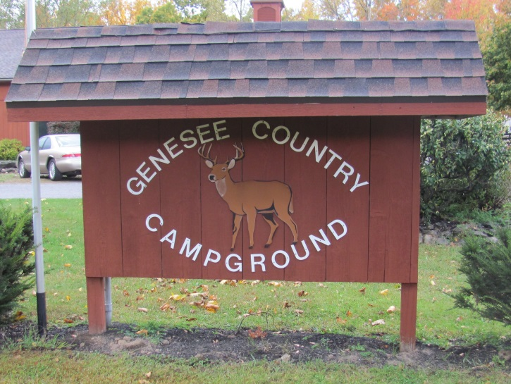 | 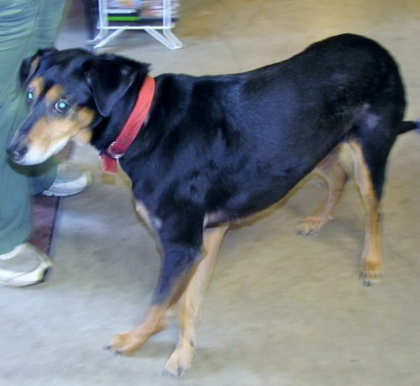  Marky … the Campground host!

WNY SAMS October 16 – 18, 2015 Camp0ut
@ Genesee Country Campground
(Editor/Reporter/Photographer: Diana Fackler (Contributing photographer: Dick Cox)
Camp Hosts: Rich & Carol Ward and Dick & Judy Cox

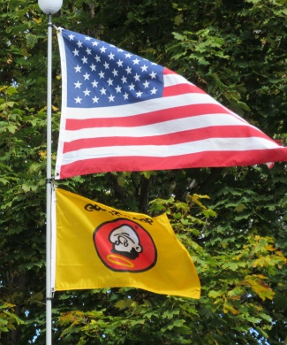
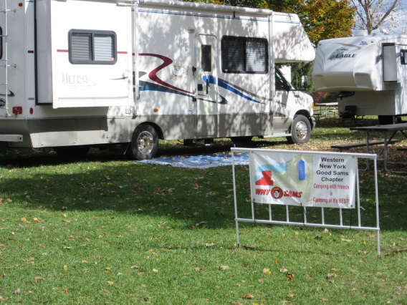
Arrivals at the campout arriving on Thursday were: Dick & Judy Cox, Jim & Ellie Strickland, Ed & Diana Fackler and Rich & Carol Ward. Friday arrivals included: Jack & Ginger Morinello, Mike & Linda DeRose, Bill & Ann Marino and daughter (sorry, I can’t remember the name), Don & Terri Sokol, Bob & Debbie Reuman, Dick & Bev Elliott, Keith Pierce & Nancy Craig, and Dave & Carolyn Nelson and guest. Saturday’s arrival was our newest members Jim Gray & Sherrill DeVantier.. AND, let’s not forget our 4 legged friends: Bert & Ernie Morinello, Ralphy Ward, Morgan Nelson and Oliver Craig/Pierce. We were sorry to hear that some of our members were not feeling up to “par” and had to cancel their reservation. Our thoughts were with you as well as with Butch and Carol Ellis whose motorhome was not feeling up to “par.”

Does anyone see anything wrong with the picture to the right? It looks like someone (Eddie ??) must have been feeling a little “off” during the campout and poor little Good Sam had to stand on his head the entire weekend! Sorry Good Sam!

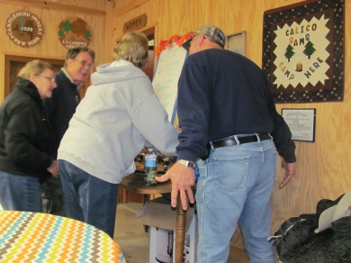
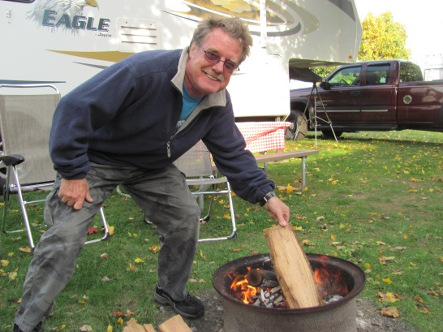
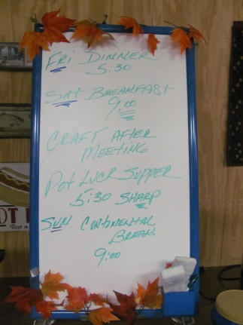
As always, Ed started a campfire on Thursday afternoon. Uh oh . . . is that Rich sneaking in a piece of wood when Eddie walked away to get more? Rich must be getting quite BRAVE but then again, Jerry had previously named him the new firemaster. Rain soon appeared a short while later and everyone scooted back to their “weekend home” to fix some supper. It wasn’t much longer when everyone decided to take a walk up to the shelter area and a few games of FARKLE and EUCHRE were played. Unfortunately, Jim and myself were NO MATCH for Eddie and Little Dick. While we were there, Rich had to get the “Agenda” on the Board for the weekend. Poor guy had 7 of us telling him what to put on there … lol and the finished project turned out great! Great job Rich and a big thank you to you, Carol, Little Dick and Judy for hosting the weekend! You guys did AWESOME – especially with the breakfast on Saturday morning (pictures to follow a little later).
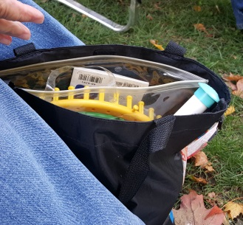
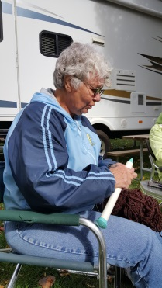
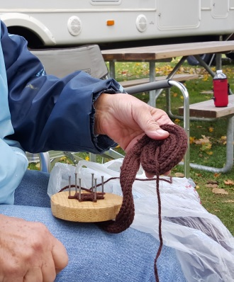
Friday morning found several of us taking a hike through the campground as we anxiously awaited more arrivals. An afternoon fire was soon started and Ginger brought out her bag of “projects.” Everyone kind of “jumped” back when she came out with her BIG needle. Then she came out with a project she has been working on since she was 10 years old …. Do you think we will ever get to see it Ginger? I believe the finished product is suppose to be a rug.

It wasn’t long before more rain arrived and started to dampen our fire. Shortly afterwards, several of our members had left for the Leroy Country Club for dinner. The best I can tell, the following had attended: Dick & Judy, Mike & Linda, Bill & Ann & daughter, Jim & Ellie, Jack & Ginger, Don & Terri, and Bob & Debbie. Sorry if I left anyone out and, unfortunately, I didn’t have “Big Dick” there to take pictures for me! The group returned from their dinner and soon the BEANBAG BASEBALL game came out while a few others played FARKLE. As always, a GREAT time was had! I believe the guys won one game and the girls won another. But … Rich … should we vote on that? All in favor, raise your hand! The girls have it!

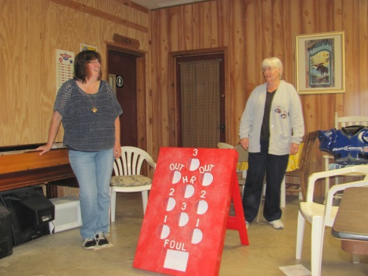
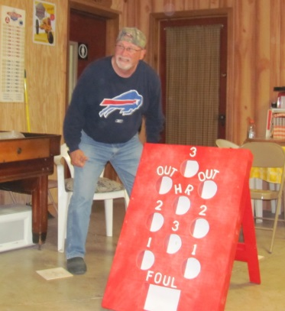
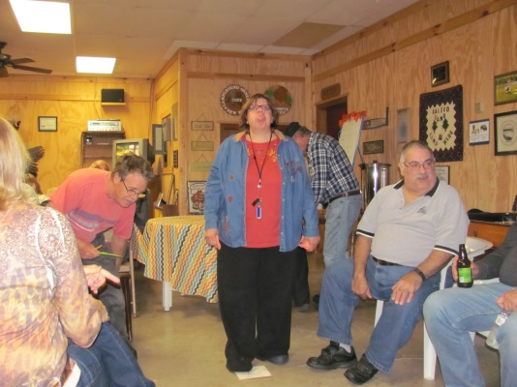

An AWESOME breakfast was served on Saturday …. I even went back for seconds and most of you know, that I very, very seldom do that!
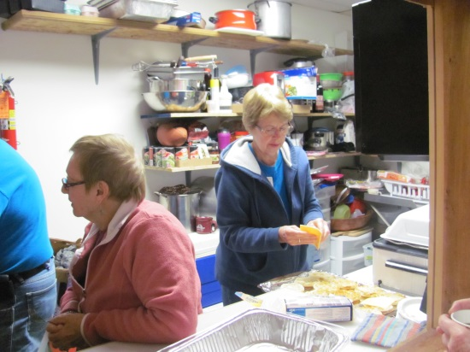
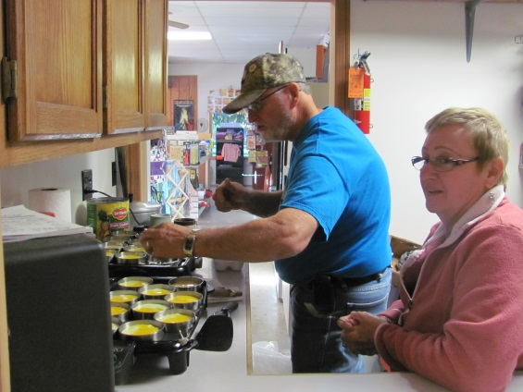

With the absence of President Chuck, a short meeting was initiated by myself. The highlights of the meeting are were:

- Meeting was called to order at 9:50 AM by Diana. The Pledge of Allegiance followed as well as a “Camper’s Prayer.”
- MOTION was made by Nancy, seconded by Jack and carried that the reading of the minutes of the September campout be dispensed of. Carried.
- Treasurer’s report was not available. It was discussed that the last actual report we had was at the Canandaigua KOA campout. While Diana reviewed the minutes, the Treasury at that time had a balance of $953.07. Paperwork is currently in the “works” for the Treasurer’s position to be filled by Keith.
- Terri reported that the 2016 Camping Schedule is almost finalized with the following campgrounds: May – Woodstream; June – Four Mile Creek State Park; July – Samboree; August – Dream Lake (near Camp Getaway for those that would like to volunteer at the Camp); September – Sleepy Hollow; and October – Southwoods. Terri also stated that they will be checking with Genesee Country Campground for availability in May 2017. Middle Dick (Elliott) stated that Dream Lake does offer options for Saturday night and they can provide a catered meal if we are interested. Diana had also asked if Terri was able to get a check for the Sleepy Hollow deposit that she had requested. She responded that she has not but she has been busy and didn’t get to finalizing everything as of yet.

OLD BUSINESS:
- Brief discussion was raised by Diana that the “scheduled events” for the monthly campouts need to stick within the time frame that had been scheduled. Problems were encountered with the last few pot luck meals regarding the time and we need to work on those areas a little bit more.
- Details for the Christmas party have not yet been set – more information will soon follow.
- Question was asked if the chapter monies designated for charity had been sent to Camp Getaway. Nancy stated she had received an email saying “thank you” and is assuming (but not 100% sure) that they did.

NEW BUSINESS:
- Diana reported that there will be a Regional Event at Turning Stone campground in 2016. This is not , by no means, taking place of the Rally/Samboree in Herkimer. One hundred sites have been reserved for the weekend of June 10 – 12, 2016 (Friday, Saturday and Sunday nights) at a cost of $112. Additional nights can be purchased at the campground rate. The campground is working with the casino to get complimentary casino cards and plans are also being made for some type of dinner. A free shuttle will be available from the campground to take people back and forth to the casino. Diana stated that those interested in attending should make their reservations soon. The event will be open to everyone in the campground in the hopes of recruiting more Good Sam members. Little Dick commented that the fee for extra nights at Turning Stone are $34/night with the Good Sam discount.
- The Regional Directors had also discussed at the Fall Fest that other Regional Rallies are being planned for 2016. More information to follow.
- A vote was taken at the Fall Fest in September and it was agreed that NYS Charity monies for 2015 will go to Operation Injured Soldiers and monies for 2016 will go to Roswell Research. Little Dick commented that on behalf of Operation Injured Soldiers, he would like to thank everyone for making that donation possible.
- The theme for the 2016 Rally/Samboree will be “Celebrating 50 years of ______________.” It will be up to the individual chapters to fill in the blank and suggestions at the Fall Fest had been to go “retro” (ie, egg/spoon toss, balloon toss, hula hoops, etc)
- Elections will be held in December. Diana stated that the positions up for vote are President, Secretary and Treasurer (as Keith’s nomination was for current year). It was also discussed that there is need for a position of Vice President. Following discussion, a MOTION was made by Jack and seconded by Rich that the position of Vice President be created. Carried. Further discussion took place on having a ballot for the December meeting with the names listed for those that are interested in running for one of the positions. Write-in votes could also be added. Question was raised if anyone was interested in the position of President. As no one else indicated an interest, Diana stated that she would have her name added to the ballot for President. The only possible interest for Secretary was from Linda but she stated she would need to think about it a bit more. Discussion of Treasurer was brought up and Keith was “kiddingly” told that he had a life appointment. All kidding aside, his name will be put on the ballot for Treasurer. Rich volunteered to have his name put on the ballot for Vice-President. An email will be sent out to the membership asking that Diana be contacted if anyone is interested in having their name put on the ballot for any of the positions.
- Discussion was raised as to votes – is it 1 per rig or 1 per person. Following brief discussion, a MOTION was made by Nancy and seconded by Little Dick that the policy of “votes” be changed from 1 per rig to 1 per person. Carried.
- Discussion was also raised as to the campout “fee” of $5 per unit. Is the amount sufficient to cover the costs involved each campout? Little Dick commented that we had 13 units (2 of which were guests) for the campout. Total income (from 11 units) @ $5/unit was $55. Expenses for the weekend were $107.59 which was $52.59 more than we received. It was decided to hold off a little bit longer before raising the fee back to $10/unit.

OTHER BUSINESS:
- Rich raised discussion that emergency numbers are needed for each unit attending the campouts. He suggested that a sheet be available when registering so that members can list an emergency contact number. It was also suggested that emergency numbers be attached to the rig. Following discussion, a MOTION was made by Rich to have a sign in sheet listing a number to contact in case of an emergency as well some type of medical record (heart, diabetes, etc.) with a designated person in the group. Motion was seconded by Bob and carried. Ginger stated that the person who does the name tags is also able to make name plates (license plate size) for rigs for identification purposes at $25 each. Judy asked if she would be able to send a picture via email of a sample of the plate.
- Jim & Ellie Strickland were introduced and voted in as new members.

MOTION was made for adjournment at 10:18 AM. Seconded and carried. (At the beginning of the meeting, I promised to not go over a half hour and Jack reminded me that I went over by 2-3 minutes. Sorry Jack .

A special thanks to Linda for taking the minutes for me at the meeting!

The “BASKET KIT” craft followed the meeting and the ladies did a WONDERFUL job! Everyone that participated in the class was asked to bring their “Cookie Sharing” basket to the Christmas party filled with cookies to share – don’t forget ladies!

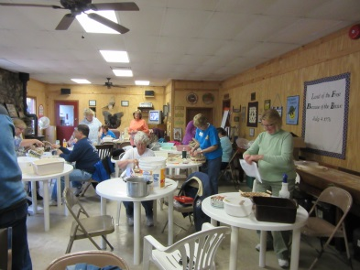 | 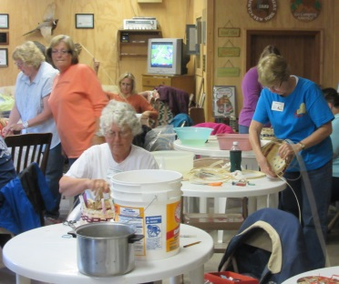 | 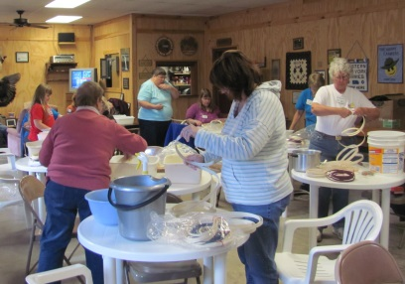 | 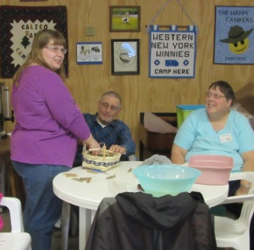

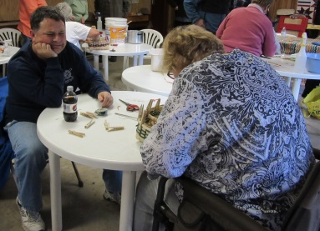

And the prize for best picture goes to ………..

I’m thinking Keith wasn’t too sure of what
Nancy was doing!

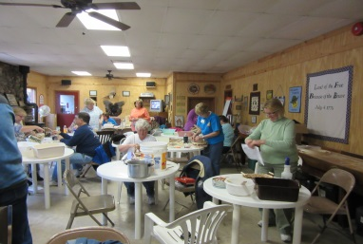 | 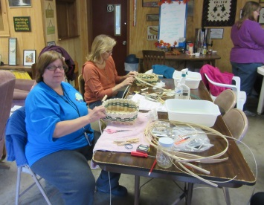 | 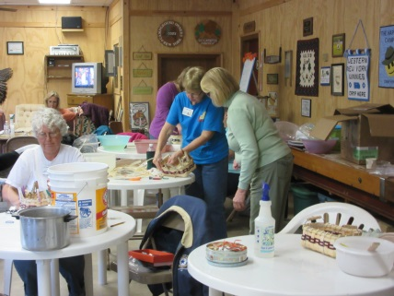 | 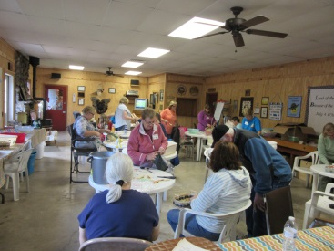
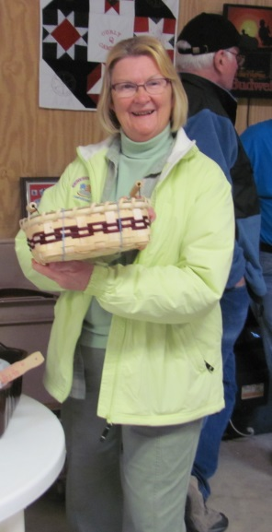
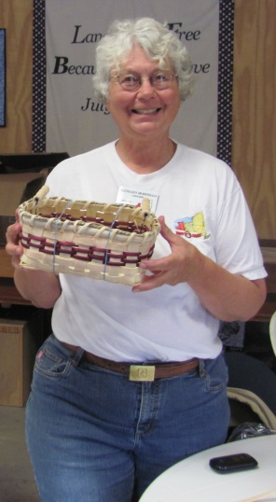
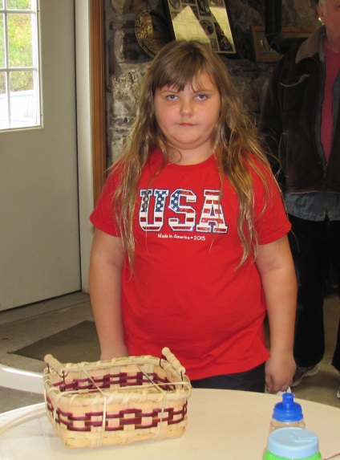

Some of
the finished
Baskets. I thought I had
more pictures
but cannot find
them.

Who is up for doing a picnic basket next year?

During our craft, the guys enjoyed a nice warm fire.
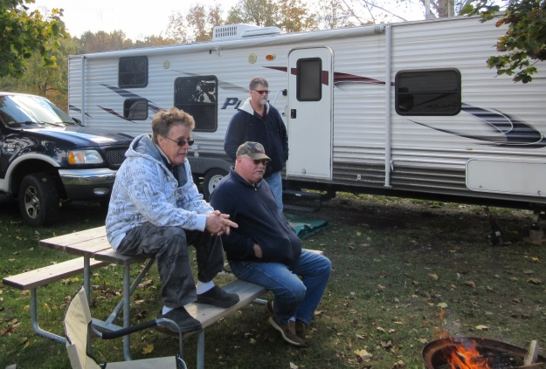
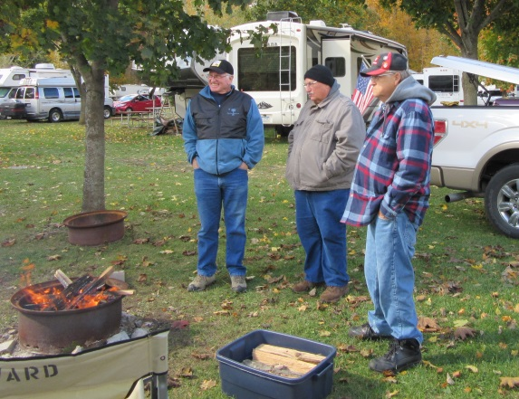

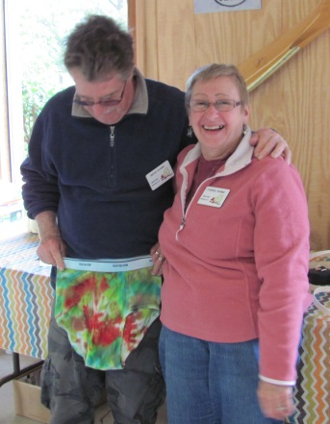
Remember the tye dye items made at the September campout? Everyone was suppose to model their item at the October campout but only one was brave enough to “wear” his EVEN though it was a little “embarrassing!” Good job Rich!

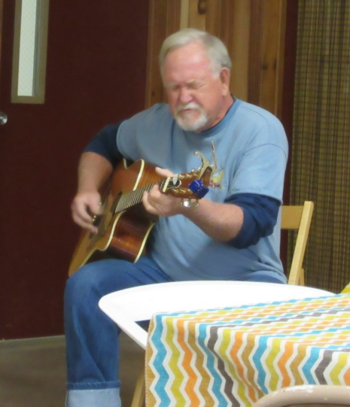

The basket class had gone a little longer than planned so once our “mess” was cleaned up, many of us headed back in order to get our pot luck item prepared. Jack also brought out his guitar and entertained those that were able to stay behind.

Thanks Jack!

Our other new members (Jim Gray and Sherrill DeVantier) arrived mid-afternoon and were able to join us for our potluck meal. And, as always, we outdid ourselves with the potluck once again! Linda led the group in a short prayer before the “feast” began.

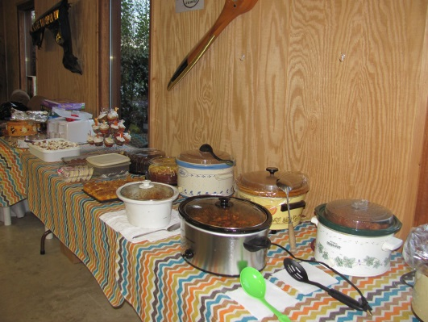
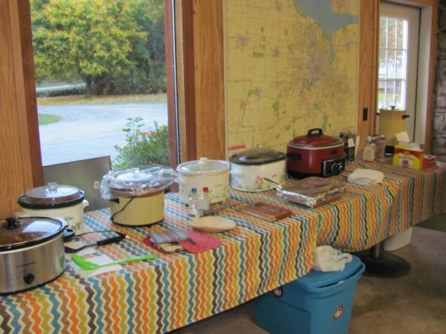
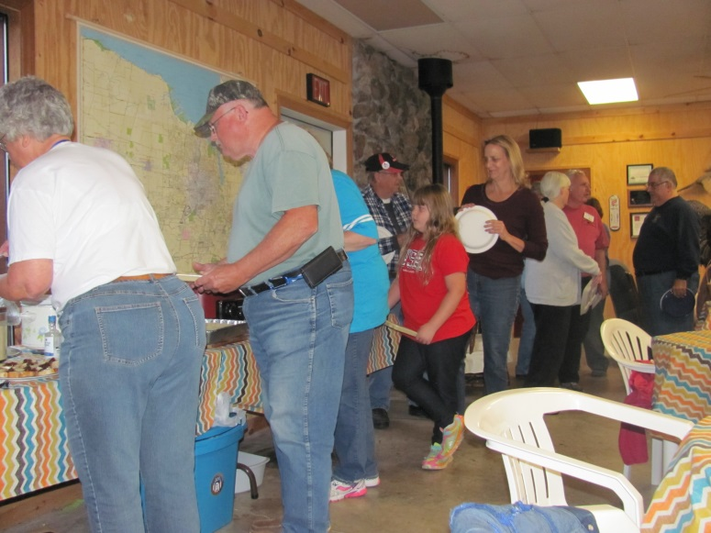
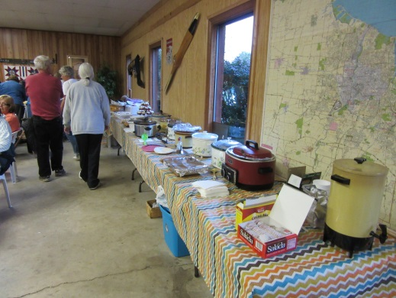
Ginger even managed to SURPRISE Jack with a birthday cake for his special day and stated that she had got him an AWESOME present – tickets to the Paul McCartney concert on Thursday evening! Jack must have been a very good boy this past year to get such an AWESOME present!
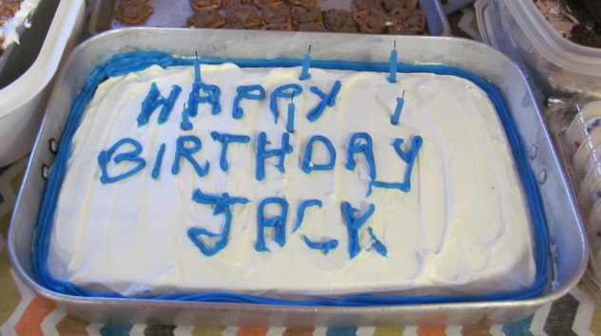

Everyone hung out for a little bit after dinner and some arrangements were made for the Four Mile Creek State Park campout next June. Another game of FARKLE was soon begun. It was a close competition and I believe, Judy “stole” the game from me … lol. Rich and Little Dick kept laughing at my “hesitation” in taking another roll of the dice BUT remember a little bit at a time gets you farther than taking the chance of getting a FARKLE!

I believe we woke up to snow on Sunday morning and we even had some hail over the weekend. Everyone headed up to the shelter for a continental breakfast and to say our “farewells” until December. Ginger talked about getting some type of activity together before they leave for Texas. Possibly bowling? Sounds great. Just because it might be a “tad “ cold to camp doesn’t mean we can’t still get together for some fun.

A few more pictures to share with you from the weekend.

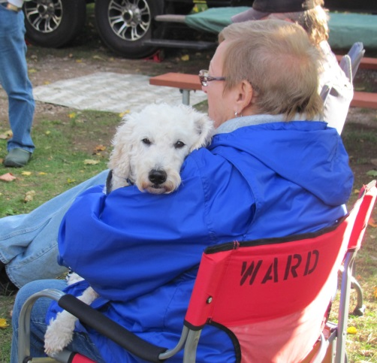

Ralphy “chilling” with his Mommy.

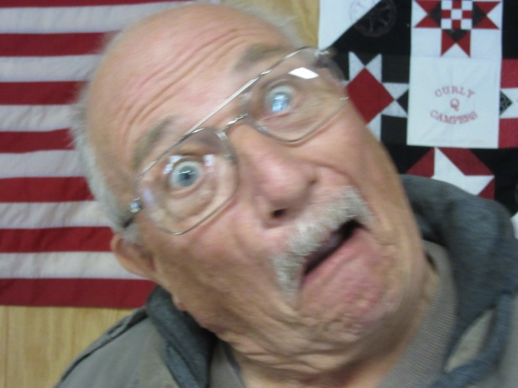

One of our newest members (Jim Strickland). Looks like he is going to fit right in with our group, doesn’t it ?!?!?

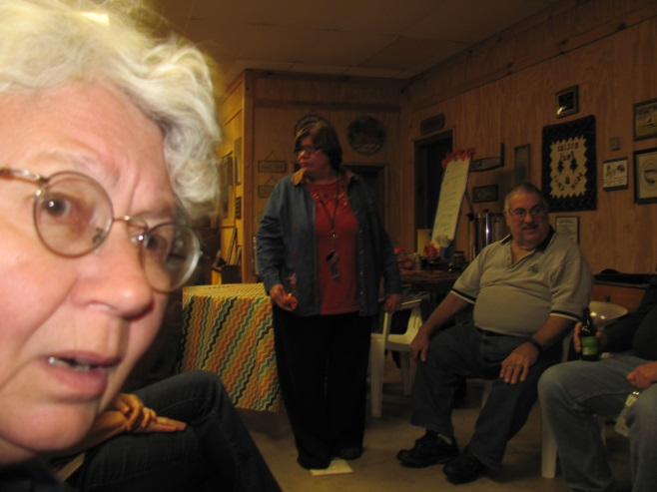

Sorry Ginger, I couldn’t resist posting this one! (I was actually sitting next to Ginger and was taking a picture of Linda when Ginger moved into my line of vision … lol)

And now, our newest members:

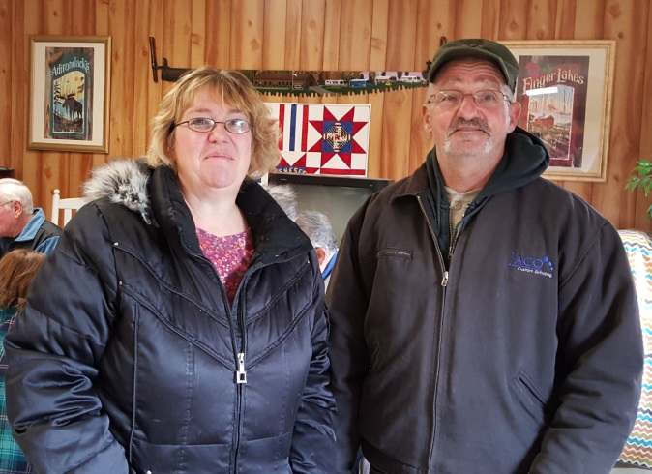
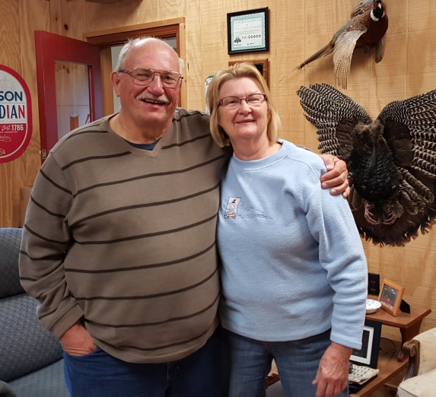

Jim Gray & Sherrill DeVantier
Jim & Ellie Strickland

WELCOME ABOARD!

Don’t forget, if you are interested for having your name added to the ballot for any of the positions (President, Vice President, Secretary or Treasurer), please let me (Diana) know and your name will be added.

Hope to see everyone at the Christmas Party on December 12th (1:00 – 4:00) (as reported via an email from Marge Meyer following the campout) at the Hamburg Camping World. Don’t forget to bring a gift (per couple) if you are interested in doing a gift exchange. You bring a wrapped gift worth @$25 and get one in exchange. We really had some AWESOME gifts last year! I’m sure you will be getting more details from the Christmas Party Committee. See you soon!

