WNY SAMS CAMPOUT at the 44th NYS SAMBOREE
July 9 – 12, 2015
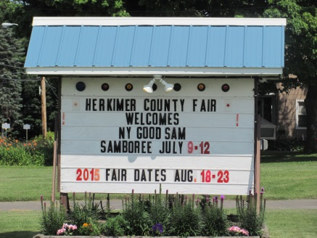
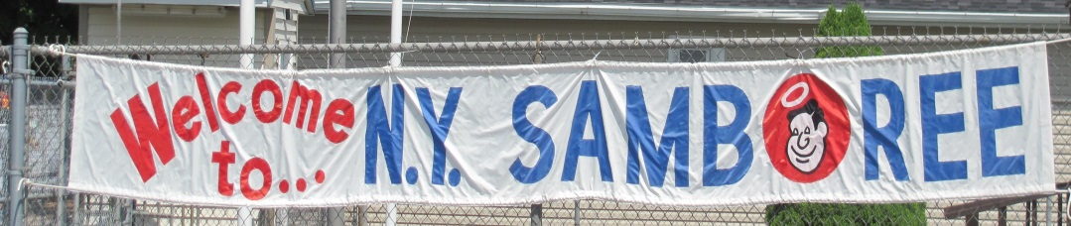

Editor/Reporter/Photographer: Diana Fackler Contributing Photographers: Dick Kashdin & Chuck Bradford

Home for several of our members this past weekend was the 44th NYS Samboree at the Herkimer Fairgrounds in Frankfort, NY. Those in attendance were: Chuck & Pam Bradford, Butch & Carol Ellis, Dick & Maryann Crouch, Ed & Diana Fackler, Dick & Judy Cox, Paul & Cathy Schulz, Dick Kashdin & Sandy Donovan, Jerry & Marge Meyer, Rich & Carol Ward, Keith Pierce & Nancy Craig and Jay Wopperer & Linda Schmieder. One of our newest members, Dick & Beverly Elliott stopped in to visit for a bit. We missed those members that were unable to attend and hope that those who did, had a GREAT time!

For those that have never attended a Samboree before, you will find a lot of activity and a lot of fun when you are with your Chapter. Ed & myself had attended by ourselves a few years ago and there was a lot of down time with very little interaction from others, and we both said we would never attend again. Well you know what they say, NEVER say NEVER! Last year was the first year we had traveled back to the Samboree and we had a great time. This year was even better yet! So, if at all possible, try to make plans for the FALL FEST in September and/or the Samboree next July. You will find the registration form for the FALL FEST on the NYS Good Sam webpage (http://www.newyorkgoodsam.com/index.html) . Speaking of the NYS Good Sam webpage, the minutes and Newsletter should be posted in the next few days. Keep checking the page periodically until they are posted.

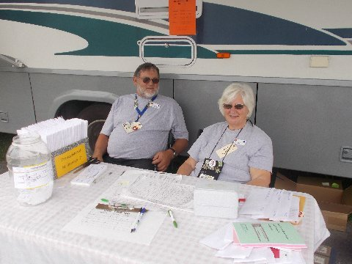
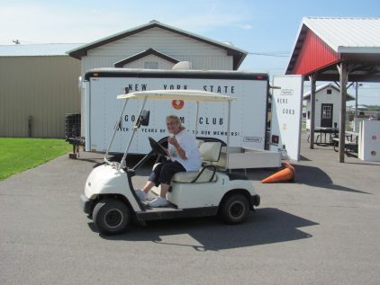
Maryann & Dick did an OUTSTANDING job this year as Directors. They didn’t stick to the “same old, same old” that has been past tradition. New things were incorporated and some were done away with. Butch & Carol also did a terrific job as Registrars. Thanks to all of you for all of your hard work! I’m sure it will take quite awhile for all four of them to catch up on their sleep. I believe most of our members present at the Samboree also chipped in and helped with whatever was needed to
be done – either for the State or for our own Chapter. It was definitely a VERY BUSY few days but very rewarding too.

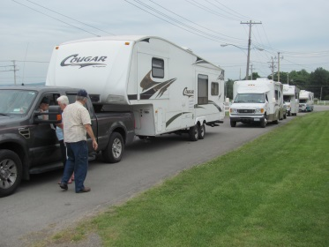
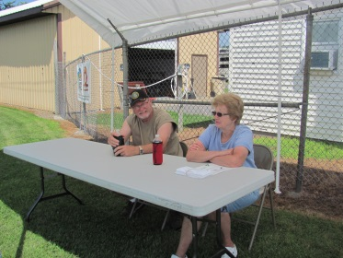

One of the BEST new things was the TOILET PAPER TOSS that Maryann came up with on Saturday evening. It was so funny watching everyone scramble to get some toilet paper. Who would have ever thought there would be so much excitement?!?!?! (Pictures will follow a little bit further in the newsletter!) With all that being said, on with the newsletter and the Samboree happenings!

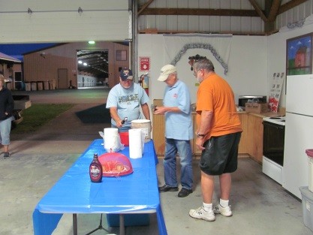
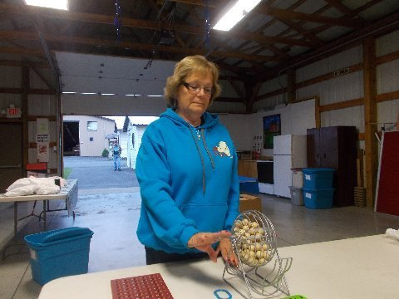
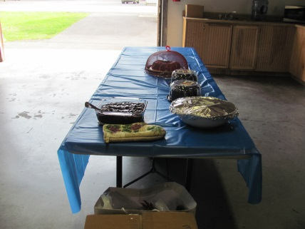
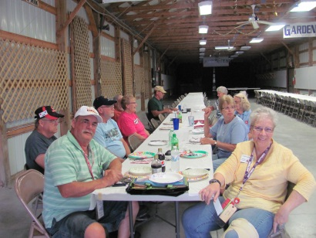
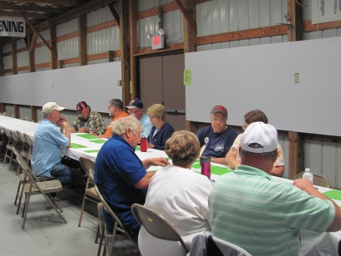
A POT LUCK dinner was held on Wednesday evening for those that were in attendance. I believe the majority of the group was from WNY SAMS and, of course, there was plenty of delicious food and desserts! Shortly after the Pot Luck, it was time to play CANDY BAR BINGO and they were stuck with me calling the numbers. Sorry to those that had a hard time keeping up with the speed in which I called the numbers. I tried several times to slow myself down and hope that I accomplished it by the end. Maryann explained that the normal admission is a candy bar which would then be handed out to the BINGO winners. However, since few were aware of it, she purchased candy bars and those winning got to pick their choice. Unfortunately, I did not have my notepad with me so I cannot remember which of our members won but there were a few.

Earlier in the day, a road trip was made by Ed, Little Dick (Cox) and Dickie Doo (Crouch) to pick up the ice cream being donated. They had no idea where they were going and we think they might have gotten a little detoured on the way back because they had made it back just before the Pot Luck meal was served. They won’t admit to it, but we also think they might have been searching for some spoons on their return trip to taste the ice cream ?!?!? Anyways, they did make it back and ice cream was dished out as a surprise treat following Bingo!

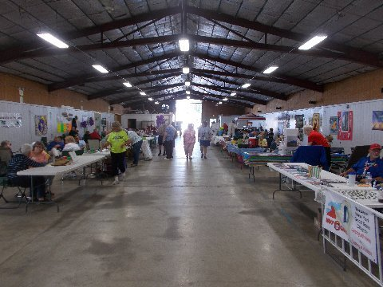
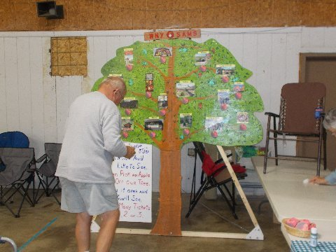
On Thursday morning, a lot of activity took place in the Main Hall while all the Chapters began working on their Booths. I might be a little prejudice, but I thought our booth turned out AMAZING and was really surprised that it didn’t place in the top 3 – Anyways, thanks for all your hard work Jerry & Rich. Camping World had donated some folding chairs and a lounge chair which were awesome. Several of our own members (including myself!) would have loved to have won them but, unfortunately, none of us did.

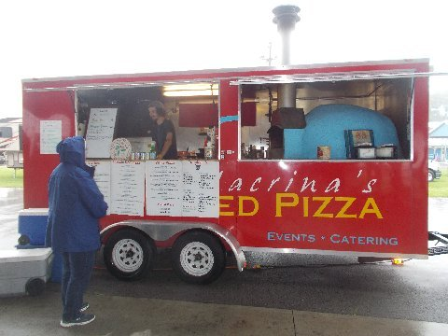
The Snack Bar was open from 11:30 AM – 1:00 PM for those wishing to grab something to eat. I believe it was also on Thursday that Paul & Cathy had taken the Erie Canal Cruise. Jay & Linda had arrived Friday evening and had also made plans to take the same cruise while at the Samboree. A few activities were scheduled to be held – CORN HOLE TOSS & CRAZY GOLF – but the Chapter doing the Corn Hole Toss had not yet arrived. I don’t believe any of our members participated in the Crazy Golf.

The FOOD TRUCK was something new this year and was AWESOME! They arrived amidst a downpour on Thursday afternoon but the food made up for the nasty weather. They had several items including meatball sliders, wood fired pizza, gourmet pizza, salads, etc. It was definitely a busy place for awhile!

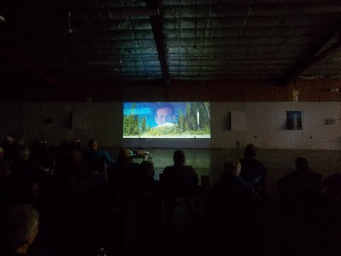
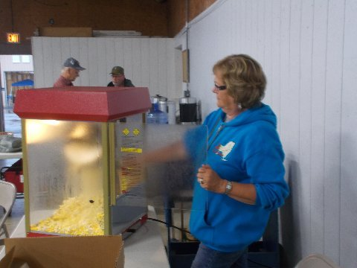
Another new item for this year’s Samboree was POPCORN (free) sales and a MOVIE on Thursday evening. There were sounds of laughter as those in attendance chewed on their popcorn and watched “RV” with Robin Williams. Ice cream sales were also taking place for a short time. Following the movie, local restaurant gift certificates were given out to a few lucky winners!!

Friday morning arrived bright and early as the announcement was made @7:15/7:30 for the Golf Outing – everyone was asked to meet at the Main Gate and a carpool would go from there. Coffee & Donuts were served in the Main Hall.
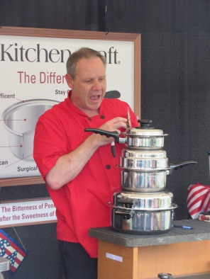
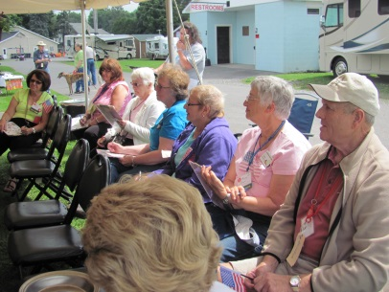
Several activities took place on Friday, including a COOKING DEMONSTRATION (held multiple times Friday & Saturday), CHAPTER BOOTHS were open in the afternoon, and BEANBAG BASEBALL which drew quite a crowd. Several of our “ladies” attended the demonstration and Chuck & Pam participated in the Baseball game. Incidentally, I have been told that Pam drew the “lucky ticket” for a door prize at the demonstration and she drew Marge’s name. Congratulations Marge!
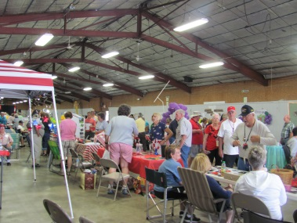
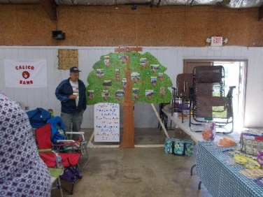
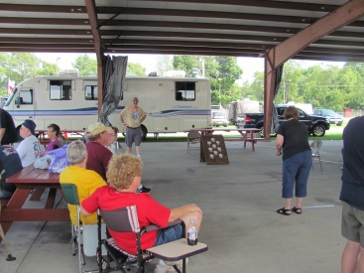

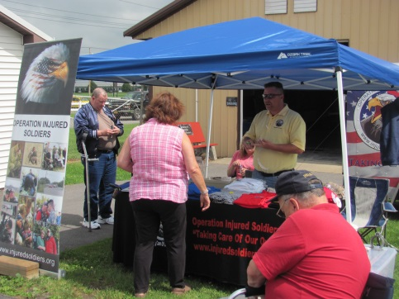
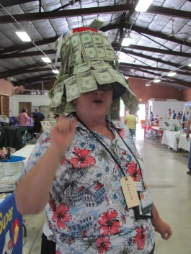
Several members of our group visited the OPERATION INJURED SOLDIER BOOTH between Thursday afternoon and Saturday. Ed Spence, OIS Representative, spoke Friday night about what his organization does as well as what they had done for him personally. They had held a 50/50 raffle and Paul & Cathy were the lucky winners. They graciously gave the monies back to OIS.

The ticket sales for the $50 HAT were also being sold by our Chapter. Last year, Butch was the top salesperson but the title this year goes to Nancy. She was even overheard saying “Let me help you spend some of that money.” She did a terrific job and, I think that maybe her and Butch ought to team up next year. Can you imagine the money they would raise? Unfortunately, I did not get the amount of monies that was actually collected this year.

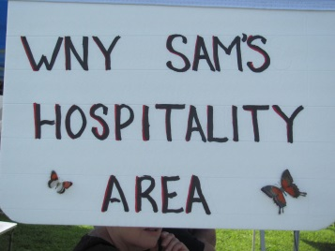
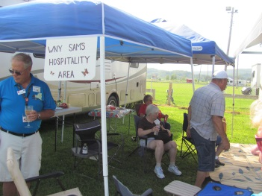
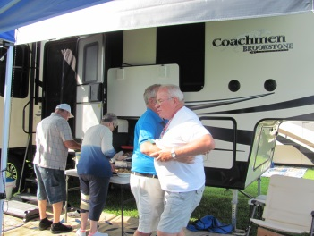
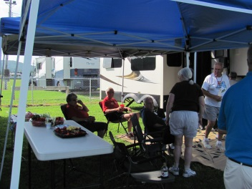
Early Friday evening was the “Hospitality” time for our Chapter back in our camping area. Marge and Carol did a wonderful job and I (as well as several others) NEED the recipes for the pizza dip and taco dip! They were both to “die” for! Tom and Nancy Kilmer (Northeast Regional Directors) stopped in and joined us in some appetizers. Tom also spoke about some changes coming as well as some “tips” for our group. It was definitely a very enjoyable time and a great idea Chuck!

OPENING CEREMONIES AND PARADE OF CHAPTERS was held prior to the evening’s entertainment. Announcements and Thank Yous were made by Maryann. The Vermont Directors (Linda & Morris Stickney) talked about the upcoming Samboree in their State. The North East Regional Directors (Tom & Nancy Kilmer) also spoke of “happenings” and relayed information about the Ontario, Canada Samboree in August.

Friday evening’s ENTERTAINMENT was Mike Boslet who performed musical trivia. Candy bars were given as prizes for those that guessed the artists, or the name of the song, or some other information he was looking for. Evidently we have quite a few musical experts in our group as several won candy bars and could have received them numerous times but Mike was trying to “spread the wealth” among the Samboree attendees.
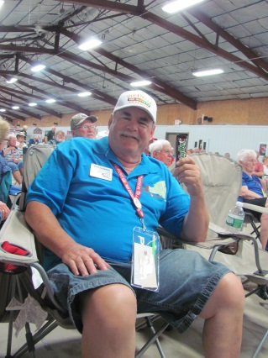
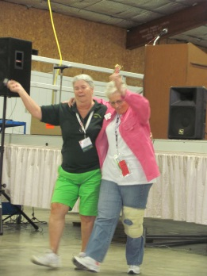
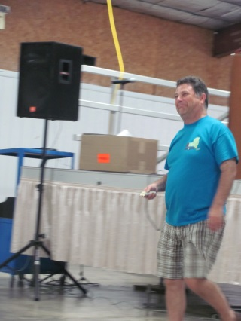
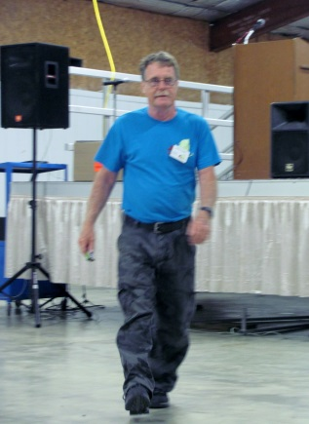
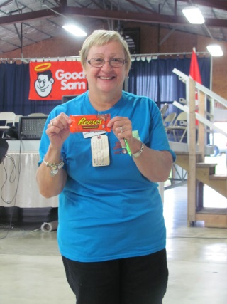

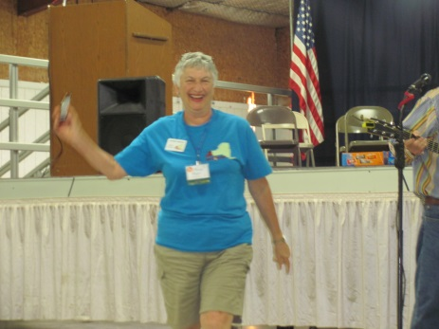
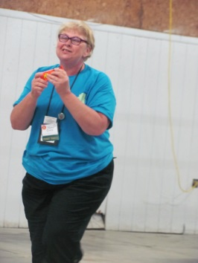

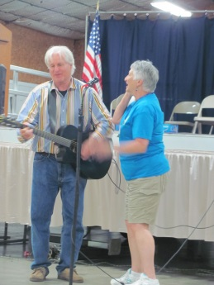
I believe there may have been a few other winners but I only captured the above photos. Another photo taken was that of Marge who was known as the other “Everly Sister” as she sang along with the Entertainer (Mike Boslet) with “Bye Bye Love.” Great job Marge!

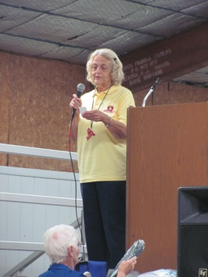

At the conclusion of the Entertainment, Maryann drew some names for stage prizes as she stated she was going to do it throughout the weekend rather than all of them on Sunday morning. Great idea Maryann!

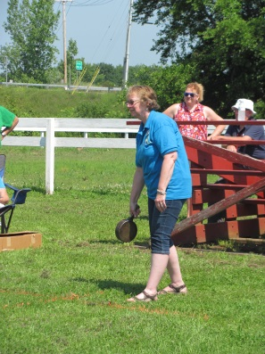
A hot BREAKFAST was served first thing Saturday morning. It was definitely a very busy day on Saturday. A FLEA MARKET/SWAP MEET/CRAFT SALES was held in the Main Hall and DOOR PRIZES were picked up at the First Aid Building. Chapter Booths were open again from 9:30 – 11:30 AM and CHARIOT RACES were held in the Pavilion. A 1st TIMERS MEETING was held as was a GOOD SAM BENEFITS AND SERVICES Seminar. (There was a total of 25 First Timer’s at the Samboree this year!) The Frying Pan Toss was held and our Chapter walked off with 3 of our members in 2nd place for their divisions: Pam, Chuck and Marge. Congratulations to each of you! Incidentally, Chuck, I wouldn’t upset Pam too much – she has quite the arm on her and was able to throw the frying pan 28’ in a straight line! Other seminars held during the day were: Immediate Care of Common Medical Problems and Tire Safety.

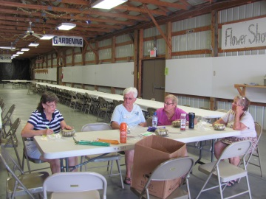
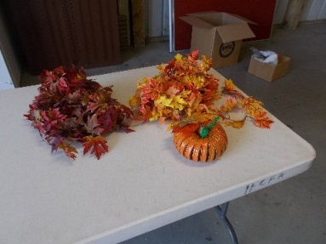
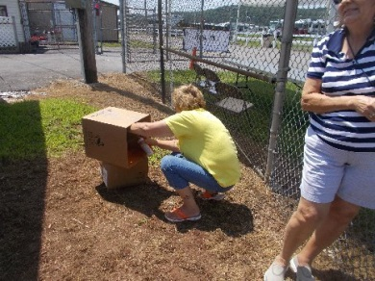
Afternoon activities included another round of BEANBAG BASEBALL, CHINESE AUCTION, CRAFT PROJECT, MUSIC SESSION, BOCCE TOURNAMENT, SAMANTHA TEA and HORSE RACES. As you can see on the left, Big Dick got a photo of me and thought maybe I was choking a chipmunk or something. As I explained to him, I was actually spray painting one of the pumpkins someone had made. (I actually think it might have been Carol’s.) We had a total of 6 ladies signed up to do the pumpkin and everyone walked away with a smile on their face along with a little girl that wanted one so bad that I gave her mine.

Our group walked off with a lot of “loot” as a result of the CHINESE AUCTION. As you can notice, I only got a few pictures but a list of items won (and by who) are as follows:
Cathy – Harley Davison miniature item, Frosty knick knack, Puzzles, Crazy golf set
Keith – Good Sam Rug, crystal game set, kid’s puzzles (Keith, I expect to see Oliver laying on the rug at the
September campout!)
Chuck – awning shade
Nancy – hot pad set, cosmetics, chopper & wall picture, double packages of candle holders, yahtze game
Marge – Statue of Liberty figurine, set of “plant” cards
Sandy – dessert fondue, dual phone answering system, books, electric scissors
Rich – boat shaped knick knack holder, bells and welcome sign holder
Carol – travel bag

Keith was a bit disappointed as he didn’t realize there was a portable sewing machine which he could have used to make the vest he wanted. AND, rumor has it, Nancy threw out the picture and everyone was on the lookout for Ed to go dumpster diving for the wood. (Sorry if I missed anyone above.)
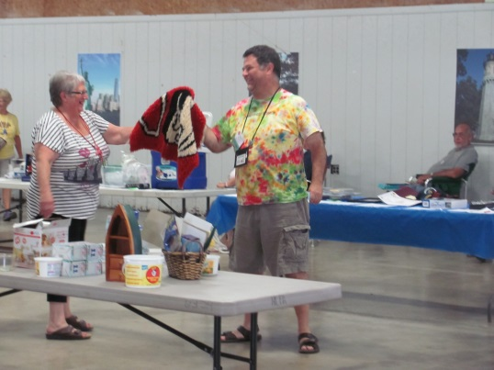
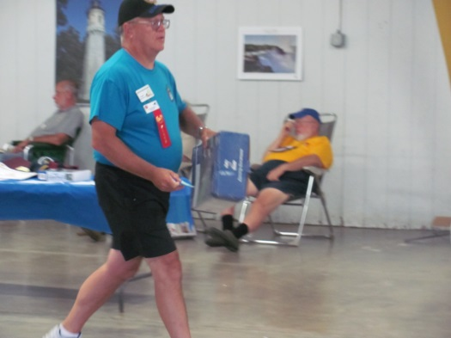

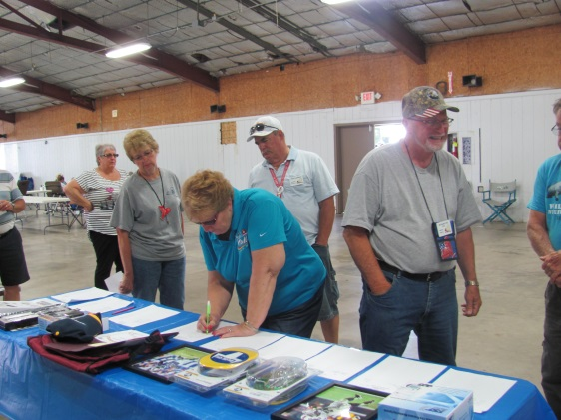
Following the CHINESE AUCTION, last bids was called for the SILENT AUCTION. Several of our members placed bids on items and, as you can see, there was a mad rush to get the last bid in before closing time. Pictures of all the winners have been posted in the Samboree Newsletter on the State page (http://www.newyorkgoodsam.com/index.html) .

The winners from our chapter were:

Container with various paper products – Pam; Blue Ox Tow Bar Cover – Rich;
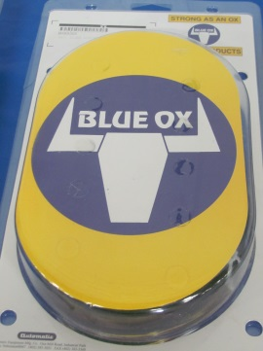
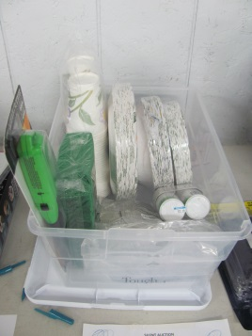

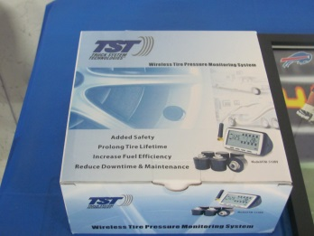
Tire Monitor – Truck System Technology – Little Dick (Cox) as well as a Buffalo Bills Picture.
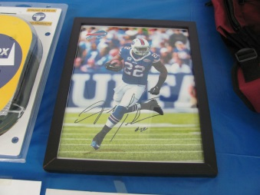

CONGRATULATIONS TO ALL OF YOU!

The AMISH had come once again with their delicious baked goods – on both Friday (new this year) and on Saturday. They also cooked the HAM DINNER again and had quite a turn-out of attendees.

The ENTERTAINMENT for Saturday evening was THE REMINDERS from Buffalo, NY. They were awesome – even better than when we went to hear them in January! Several of our “Fred Astaires and Ginger Rogers” got up to dance and, to my shock, Eddie even got up to dance with me! (Sorry Butch, I know you tried your best to dance with him on Friday evening but he just wasn’t in the mood then!)
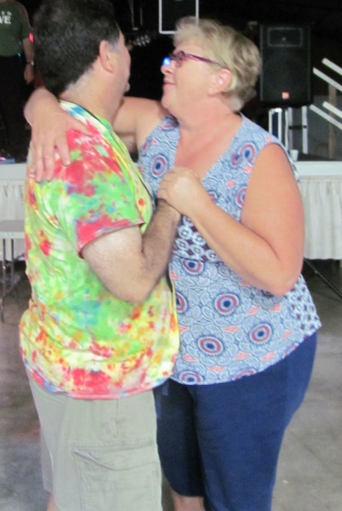
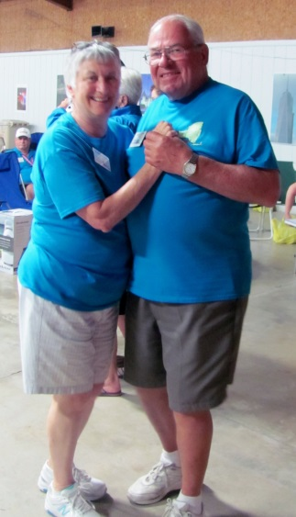
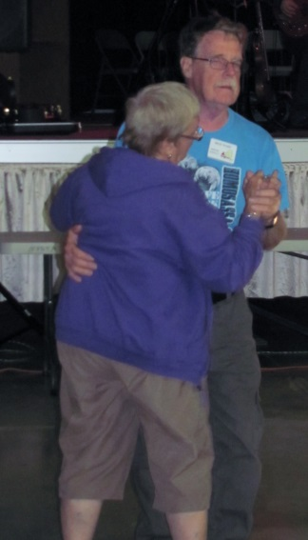
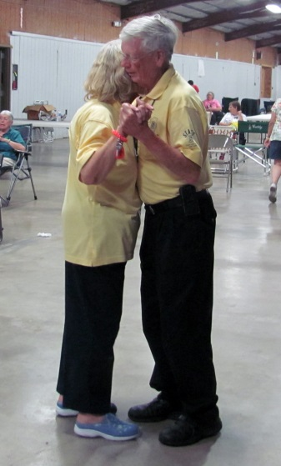

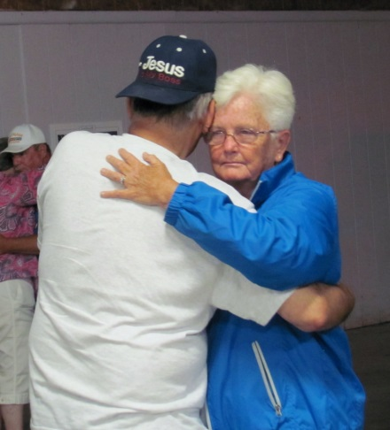
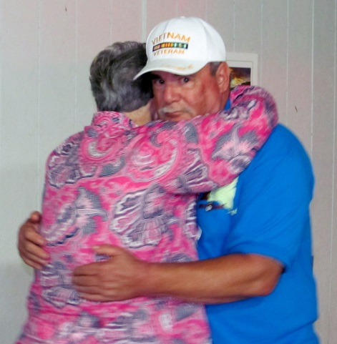

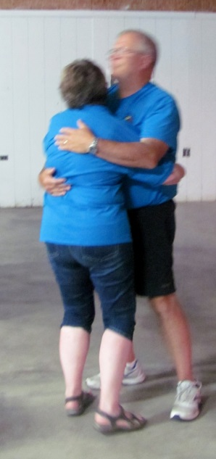
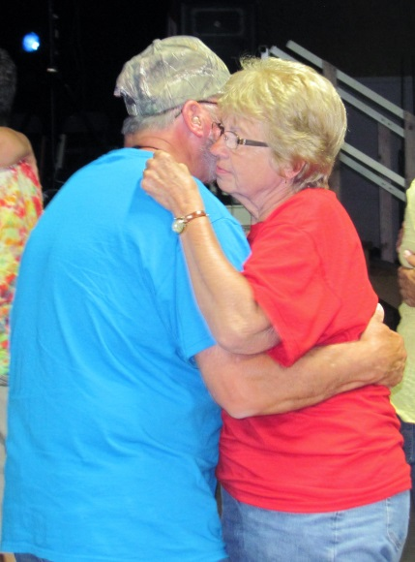
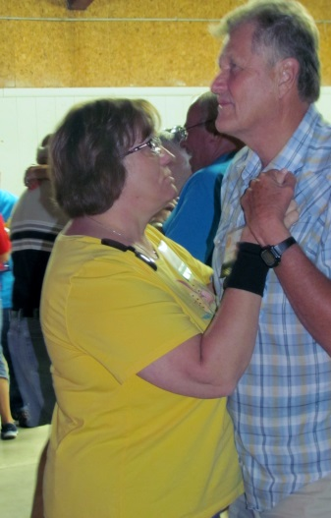

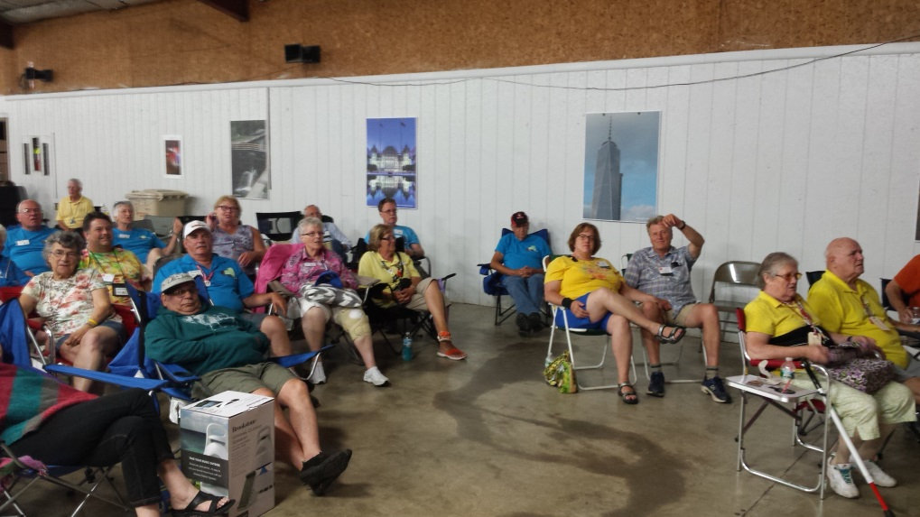
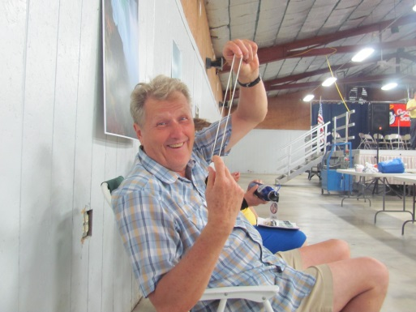
During the Band’s intermission, the Chapter Representatives were asked to come forward so that winners for their raffles could be picked. It turned out that Pam was the winner of the Merchant drawing – Congratulations Pam! Additional stage prizes were handed out and Jay kiddingly announced that he won a rubber band. Congratulations Jay – AWESOME gift!

Now, pictures of the new game introduced this year …. TOILET PAPER TOSS. The crowd went WILD (at least WNY SAMS did!).
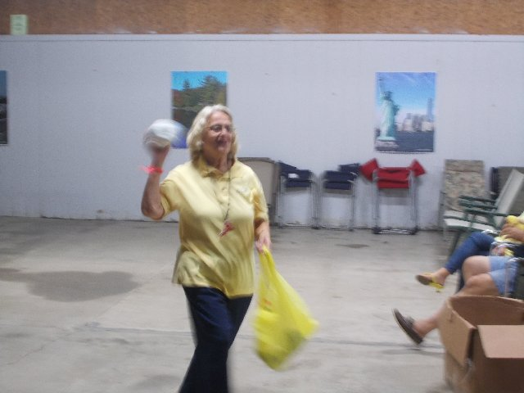
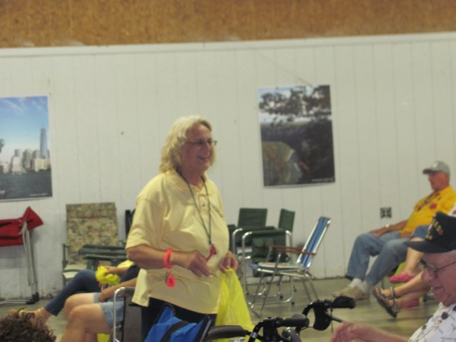

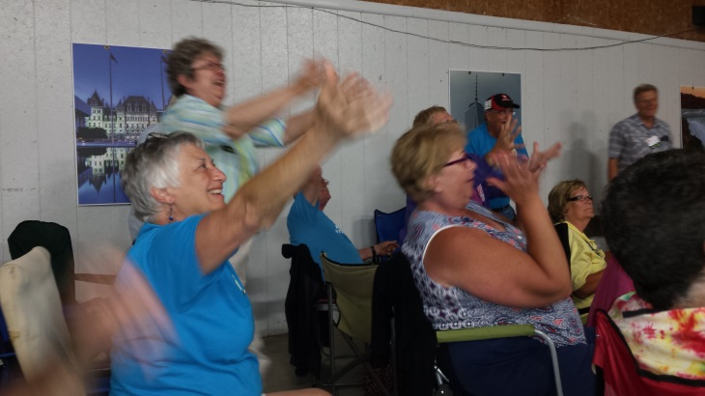
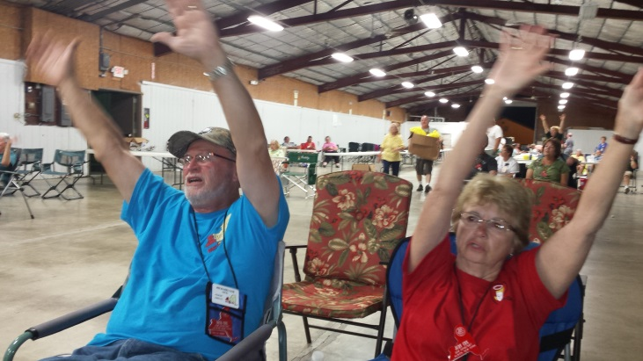

Following the entertainment, WNY SAMS went back to their area and were treated to a campfire – that is a Citronella Candle Campfire! It wasn’t quite as spectacular as the ones that Ed builds but it served its purpose!

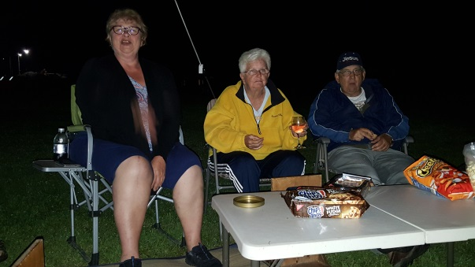
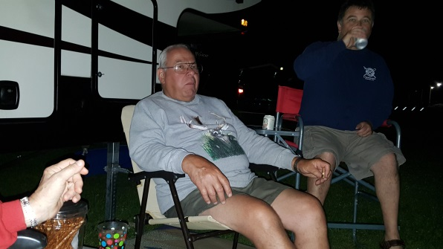

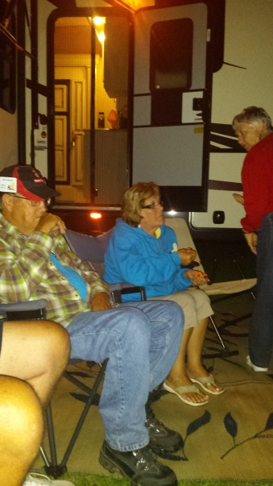
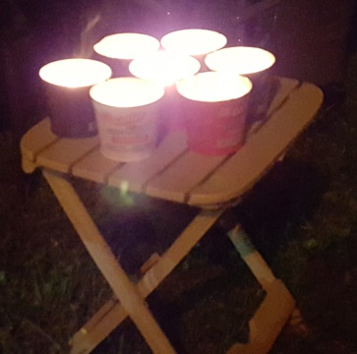

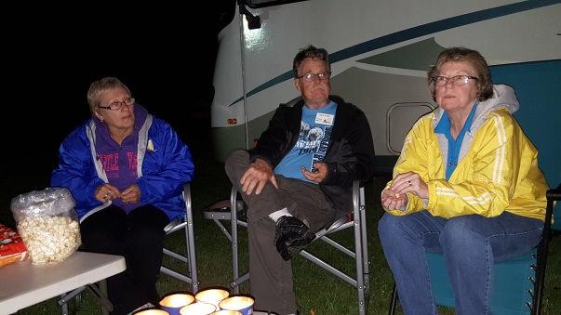

It was quite interesting to hear some of the stories being told and we soon found out who we don’t want to have as a Wagon Master in our group:

Paul & Cathy commented that one time they accidentally camped on a boat launch and an airplane area.

Marge & Jerry stated that they once camped at an old dumpsite accidentally.

A few more stories were told but those were the ones that stood out in my mind the most (and the ones I remembered to write down in my notes … lol).

Sunday morning rolled around before we knew it. Where did the weekend go?!?!? Coffee & Donuts were once again served in the Main Hall. A State Committee Meeting and a Non-Denominational Service were held. CLOSING CEREMONIES took place and the Merchant Winner and Tag Number winners were announced as were the POT OF GOLD and $50 HAT winners. Remaining stage prizes were given out. Everyone in attendance over the weekend, unless they were not present at any of the give-aways, received a stage prize. Some lucky members actually received two! The Chaplain (Rich Ferolito) said a closing prayer and read a poem entitled “I’m Fine.”

Following the CLOSING CEREMONIES, everyone returned to their RVs and started the dreaded packing before “hitting the highway.”

JUST A REMINDER: Ed and myself will not be at the August campout and someone will need to be in charge of the newsletter from that campout. (Sorry!)

