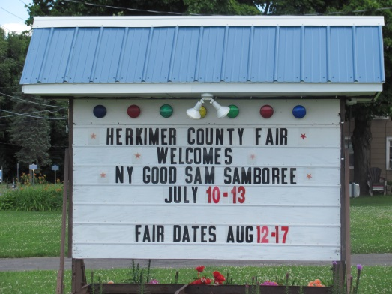
WNY SAMS CAMPOUT at NYS SAMBOREE
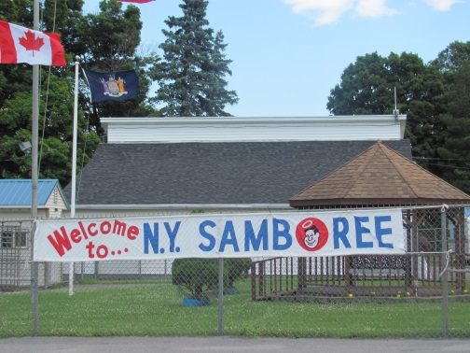
July 11 – 13, 2014

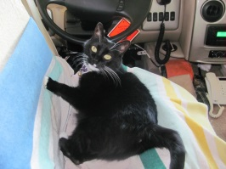
Dizzy Kashdin/Donovan
AKA Baby Girl

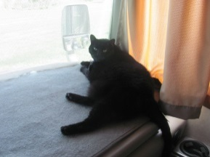
Campers are always at home, wherever we roam and for this past weekend, home was the Herkimer, NY Fairgrounds in Frankfort, NY. Those in attendance were: Ed & Diana Fackler, Richard & MaryAnn Crouch along with Lily and Teddy, Jack & Ginger Morinello along with Bert & Ernie, Butch & Carol Ellis, Dick Kashdin & Sandy Donovan along with Dizzy and Stormy, Dean & Bonnie Stenshorn, Chuck & Pam Bradford, Rich & Carol Ward along with Ralphie, Norbert & Dawn Wolf, Bob & Debbie Reumann, Paul & Cathy Schulz, Robert, SaDonna, Frances & Taylor Wolf along with Lobo, Mike & Linda DeRose, Mary Thompson and Virginia Groff.
StormyKashdin/Donovan
AKA Big Girl
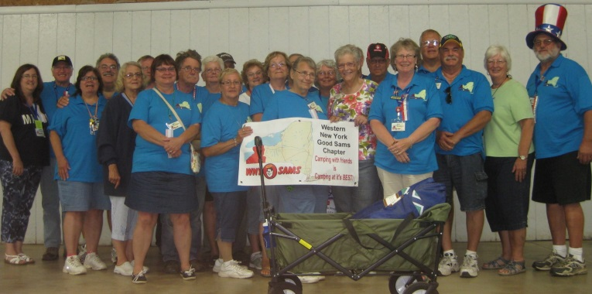
Of course, our 4 legged members are missing from the picture plus a few other members. Maybe, next time we will have to make sure the “shortest” members are in front with the taller ones in the back so that no one can hide behind others.
Before I continue on with the “happenings” of the weekend, I would be amiss if I didn’t highlight the new 4 legged members that were in attendance as well as the one I left out last time (Sorry again Ralphie!).
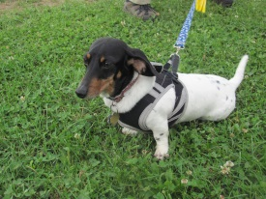
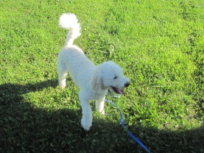

Ralphie Ward

As the WNY Sam members arrived, the new t-shirts and polo shirts were distributed to those that purchased them (YAY!!!) For the most part, everyone was happy with them and proudly wore them as you can note in the group picture. The only unfortunate problem was that the polo shirts must run a little larger than a regular t-shirt – especially for us gals! And, actually, everyone that ordered received a refund as the tax was actually included in the prices quoted instead of added on top of the cost. What a surprise that was!
The pre-activities began on Wednesday evening with a Samboree potluck meal enjoyed by Ed & Diana, Jack & Ginger and Butch & Carol. Later in the evening Carol and Diana played “Card Bingo” along with other early Samboree arrivals. Carol was a “double winner” which made up for Diana’s lack of winning! (Actually, Diana was the only one in her group of 4 that didn’t win at all – everyone else won 2 games each!)
Following the potluck, Ed & Diana put up the awning for the Chapter Booth and Diana completed the decorating of the booth with balloons on Thursday morning. One Samboree attendee commented to Diana that she must be “full of hot air” with all the balloons she blew up! I’m afraid she was probably right!
President Chuck arrived with the Duck Pond and the finishing touches were put on the booth as you can see on the following page:
Lobo Wolf

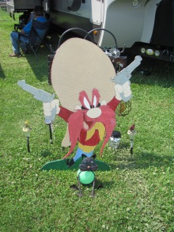
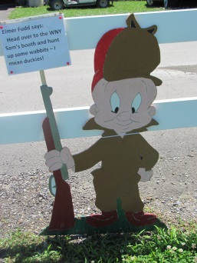
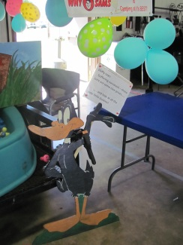
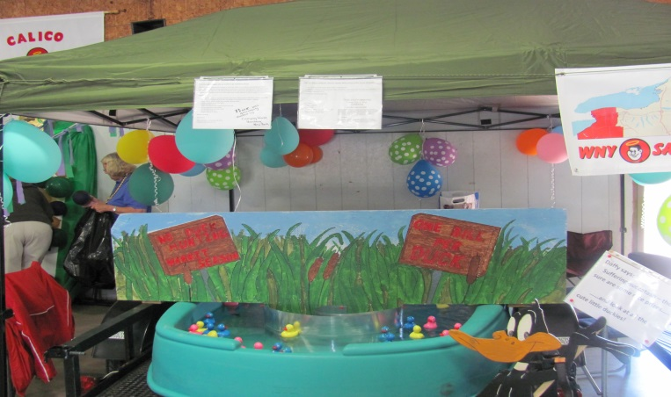
We would also like to thank Jerry Meyers for the fantastic signs he made! Daffy Duck was placed with the duck pond but Elmer Fudd and Yosemite Sam were out on the grounds trying to draw up some business for the duck pond.

Sorry, Ed, but Yosemite Sam had to go back to Jerry! (Maybe he will visit again sometime!)

Thursday evening provided attendees with ice cream sales and Entertainment by Gary & Linda VanSlyke. Gary did an awesome job singing and playing a variety of string instruments as well as a harmonica! He gave an interesting background/history of a lot of the songs he sang and his wife, Linda, “jammed out playing the drums.” It was definitely an excellent performance by the two of them.
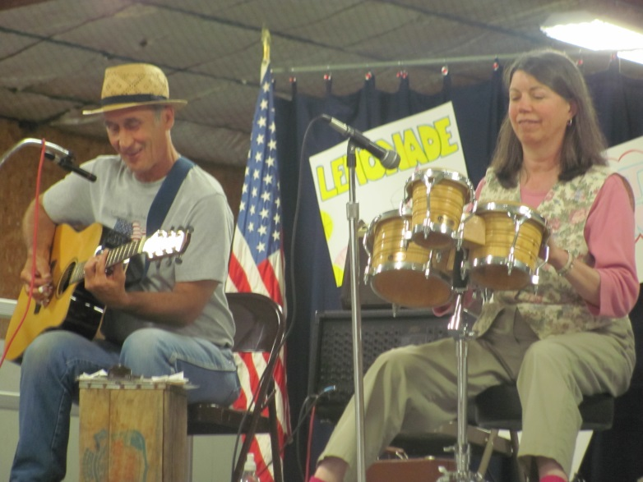

Friday found Jack & Ginger going off for the brewery tour as others visited the Chapter Booths. Mike DeRose was able to get 3 “hole in ones” and Diana was able to throw the roll of toilet paper into the toilet. I’m sure there were other game winners at the Chapter Booths but they were too shy to mention them to me.
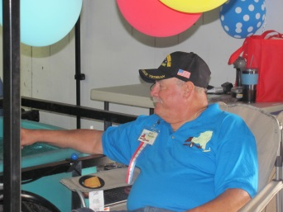
Much activity took place at our Chapter’s Duck Pond with “Dick the Duck Doctor” assisting with those ducks who insisted on taking a dive! Incidentally, speaking of Dick, did you know that there is actually an official organization called DOA – Dicks of America?!?!? They even have a quarterly newsletter called “Dicktation!” The things you learn about people as you sit around and chat back and forth. Dick did say that if any other Dick’s joined the organization, he was still the “Big Dick” and the others would be “Little Dick.”

Several members took off for a local restaurant for dinner on Friday evening and reported back on their delicious meals.

Entertainment for the evening was provided by Edward Clifford – the Human Jukebox. AND, pictures were taken of our very own Fred Astaire and Ginger Rogers:
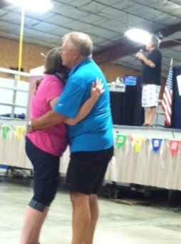
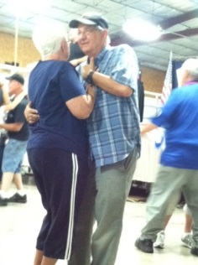

AKA Paul & Cathy Schulz
AKA Chuck & Pam Bradford
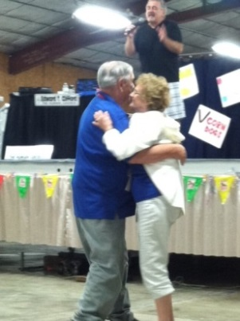
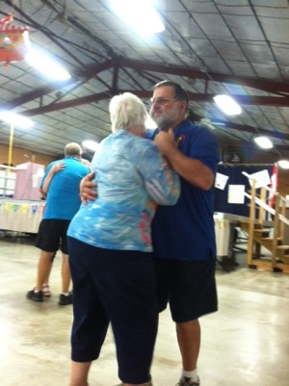

AKA Butch & Carol Ellis
AKA Dean & Bonnie Stenshorn
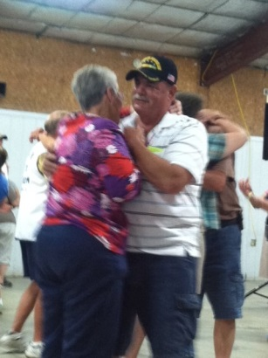

AKA Dick Kashdin &
Sandy Donovan

Following the entertainment, the Opening Ceremonies began as each chapter marched through the Main Hall with their banner. We had a few that had to make a rush for it as they also marched with the Calico Sams.

Winners were then announced for the Early Bird Drawing (first 50 registrations received) and the winner was Paul & Cathy Schulz. They walked away with a Weber Grill. Dick Kashdin & Sandy Donovan also won an alternate prize in the drawing which enabled them to go out to lunch on Saturday as it was a gift card for a local restaurant. We heard the meal was DELICIOUS! Congratulations to both!

Saturday morning arrived and many of the members enjoyed a full breakfast of scrambled eggs, sausage, potatoes and rolls. Following breakfast, many returned to the Chapter Booth to help with the duck pond and others checked out other Chapter Booths.
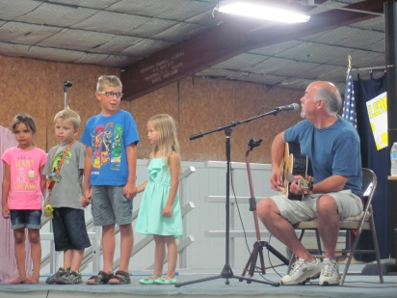
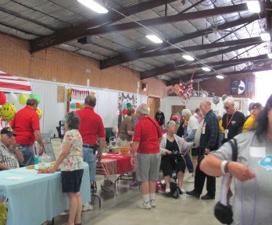
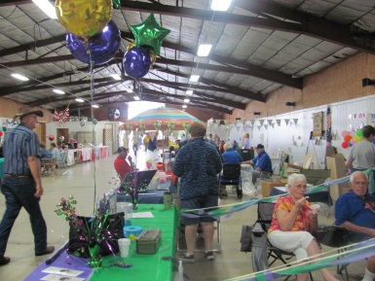
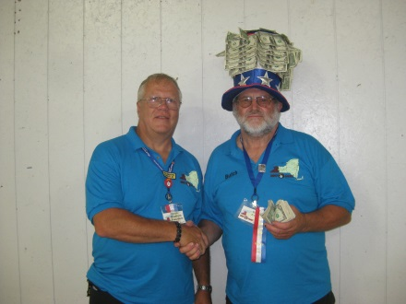
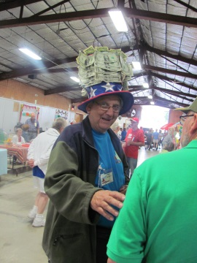
And, then for others, they were soliciting sales for the money hat. Incidentally, through the efforts of our salesmen, our Chapter raised a total of $406 for the State’s charity. GREAT JOB GUYS!
Chuck and Butch Ellis – our top seller!
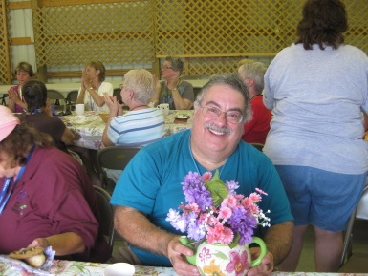
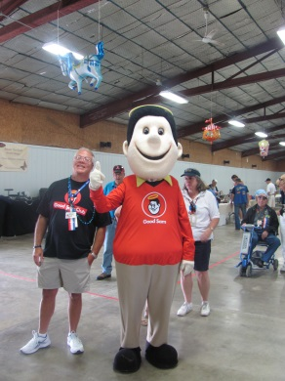
Good Sam made an appearance during the morning and was actually photo bombed by President Chuck. Since the Chapter Booths closed at 11:30 AM on Saturday, members were able to enjoy some free time to do as they please. Several activities took place: Crazy Golf, Chinese Auction, Chariot Races, Frying Pan Toss, Seminars, Craft & Flea Market, Bean Bag Baseball and the Samantha Tea in which Mike DeRose walked away with a large teapot. (Other participants in the Samantha Tea also received a small plant.) Also during the afternoon hours on Saturday, a “mad rush” took place for the Amish Baked Good Sale – the items were disappearing from the table as fast as the girls were putting them out. Delicacies included homemade pies, cookies, bread, rolls, sweet rolls, etc. YUMMMMMMM.

I also understand that the WNY Sams made quite the haul on the Chinese Auction with Sandy Donovan, Jack & Ginger, Bob & Debbie, Mary and Bonnie all walking away with items they won. Congratulations on your winnings!

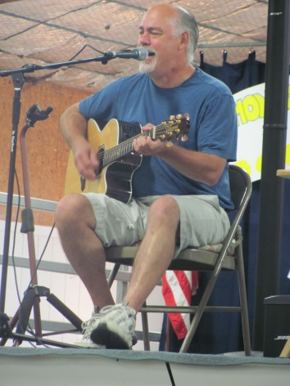
After an afternoon of rest, many of our members (as well as other Samboree attendees) joined in on the Amish cooked ham dinner. They returned with full stomachs and everyone headed back to the Main Hall for the evening’s activities. Entertainment was provided by Acoustic Rick and we even had some “little ones” joining in and helping out.

During the evening, we once again had yet another Fred Astaire and Ginger Rogers dance to the tunes. They were joined by the others that danced the evening before. Whoever knew we had so many dancers in our group!
Paul Schulz

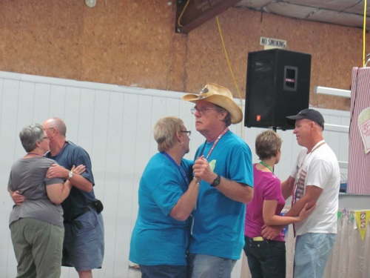

Rich & Carol Ward

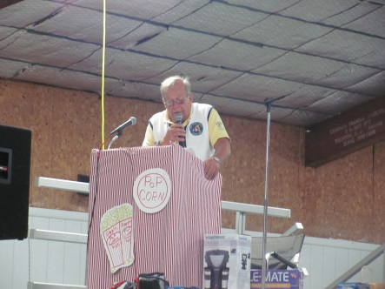
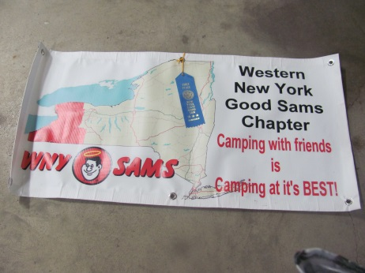
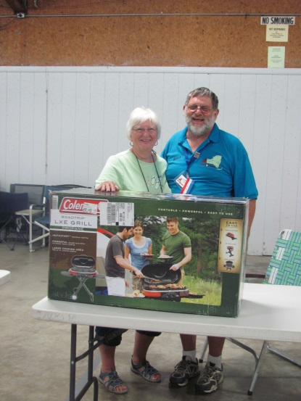
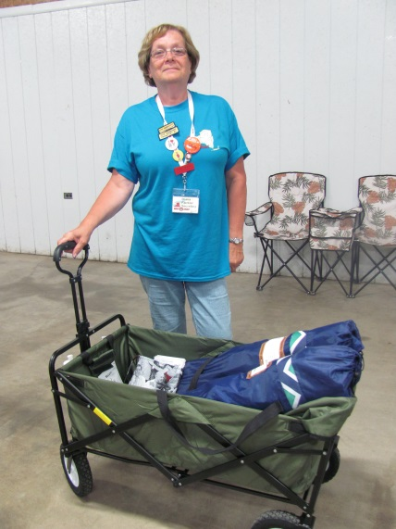
A short intermission was held while drawings were announced for the Chapter Raffles and Money Hat. When drawing the winner for the Duck Pond, President Chuck announced that WNY Sams raised a total of $222 that will go to “Camp-Get-Away.” The winner of the foldable wagon and 2 chairs being raffled by our group was ……………… ME (Diana)! Honestly, I was only kidding when I said I had the winning ticket!! BUT, that wagon sure will come in handy for our campouts – those crock pots got a little heavy carrying them from the trailer to the pavilion! Or, maybe I can take out a newspaper route and use it to carry the papers! Butch and Carol were also lucky winners of the Tri City Chapter’s Raffle and they walked away with a beautiful Coleman grill. Dancing continued after the raffles, and Bonnie practically “danced the pants off” Dean who had to sit down before they actually did fall off!

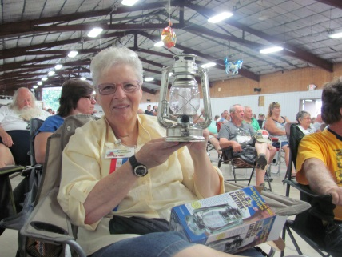
Sunday morning found many packing up and leaving before the closing ceremonies. Several members stuck around to attend. Results of different activities were announced and we are proud to announce that: Frances Wolf won 3rd place in bocce ball and 1st place (for girls under 20) in the Frying Pan Toss. Great job, Frances! Dick & Judy Cox (soon to be new members) won the Pot of Gold (50/50 raffle). Other prize winners were: Sandy Donovan & Dick Kashdin (Olde Brooklyn Lantern), Diana & Ed Fackler (astro turf door mat), Butch & Carol Ellis (3X pocket hose), Linda & Mike DeRose (wood chisels and Bob & Debbie Reumann (Wineguard Baseball cap.

The winner of the Chapter Booth was . . . . . . .
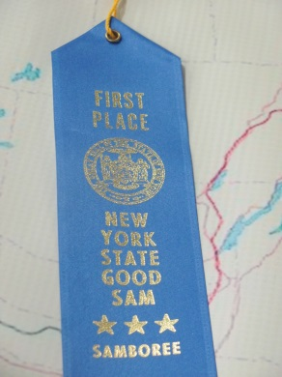
Not bad for our first year!

Announcement was made that a total of 154 rigs were present at the Samboree. The breakdown was:

Canada – 1; Connecticut – 9; Florida – 4; Massachusetts – 3; Michigan – 1; New Hampshire – 3; New Jersey – 6; North Carolina – 1; Pennsylvania – 5; Rhode Island – 1; South Dakota – 1; Tennessee – 1; Vermont – 2 and New York – 116.

There was also 48 first-timers at this year’s Samboree.

Glenn (State President) also announced that the Fall Fest will be held at the Herkimer Fairgrounds during September 25 – 28. A barbeque dinner will be held and different activities will take place. The registration form will be posted on the NYS Good Sam web page soon. The ceremonies came to a close and everyone headed back to their rigs and headed home or to other points.
I hope everyone that attended had as good of a time as Ed and I had. The only negative point to us was that there was no campfire. Poor Ed just didn’t know what to do without having a “fire to tend to!” Next campout will be here soon, Ed!

Speaking of the next campout, it will be held at Camp Bell Campground in Campbell, NY during the weekend of August 15th – 17th. The campground will only hold the sites until July 18th so reservations need to be made now. As President Chuck announced in an earlier email, Ed & Diana will be Camp Hosts (assisted by Mike & Linda DeRose and Jack & Ginger Morinello). Instead of the usual coffee and donuts, they will be preparing a scrumptious breakfast on Saturday followed with pastries on Sunday. We are looking forward to seeing as many of you that can possibly make it!

Also, orders can still be taken for t-shirts, etc. Prices are:
Regular t-shirts - $8
Long Sleeve t-shirts - $8.50
Polo Shirts (run big for the ladies) - $17.50

I have also asked the printshop to do a coffee mug, can koozie and lanyard which I will bring to the next campout. Not sure what the prices are, other than the coffee mug which will be $9.99 because of a small quantity. In his last email to me, he stated that they can do over 4,000 items – I can’t even imagine what they would possibly have to have that many items available!

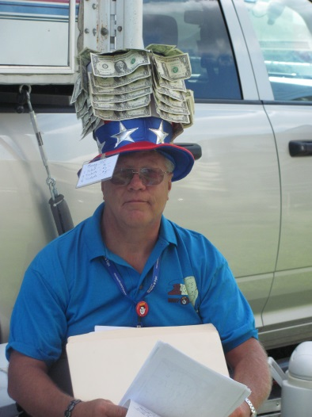
New to this newsletter is the “President’s Corner” … so here is President Chuck with a few (well, maybe a little more than a few) words:
The WNY Sam’s has reached a number of milestones in our chapter’s young life. Many have been more than just noteworthy, they have been overwhelmingly successful.
First, and this is a surprise to some since we just had our first camp-out in May of this year, our chapter is one year old now. Our chapter charter is dated July 2013, and what a year it has been. After a slow start, we really got the ball rolling in November when we added 20+ names to our chapter registration.
Then, over the next few months we ironed out some bumps in our new creation, and started planning for this camping season.
I won’t go into the campout details (Diana has done a fabulous job of heralding those events) but from the comments I receive, everyone that has participated has had a ball.
That brings us to the 1st NY State Samboree that our chapter has participated in. I am not bragging (well maybe I am a bit) but to say that we started off with a bang, is an understatement. Our group constituted the largest chapter group at the Samboree this year. We had 30 individuals there!
We had a great booth that everyone at our June camp-out helped to make, which looked great and attracted a lot of attention – in fact – we took 1st place in the booth competition judged by State Directors from out of state, looking at attractiveness, group activity, and ingenuity of the booth. Our Duck Pond generated more money than any other booth at the Samboree. We will be able to donate $222 to Camp Get-a-way. Thanks for all your help in making this happen.
Another activity that our chapter handled with extremely good results was the sale of tickets for the $50 Hat. It turns out that we have a great salesman from a fellow camper – Butch Ellis. With the help of some other “Hat Wearers” we were able to hand over $406 to the NY State Good Sam’s to be given to charities, that will be decided at the Fall Fest in September. This amount is more than double the amount generated by the $50 Hat at the 2013 Samboree.
Just a quick note regarding the NY State Fall Fest I mentioned above. It is slated for September 26-28 weekend with early arrivals available. Details will be up on the State Good Sam’s Site soon. This is the Chapter President’s annual meeting, but all chapter members are invited. Fee for the weekend (including some great eats) will be around $55, with lots of fun and entertainment too! I will email everyone when the registration is online. I encourage everyone to check it out – last year’s event was lots of fun.

One last note, I want to wish Good Luck to Sandy Donovan as she heads to surgery on August 4th. We will keep you in our thoughts and prayers Sandy!

