WNY SAMS June 19 - 21, 2015 Camp0ut @ Hidden Valley
(Editor/Reporter/Photographer: Diana Fackler)
(Contributing photographer: Dick Kashdin)

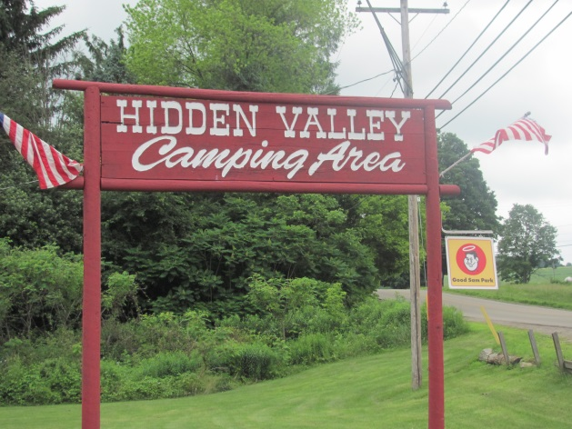
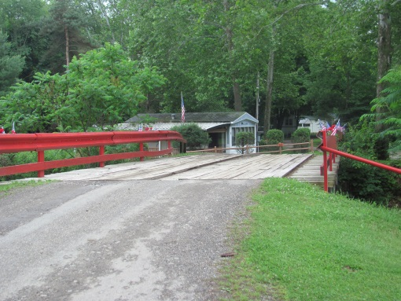
Across this little wooden bridge (which scared a few of us as we went over – wondering if it would hold the weight of our vehicles!) was an awesome campground – Hidden Valley Campground located in Jamestown, NY. We couldn’t have asked for a more accommodating owner. The owner and his wife were there to meet our every need from the time we arrived to the time we left!
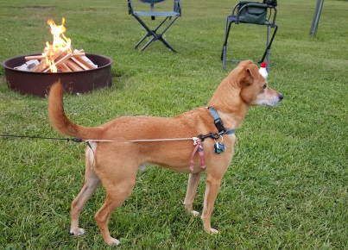
Thursday arrivals included Ed & myself as well as “Big Dick” Kashdin & Sandy Donovan along with Big Girl & Baby Girl; Rich, Carol & Ralphy Ward; Jerry & Marge Meyer (and grandpuppy – Skippy); Chuck & Susan Massey; and Butch & Carol Ellis. After a relaxing afternoon, everyone gathered around the campfire in anticipation of the rest of the gang on Friday. Rich brought out his “Bear Finder” that he got at a “steal” at a yard/garage sale. Upon seeing and hearing it, Carol E started looking for the closest vehicle to run to. Thankfully, no bears were found and the bear finder was soon put away.
Skippy

Friday arrivals included Jack & Ginger Morinello along with Bert & Ernie; Mike & Linda DeRose; Chuck & Pam Bradford; Dick & Maryann Crouch along with Teddy & Lily; Bob & Debbie Reumann; Keith Pierce & Nancy Craig along with Oliver; Mary Thompson & Ginny Groff; and Don & Terri Sokol. We also had 2 new units join us – Dick & Bev Elliott and Bill & Chris Irish:

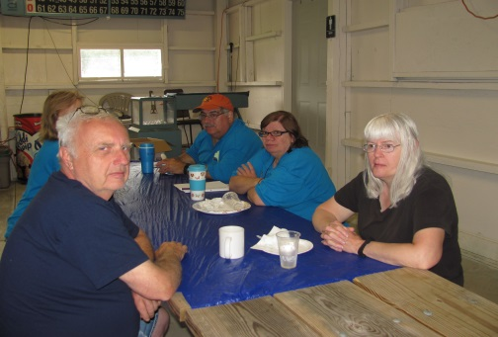  Dick & Bev Elliott | 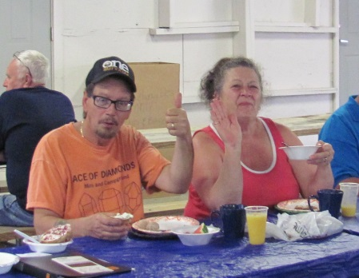  Bill & Chris Irish

WELCOME ABOARD!

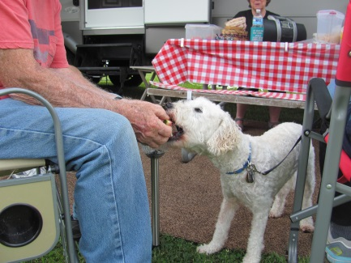
Throughout the afternoon, gatherings were soon made. President Chuck & Pam provided us with some mouth-watering watermelon! It didn’t take long before Ralphy noticed the watermelon and thought he should have some too. Not sure about anyone else, but Ralphy cleaned that piece of watermelon right down to the rind and still wanted MORE!

Saturday’s arrivals included the Marino family who were not able to arrive on Friday as planned. Glad everything worked out for them so that they were able to join us.

Jerry soon brought out his beanbag baseball game Friday afternoon and it was the ladies vs. the guys! Now the guys should know better than to take on the ladies … they just never seem to learn. Needless to say, the ladies gave the guys a” break” in the beginning but after much “bragging” on the guy’s part, the ladies decided it was time to get down to business … right Linda?

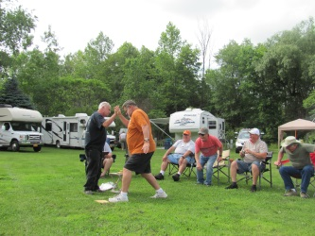 | 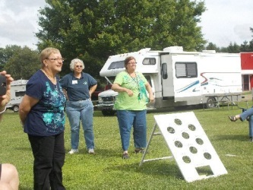 | 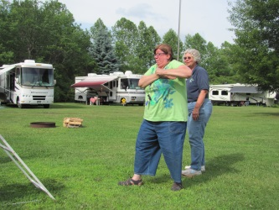 | 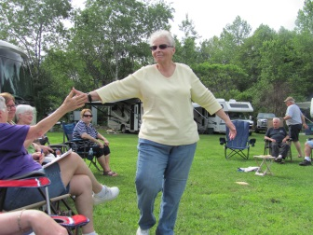

It was interesting to hear that “Big Dick” got to 3rd base and that Bob only got to 1st base. Mike had pitched two “3rd base” hits and the guys thought that he should actually be able to take 6 bases! REALLY Guys ?!?! Sorry, it doesn’t quite work that way! By the 7th inning stretch the girls were ahead and won the game 21 to 14. The game had to be called at the end of the 7th inning so that some of our members could get ready to depart for dinner reservations.

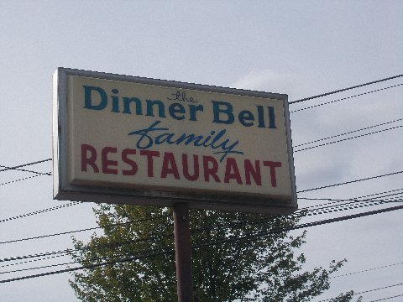 | 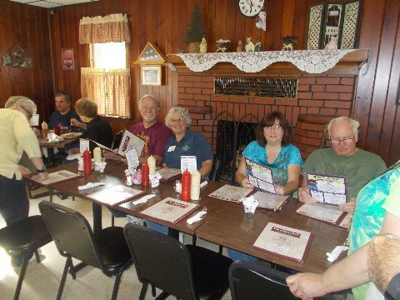

It appears that the 4 couples had some delicious meals but it was also discovered that the cream puffs were to die for and that “Big Dick” was dared to lick the plate and did so! (Sorry … wish I would have been there to take the picture but I had stayed back at the campground!) Deb disappeared for a bit while Bob was sitting around the campfire. As they got a cream puff from the restaurant to bring back with them, we thought maybe Deb had snuck off to eat the cream puff all by herself. It was discovered the next morning, though, that it wasn’t the case as the two of them had devoured it when they left the campfire for the evening.
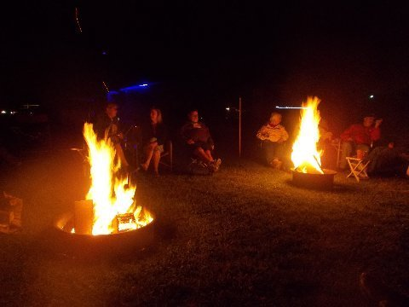
Another glorious campfire was started by Ed but it soon proved that the one campfire was not enough for the large group that circled the fire. Jerry soon started another which will probably be the need to for all of our future campouts. MANY THANKS to those that donated wood for the fires.

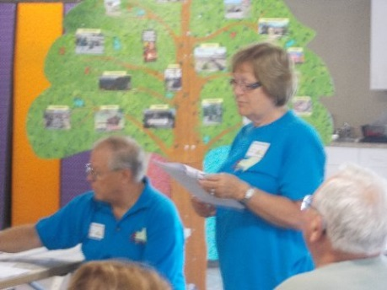
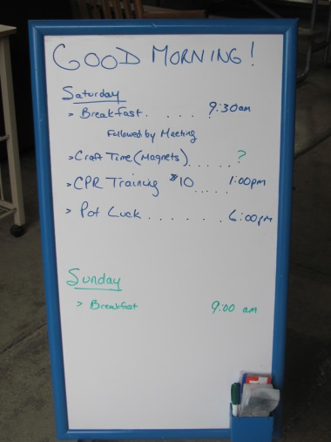
Saturday morning soon rolled around and everyone started gathering in the pavilion for breakfast which was followed by another “lengthier than normal” meeting. The meeting was called to order by President Chuck and was followed by the Pledge of Allegiance. Opening prayer was led by Carol E.

Highlights from the previous meeting were read by myself.

Other business included:
- Mary reported that she did not have the latest Treasurer’s report with her but that it would be the same as last month ($953.07) plus another $30. MOTION to accept the report was made by Linda and seconded by Deb. Carried. Mary also questioned on how much information is needed as to income and expenses of the group. Little discussion followed. MOTION was made by Pam that the Treasurer needs to divide the ledger showing where our money is going and that a budget be prepared for the next meeting. Seconded by Chuck M and carried.
- Camp hosts reported that there were 17 units in attendance and reminded everyone of the $10/unit fee for the weekend’s breakfast. It was also announced that the Camp Hosts for August will be Chuck & Pam; and September’s hosts will be Keith & Nany.
- Wagon Master Committee reported that they have started looking at campgrounds for next season and already have the May and October campouts reserved. They are currently looking at a place for the June campout which would be $94 for 2 nights. Question was asked if there should be a “cap” put on the cost of the campouts and if the $94 was too high. Much discussion took place in regards to cost and distance. Suggestion was made by “Big Dick” that the campouts be kept in Western New York. Carol E commented that the Committee has a large job to do and they need to find something reasonable in regards to cost and mileage because of the number of units we have and that we should let the Committee choose. MOTION (reworded by President Chuck) was made that Carol E had expressed her opinion in regard to the Wagon Master Committee and that they should use their judgments to figure out where to go. Seconded by Mary and carried. Question was also raised by President Chuck if we should not stay at KOA’s because of the experience in Canandaigua. It was felt that we shouldn’t “scratch” all KOA’s off our list of possible campgrounds because of the actions of one KOA’s manager.
- Introduction of new guests (Dick & Bev Elliott and Bill & Chris Irish) were made by President Chuck.
- Samboree update was given by Maryann. She stated that she had reached her goal in that she now needs to rent a trailer to take all the stuff with her that she has been gathering. It was also reported that she needs someone to volunteer to lead the “jam session” on Saturday afternoon as the previous volunteer will not be able to attend due to another commitment. Maryann stated that she had received suggestions from others that we should have a blood drive at the Samboree and possibly a Safe Driving course. Unfortunately, it is too late to pull off the blood drive but it will be put on hold for next year’s Samboree. The Safe Driving Course is still a possibility but it would have to be held before the official start of the Samboree. Carol E announced that she has registration forms if there is anyone interested in going to the Samboree (and has not yet registered), to please see her as the early registration ends on June 26th – after that time it will be an additional $5.
- Question was asked by myself as to what was decided on for our Chapter’s prize at the Samboree. President Chuck responded that Butch & Carol had volunteered again to contact Camping World to see if they would be able to provide something again this year.
- Topic of the Chapter responsibility for the $50 hat at the Samboree was brought up by President Chuck. He asked if it would be better to place one $50 bill on the hat or if we should follow what we did last year by placing fifty $1 bills on the hat. It was expressed that we do the same as last year as it will get more attention than having just one bill on it.
- Question was raised by Marge as to the time the members of our chapter can get together for the hospitality gathering in our area at the Samboree. Maryann was asked for the schedule of activities and it was then felt that 5:00 PM on Friday would be the best time. Mage also asked if there is a budget for the “Hospitality Committee” to work with. Discussion followed and it was decided that everyone should bring their own drinks and that the committee only provide snacks. Marge made a MOTION that the Treasurer be authorized to give the Committee $50 for the get-together. Seconded by Diana and Sandy. Carried.
- Rich brought up the topic of the $10/rig fee for the weekend and asked if there were any objections to lowering it to $5/rig. Discussion followed and a MOTION was made by Sandy that the fee be lowered to $5/unit/weekend and that additional monies could be requested for the Christmas party if needed. Seconded by Carol W and carried.
- Linda briefly discussed the opinions of some members who are getting tired of potluck meals and that possibly we could try something different. Little discussion followed and it was felt that it was up to the Camp Hosts as to what they decide for the weekend. It would be the decision of those attending as to whether or not they want to join in.
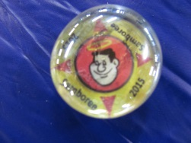
- The “craft” project for the weekend was to be our “giveaways” for the Samboree but a “crew” of members had worked on them during the meeting and they were completed. Great job Nancy and “crew!”
- MOTION for adjournment was made by Mary at 11:20 PM. Seconded by Chuck M and carried.
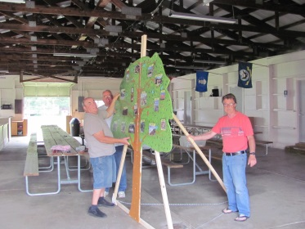

The “apple tree” made by Jerry and Rich for the Samboree was on display. A few additional items needed to be added (apples) but are in the works. Excellent job guys – it is way beyond any of our expectations!

The afternoon found several members participating in a CPR Course which was arranged by Butch & Carol at a cost of $10/person.

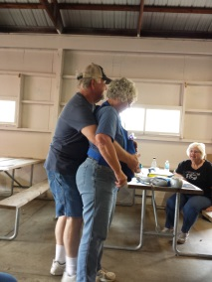 | 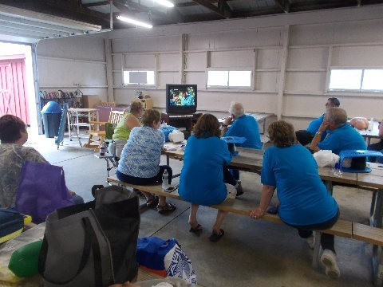 | 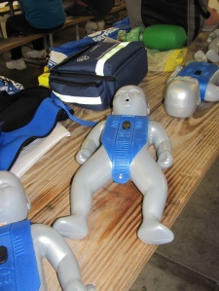

While some were doing the CPR, others tried their hand at “beanbag.” Ed and “Big Dick” were the team to beat (5 wins, 0 losses) but they never went up against Carol W and myself … I think they would have had a bit more competition as Carol W and I also beat the opponents we took on. Unfortunately, the worse loss for the day was Ed and “Big Dick” against Ginger and Jerry – score resulting in 21 – 0. Maybe this calls for a rematch at the next campout … what do you think Ginger???

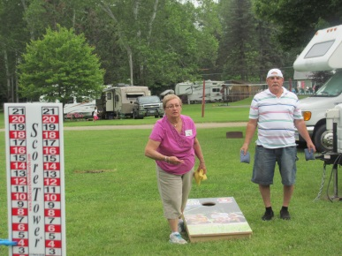 | 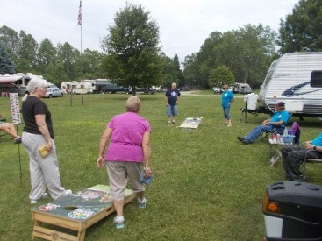

Soon it was time for the potluck meal and, as always, we were not at a loss of food.

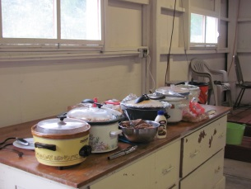 | 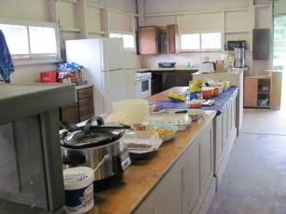 | 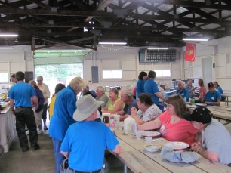 | 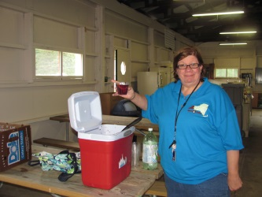

While others went back for a campfire, a new game of “Pegs and Jokers” was introduced (by Mary and Ginny) to some curious members of the group.
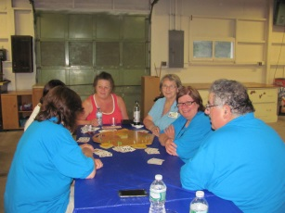 | 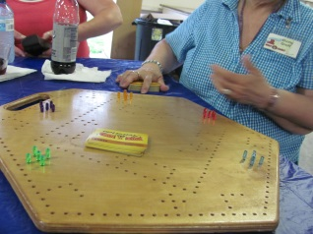
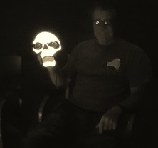
During the Saturday evening campfire, Rich brought out one of his lighted “toys” … maybe to scare away any bad men coming through the woods??? Also, President Chuck had checked on his electrical plug and was quite surprised to see a little black and white “thing” run across his feet. Luckily for both Chuck and the group, this “thing” did not realize he was there!

Sunday morning rolled around all too soon as everyone gathered for breakfast and “goodbyes.”
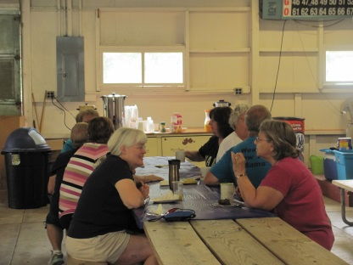 | 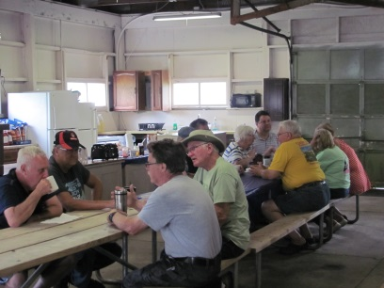 | 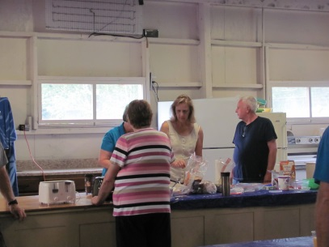

All in all, another AWESOME campout – neither the fear of the “escaped convicts in the area” nor the weekend forecast of rain kept us away!
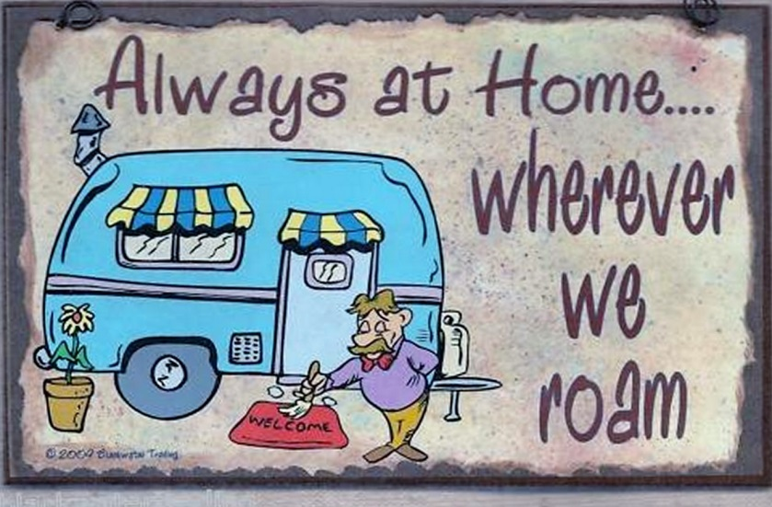

At last report, there were 8 units from WNY Sams traveling to the Samboree. Next group campout will be August 14 – 16 at Lake Bluff Campground in Wolcott, NY. I will not be able to attend due to other commitments – please let President Chuck know if you would be willing to “play me” at the next campout by taking notes, etc.

