August Newsletter 2016

For this month’s camp out we headed to Warsaw NY to Dream Lake Campground. Making the most of the weekend, and our first early arrival was Carol Ellis who arrived on Wednesday!! Now that she is confidently driving her rig, nothing can stop her and we are all grateful for that!!
Of course our other early birders soon followed. Also arriving on Wednesday were Dick and Judy Cox and Jim and Ellie Strickland. Not to be left out and arriving on Thursday were Ed and Diana Fackler, Rich and Carol Ward, Paul and Cathy Schulz and Dean and Bonnie Stenshorn.
Super Cruise night in Silverlake on Thursday night: Dean & Bonnie, Paul & Cathy, Dick & Maryann, Rich & Carol, Ed & Diana. While they were there checking out the cars they enjoyed a nice supper at the Charcoal Corral and delicious ice cream at the Ice Cream Shop. (Sorry, no pictures of this event for you. We sorely missed our photographer).An early craft session was done on Friday afternoon while we awaited the arrival of the rest of the gang! More on that later...
Those of us who are still Worker Bees soon began to arrive. These arrivals included Richard Tilton, Jan Ingerson and Cindy Jaeger, Dick and Bev Elliott, Ginny Groff and Mary Thompson, Mike and Linda
Several of the group, (Rich & Carol, Dick & Maryann, Dean & Bonnie, Ginny & Mary and Ed & Diana) went to the campground snack bar for a great dinner! They served a large and delicious fish fry and meatloaf that also got some great reviews.

Friday Night we all enjoyed another of Ed’s great camp fires and he even did a little “Shaky-Shaky” dance as he prepared a camp side favorite snack of popcorn!! Who knew he had those moves!! Thank you to Ginny for donating the popcorn cooker to the group. We will enjoy lots of delicious snacks and maybe some more dancing moves.
One forgetful couple forgot their wallet and purse at home. Not only did they not have driver licenses, money, ID, medical cards, credit cards and every other item that you should never leave home without, but they also enjoyed teasing the other about being absent minded and “good thing you have me to bail you out”, which wasn’t true at all. Thank goodness for a friendly offer of cash at Dick’s an ATM where they were able to secure a small loan to get them through the week end. Of course some of that money went towards gambling, ($5 tickets for the Chair Raffle), dinner ($10 each to have dinner at the snack bar), a hose full of poop ($5 for the Honey Wagon on Sunday morning). That left $10 for emergency money on the drive home. A GREAT BIG HEARTFELT THANK YOU TO DICK COX!! Thank you for the loan and ATM transaction. We will not forget your kindness!! Lessons learned: Don’t leave home without your wallet/purse. Play hide and seek in your RV. Be thankful for great friends who bail you out when you are stupid!! Everyone can learn to budget!

Saturday Morning: Since we had no host for the week end, there was no coffee or breakfast. We had an early meeting at 8:30 am which Diana kept on task and brief. Some of our ladies shared brownies, muffins, and cake that we all enjoyed around the meeting circle.

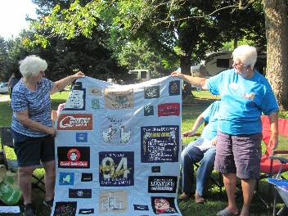
As the meeting closed, we presented Carol Ellis with a beautiful memory quilt stitched, designed and created by our very own and talented Cathy Shultz. This blanket, made from some of Butch’s well known tee shirts, was a true gift of love. We love you Carol, and hope that this will bring fond memories of Butch as you wrap the warmth around you. Thank you Cathy for making this beautiful blanket for us to share with Cathy. WNY Sam’s has the best people you can find anywhere!! Three cheers for Cathy and Carol!!

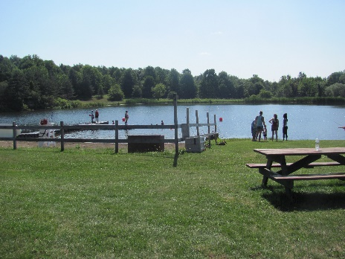
Following the meeting, a large number of our group, with a caravan of about 6 car loads headed into “down the road” to Camp Get Away. After touring the Town of Warsaw, driving around in circles, blaming the GPS, getting lost again, and wondering if the camp was really that close by, we arrived at the Four H camp and were greeting by some of the friendly staff.

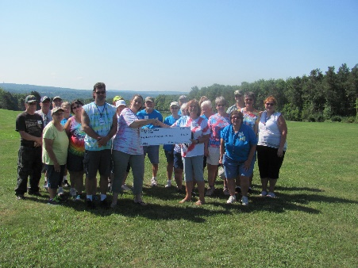
We have donated money to this camp, but it was really great to see firsthand what they are all about. Once there, Nancy took us on a tour, and we were pleasantly surprised by the beauty and calmness of this family retreat. Our group got to help the kids and families with fishing, archery, crafts and equestrian opportunities. Our donation was well spent and it was a “feel good” day for all of us!

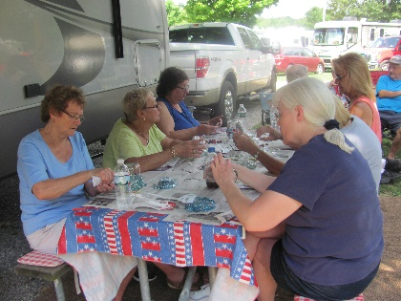
After returning to camp and grabbing a bit of lunch, everyone headed to Ed and Diana’s for the Craft Corner. By that time, four more members of our group arrived: Dick Kashdin and Sandy Donovan, and Jay Wopperer and Linda Schmieder. This month, Diana had us making a beautiful Solar Lamp made out of mason jars and stones.

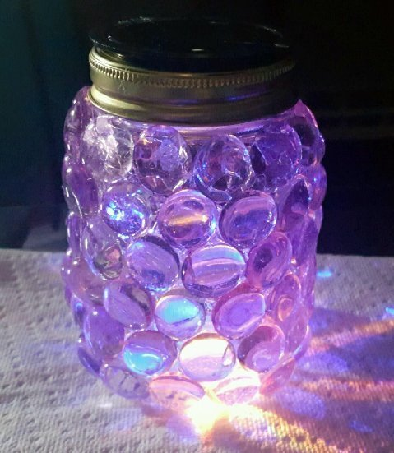
They turned out beautiful and it was fun to watch the lights flickering throughout the campground at night. Many of the ladies made multiple jars and they all turned out beautiful….Thank you Diana for coming up with such nice ideas to help us adorn our campers with.

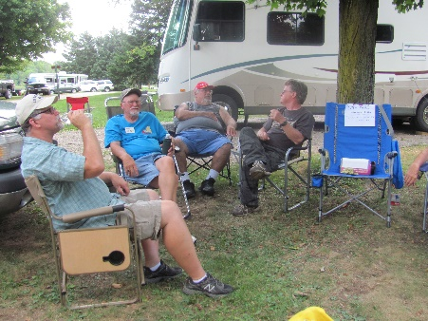
It was a very hot and humid afternoon. Because of the heat, there were no games or other activities, but everyone still enjoyed sitting together, talking and enjoying a few laughs and sitting in the shade.

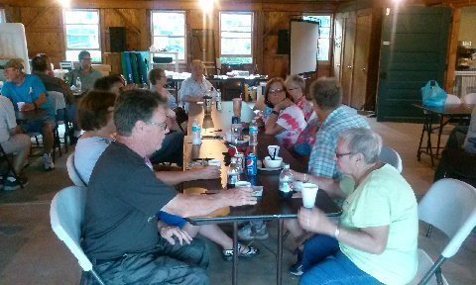
At 5:15 we all headed to the snack bar where the camp owner provided a delicious buffet for us. The $10 cost included salad, roast beef and rolls, salt potatoes, & roasted chicken. There were also several desserts provided by the group and those were also delicious and enjoyed by all.
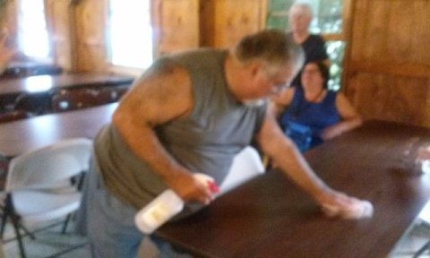
Someone had to wait and bus tables to earn money to pay for dinner. We also considered setting up a lemonade stand!

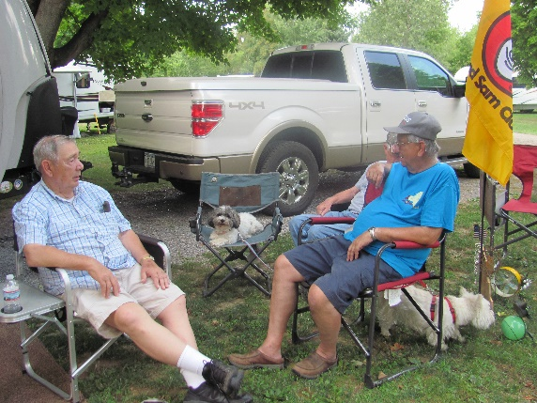

After dinner it was back to the rigs and we gathered around with our chairs for the evening’s camp fire.
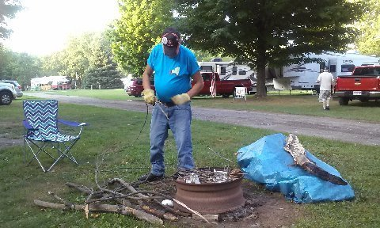

As usual Fire Master Ed got things started. Note the alligator guarding the covered fire wood. Ed has gotten very protective with the wood
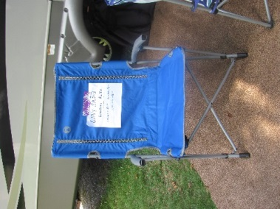
Lots of stories and tales and laughter. A set of folding chairs was raffled off. Congratulations to Maryann Crouch.
Several fans watched the Bills beat the Giants. This brought out some interesting comments and speculation about our beloved home team and the upcoming season

RECIPE OF THE MONTH: RAISIN BRAN MUFFINS (supplied by Carol Ellis)

Mixture A

3 cups white sugar
1 cup oil
4 eggs
2 tsp salt
1 quart buttermilk

Mixture B

5 tsp baking soda
5 cups flour
15 oz. (7 ½ cups) raisin Bran cereal

Mix A. Mix B. Blend both mixes together. Cover and refrigerate or bake immediately. Keeps for 6 weeks or longer in the fridge.

To Bake: Spray muffin cups with Pam baking spray. Bake 375 degrees for 25-30 minutes. Enjoy warm with butter.

