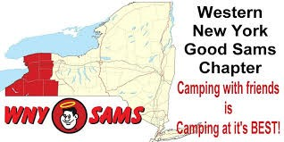
Four Mile Creek Campground
2016

WNY Sam’s Club Newsletter
(Linda DeRose, Editor)

June: Four Mile Creek State Campground Newsletter 2016

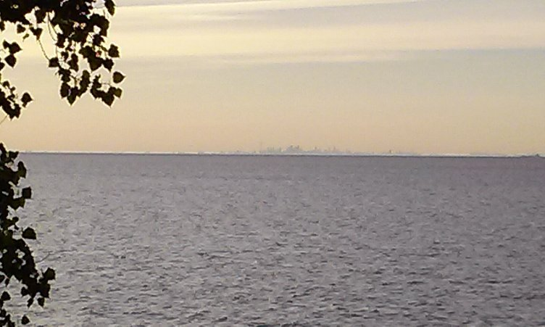

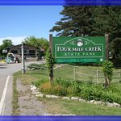
Four Mile Creek State Campground is located in the village of Youngstown on Lake Ontario. It is simply one of the Gems of Niagara County, not far from Lewiston, Niagara Falls, or Olcott. On a clear day, you can see the Toronto skyline.
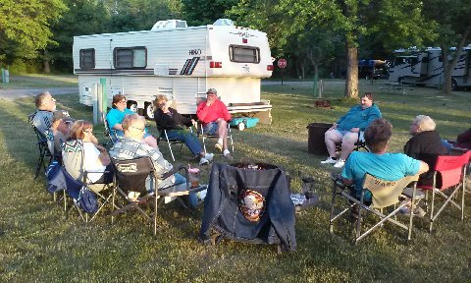
Many campers began the week end by arriving early on Thursday. We had a nice group who gathered together for fellowship, laughs, good times, and a great campfire. I noticed on this first night that many members are now sporting new fit bits, and there was a friendly competition in play over who would get the most steps in for the day. That had many of us going for walks along the trails, and up to the lake to see the sun setting and the Toronto skyline. Eddie and Diana kept getting up to walk (sneak) around to try to get the most steps in for the night. We broke up about 11 pm with everyone saying goodnight and heading back to their campers.

TORONTO SKYLINE OFF LAKE ONTARIO
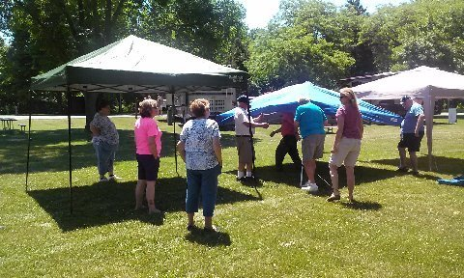
It was nice to have another full day, and on Friday morning and afternoon the group stayed around the campsites (we had a very large area with a big grassy spot between the sites), where we were able to put up a lot of easy ups to provide shelter for our group of 40 or so members for the week end. With a group effort, the shelters went up easily and picnic tables were put underneath to provide an outdoor dining area.
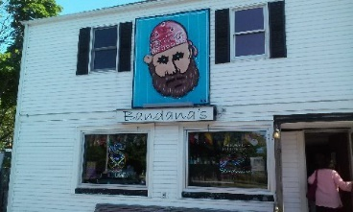
On Friday evening, a group set off with a caravan of vehicles with about 20 of us and headed to a local restaurant called Bandanas, which was located just outside the park. We were seated on the outdoor patio, and even though it was covered, it provided little shelter against the setting sun. Everyone seemed to order something different, and when the food came, there was a huge variety, with everyone enjoying their meals. It was a lively get together, and we all had a good time. After dinner we headed back to camp to enjoy the fire that was already started while we were gone.
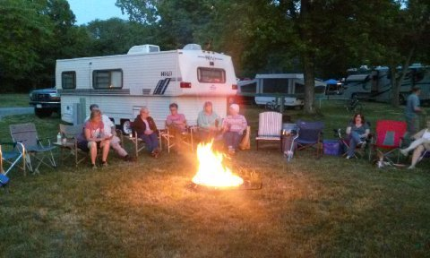

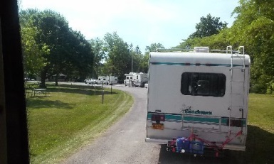

Campfires are always fun, and I was sorry that I was way too hot, tired and sticky to venture out. I soon fell asleep in the camper, enjoying the AC.
Another kind of Bandana
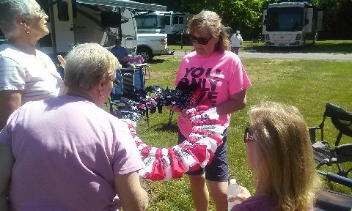
Diana is always busy with some craft or another, and she proudly showed off her beautiful flag wreath made with bandanas. She was the envy of the other ladies, as we ooed and ahhed over the craftsmanship of this beautiful wreath.
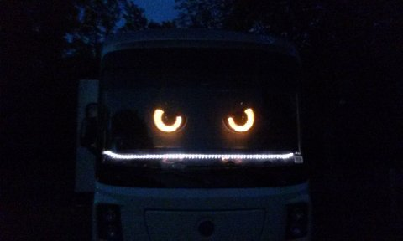
Saturday Morning we fell into our normal routine, with a continental breakfast put together by our camp hosts Terri and Don Sokol and Mike and Linda DeRose. We had home baked banana & zucchini breads, fresh fruit and hard cooked eggs, coffee and juice. Some of the campers thought they had to bring raw eggs back to their rigs to cook. After breakfast, we had our monthly meeting, followed by a Tie Dye craft with Nancy guiding the members to create their 70’s style clothing. We are sure to be a hit at the Herkimer Rally. What a bunch of Hippies!!
In the afternoon, the group seemed to split up, with everyone going in different directions. Some of us headed to Lewiston for the Garden Fest, some went to Fort Niagara to step back in history and time, and others went to the local wineries. Others stayed back and played games, rested and spent the afternoon visiting with friends.
At 5:30, a delicious catered dinner was delivered to the campground. We feasted on salad, roast beef, chicken and pasta. We had a wonderful assortment of home baked desserts and even had a Father’s Day cake and ice cream.
Everyone had their fill, and we gathered again to Ed and Diana’s for a group fire which went well into the night.
Sunday: After a light breakfast, the group sat under the canopies for a while and then it was time to break down camp. Everyone pitched in as we lowered the easy ups, washed the coffee pots and distributed the bins, boards and equipment for use at the July Rally and next chapter camp out. We said our rounds of good byes. Early birds were packed up and out by 10 am and the line at the dump stations grew longer by the minute. There was at least a 45 minute wait. Those of us who were late, stuck around till a few minutes after 11-11:30 or so, packing up, saying our last so longs and trying to find other excuses to linger on.
It was a great camping trip, with lots of members in attendance. It was great friends, good food and lots of happy times. Until next time!! Happy camping and safe trails. <3
ALWAYS WATCHING!!
THANK YOU: To Dick Kashdin, for sharing his blogs, and pictures. I really appreciate your help with the newsletters. You work diligently behind the scenes to get us the info and photos we want. Gracious!!

Happy Camping. Next camp outing is the Rally in Herkimer. Then we will see everyone in August at Dream Lake…Still looking for a few people to host the August Campout. This campout is also an opportunity to volunteer at Camp Get Away. Please be generous with your time for these kids and families.

