WNY SAMS
December 12, 2015
Camping World
Hamburg, NY
1:00 – 4:00 PM

Contributing Photographer – Big Dick Contributing Secretary – Linda
(A BIG THANKS to both of you!)

WOW …. What an AWESOME turnout for our SECOND ANNUAL HOLIDAY PARTY. Instead of listing those that were in attendance, it will be easier to list those that , unfortunately, could not attend for one reason or another: James Gray & Sherrill DeVantier, Bill & Chris Irish, Bob & Debbie Reumann, Dave Swanson, and Terry & Mary Thompson. I would have LOVED to have seen our four legged members but they had to stay home for this outing but they were all in my thoughts!

We can’t give enough THANKS to our awesome party planners – Marge Meyer and Linda DeRose and, of course, their husbands! Thanks to all those that brought some “goodies” to add to the pizza and wings generously donated by Hamburg Camping World.

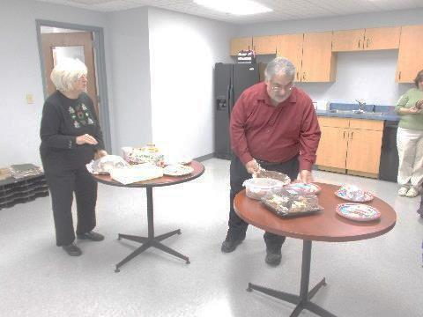  Carol E & Mike getting things set up. | 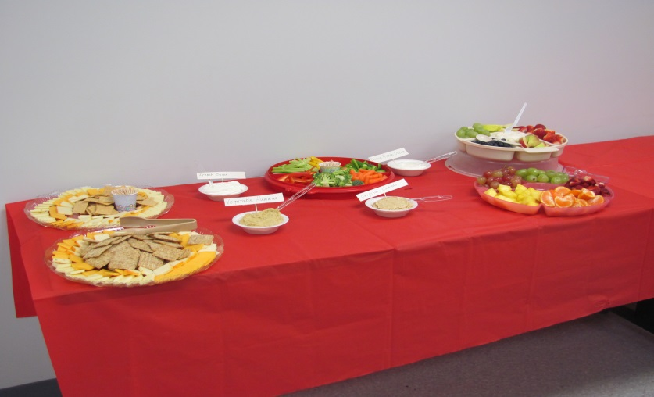  Appetizers before the Pizza and Wings arrived

A gift exchange followed our meal and it looked like there were some pretty AWESOME gifts! Following the exchange, numbers were drawn for the gift cards (2 @ $100 each) which Camping World donated. Unfortunately I got distracted and did not catch the winner of the 2nd card but the first card was won by Big Dick and Sandy.

A business meeting followed the exchange and everyone stood for the Pledge to the Flag. Chuck asked me to read the minutes of the last meeting (Genesee Country Campground in October). A MOTION was made by Big Dick (Kashdin) and seconded by Linda that the reading of the minutes be dispensed of. Carried.

Copies of the Standard Operating Procedures and updated membership list were distributed. (New copies of both will be emailed after the holidays.)

Ginger announced that she had brought the name plates that were ordered and stated that she can still take orders for those that had not ordered yet. Prices are $9 for the name tag and $21.75 for the license plate.

Maryann brought up the subject of the Standard Operating Procedures (SOPs). She stated that she would like to propose a change in Article A, #4 as there is no requirement in the Good Sam Constitution that talks about member participation other than you must be a member in good standing by payment of the yearly membership fee. Her proposal was that the Chapter consider changing the wording as written in the Good Sam Constitution (Article II, Chapters): Membership in the Chapter will be dependent upon current membership in the Club which requires the annual membership dues be paid in a timely manner. Much discussion followed as well as the problem of having 51% of membership present in order to conduct business at meetings. Maryann made a MOTION that the majority quorum be changed to 51% of those at the scheduled activity. Seconded by Little Dick (Cox) and more discussion followed. Tim made a MOTION that we change the quorum requirement to 1/3 of membership instead of 51%. Seconded by Donalee. Maryann withdrew her original motion which had not yet been put to a vote. Tim’s motion was carried with 5 members opposing. Maryann’s proposal that no participation be required to be a Chapter member was also put to a vote with 32 in favor and 11 opposed. Carried.

Rich raised discussion on the fee of $5 per campout to cover breakfast and other necessary host expenses for the weekend. This has run into a problem when there are more than 2 people per unit. Following discussion, a MOTION was made that the campout fees be raised to $3/person per weekend and that this be included in the SOPs. Seconded by Little Dick and carried.

Next order of business was the Elections. Names on the ballots were as follows:
President – Chuck and Diana
Vice-President – Rich
Secretary – Linda
Treasurer – Keith

The Election Committee was composed of Cathy Schulz, Mike DeRose, Ginger Morinello and Judy Cox.

Results: President – Diana; Vice-President – Rich; Secretary – Linda; and Treasurer – Keith

Chuck Massey thanked Chuck for his service as President for the past 2 years. A round of applause followed.

Following the elections, a request for a Treasurer’s Report was made. Keith announced that as of the end of November, there was a balance of $1,049.43 and that there is an outstanding transaction to pay of $52 to the campground hosts from the October campout. Further, twenty units have paid their 2016 membership dues. It was also reported by Keith that he has not yet recovered the checkbook from the previous Treasurer. Following little discussion, Carol (Ellis) made a MOTION that the Treasurer close out the current account and that he set up a new account. Seconded and carried.

Discussion also took place on the 2016 campouts. Terri (Sokol) stated that the tentative schedule is as follows:

- Woodstream – MAY | - Dream Lake - AUGUST
- Four Mile Creek State Park - JUNE | - Sleepy Hollow - SEPTEMBER
- NYS Samboree - JULY | - Southwoods - OCTOBER

Terri stated that she will get more detailed information out to the membership soon.

Comment was made by Ginger that this will be our last meeting until the campout in May. She discussed the possibility of getting everyone together to go bowling sometime during the first 2 weeks of January. She stated that she will pick a date and let everyone know.

Maryann reported that there is an event at Turning Stone Campground during June 10 – 12, 2016 at a cost of $112/weekend. She has the phone number to call for those that are interested. She also reported that the dates for the Good Sam Rally (previously called the Samboree) are July 14 – 17, 2016. The theme is “50 Years of _______________________.” The Herkimer County Fairgrounds have graciously offered to provide the entertainment on that Saturday evening.

Terri stated that a host is needed for the May campout at Woodstream. Ginger and Jack, and Eddie and myself later volunteered to serve as the May hosts.

Marge distributed some business cards for PJ who is our contact person for Hamburg Camping World. Carol E made the comment that if you are ever in the Store, you should let them know that you are a member of the WNY Sams chapter.

MOTION made by Carol to adjourn. Seconded by Ginger and carried.

Now, on to party pictures!

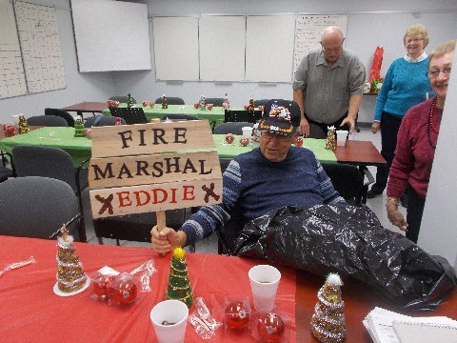  Sign made by Rich Ward for Eddie | 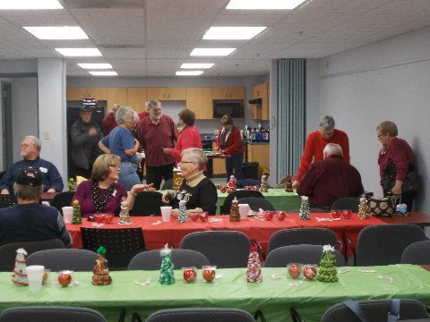  Party Fun! | 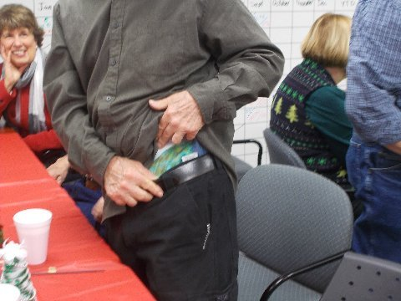  Rich showing off his “tye dyed” underwear
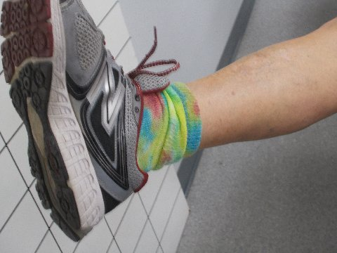  Butch showing off his tye dyed socks! | 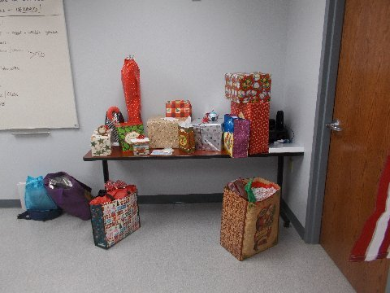  Some of the gifts waiting to be opened, | 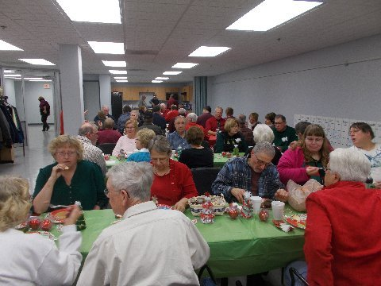  More Party Fun!
 | 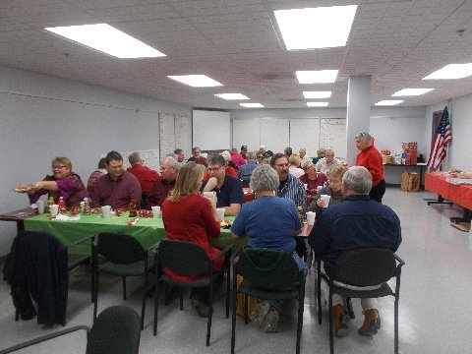 | 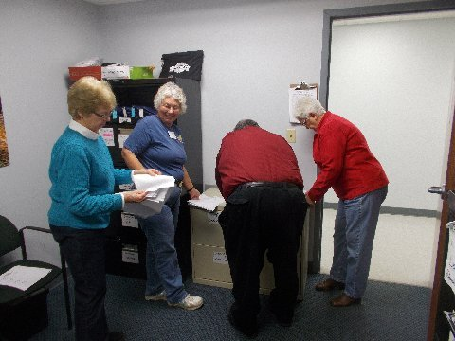  Election Committee
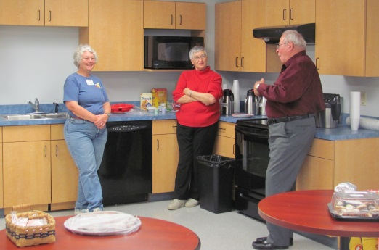 | 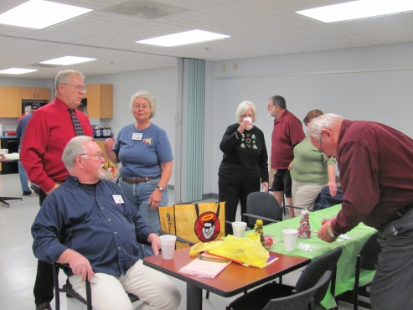 | 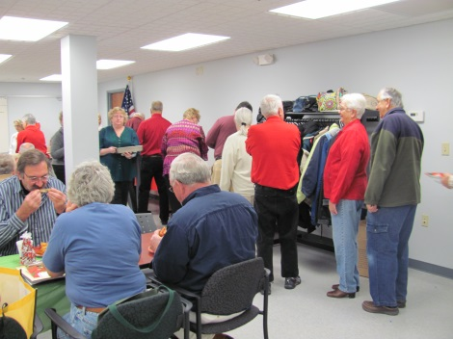
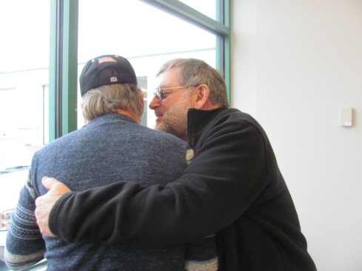  Looks like Butch caught Eddie in a bear hug! |  | 