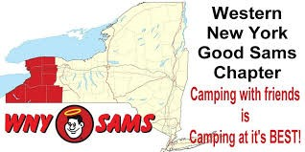
Turning Stone 2016

WNY Sam’s Club Newsletter

July: Herkimer NY Newsletter 2016

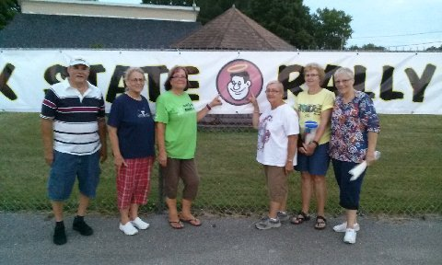

Our WNY Sam’s members headed to Frankfort, NY this month to enjoy the annual Rally. Attendees were Ed & Diane Fackler, Dick Kashdin & Sandy Donovan, Dick & Judy Cox, Rich & Carol Ward, new member Dick Tilton, Mary Thompson & Ginny Groff, Chuck & Sue Massey, and Jack & Ginger Morinello. Of course, our State Director and WNY Sam members Dick & Maryann Crouch were also there.

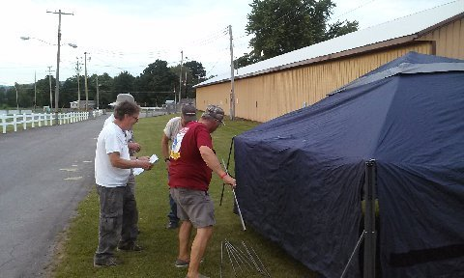

Many of our members arrived on Tuesday to help set up tents and prepare 120 Welcome and Door Prize bags. In addition to all that, they also helped put up the welcome banner to greet guests as they arrived. Nice job everyone!!
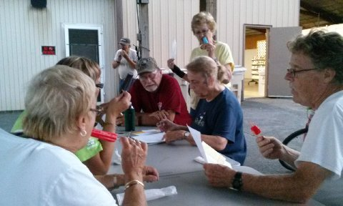
After their work was completed, they took a well-deserved break and enjoyed a sweet treat of cold popsicles. These members worked diligently in 90 degree weather to ensure that everyone was welcomed.
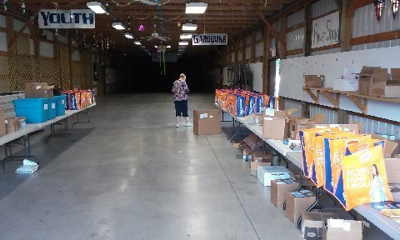
Wednesday, July 13: The day’s activities included BINGO. Our very own Diana was the caller.

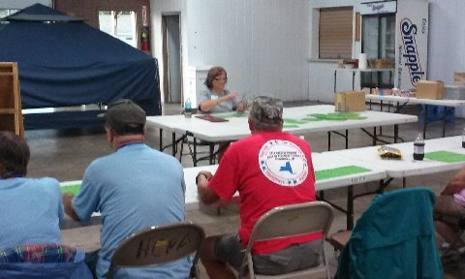

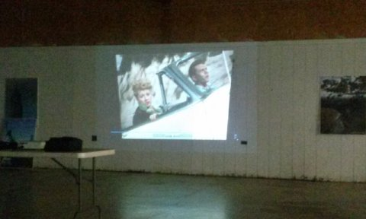

Thursday July 14, 2016
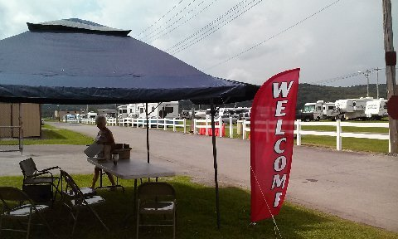
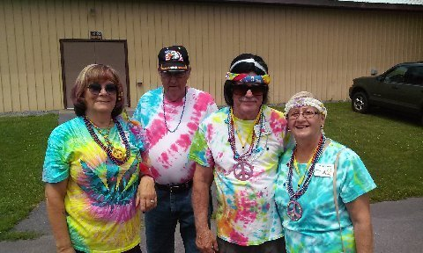
Another very hot and humid day, with temps in the 90's with high humidity and some heavy rains. Wind storms were predicted for the afternoon and evening. As Good Sam’s members from other chapters began to arrive and check in, they were greeted by chapter members who were helping to host this event. The Welcome Tent offered a little shade where they can get some relief from the sun.

Afternoon activities included a large jigsaw puzzle, food at a food truck or concession stand, and afternoon games of Bean Bag Baseball and Crazy Golf.

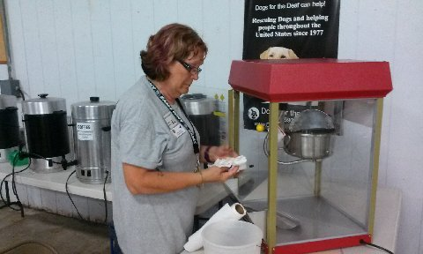
An evening movie featuring Lucy & Desi in a funny movie…The Long….Long….Trailer was enjoyed. There was even theater style popcorn served with the movie!!
Everyone had some laughs and had a good time!!

Friday, July 15, 2016: After breakfast, it was time to set up our chapter booth. The theme for the chapter booths this year was "50 Years of _____". Our chapter set out to dress as hippies from back in the 60's with all tie dye shirts we made at the Four Mile Creek camp out in June.

Some of our members really went all out. Here is Diana, Eddy, Rich & Carol

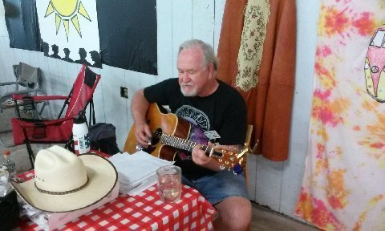
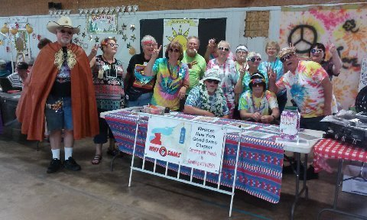
The whole WNY Sam’s group. That's Jack on the left with his guitar. Jack played and sang 60's and 70's songs for most of the afternoon.

The high today got close to 90 degrees and the humidity was close behind with mostly sunny skies. Rain storms were forecast for later afternoon.

There were many other 50 year themes by the other chapters.
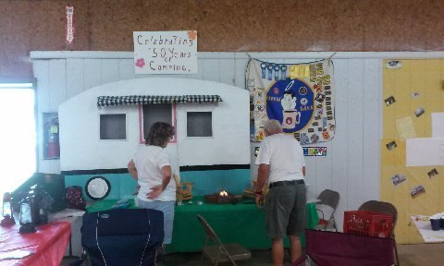
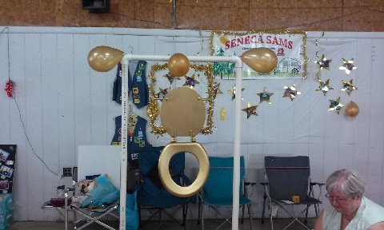

And various ways of winning and donating at the booths.

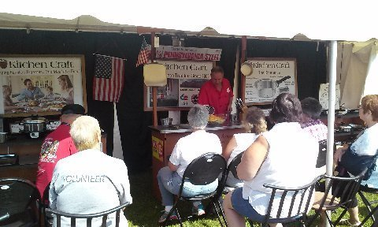
About 10 AM the kitchen vender had his demonstration. A bean bag baseball tournament was also taking place in the afternoon. Just at 4 PM when the booths closed down, the predicted and announced rain storm hit. Heavy rain and some high wind gusts came through but most everyone was prepared.

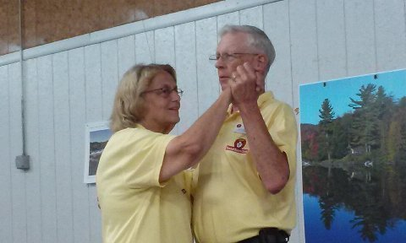
After dinner everyone returned to the main building for the opening ceremonies and entertainment. Our chapter member Maryann is the State Director and was the master of ceremonies.

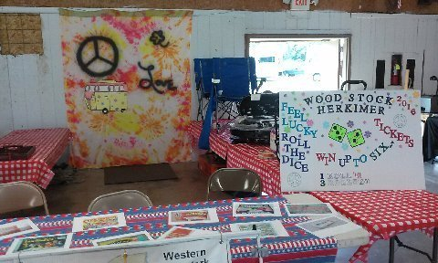
Tonight's entertainment was by "Rockin with the Crock". A one man singer who had us entertained with song and stories and the candy bars were passed out by Maryann at a brisk pace.

The Grape Stompers won first prize with their 50 years of TV game shows booth. We came in second place this year. Lots of dancing and conga lines and fun for everyone. Entertainment ended just before 10 pm
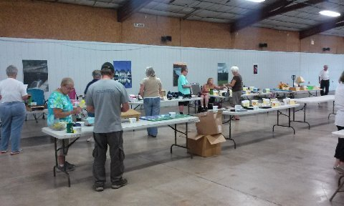
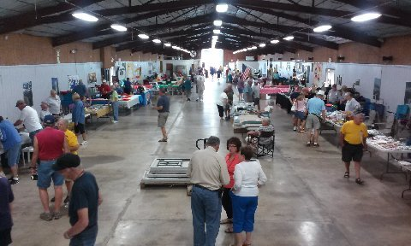
Saturday, July 16: After breakfast it was time to set up for the flea market sale. There was quite a lot of tables set up for the flea market sale from 9:30 AM to 11 AM.

The high today was in the low 80's with partly cloudy skies and still high humidity. No rain was predicted.

Following the flea market sale, there was a live auction with some brisk bidding. At one point a husband and wife were bidding against each other.

After the live auction came the "ticket' auction" formerly known as the Chinese auction.
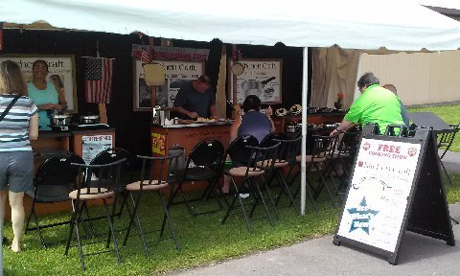
And while that was being set up there was a jam session happening on the main stage.

There was another cooking demonstration and a seminar about tire pressure monitoring systems.

A chicken BBQ started at 5 pm. The entertainment was a country band called "Grits and Grace". Good music and dancing and a good time by all.

There was an intermission where prizes and awards were passed out. Activities lasted until about 10 pm when everyone headed back to their camper and motor homes.

Sunday, July 17: It was time to say good bye and pack up. There was a Sate Committee meeting followed by closing ceremonies. Everyone had a great time and look forward to our next Good Sam’s Events.

Sue and Chuck Massey wish to thank all the campers who helped her when she fell on Saturday and when she got back from the hospital. Due to her pelvic fractures she could not walk so she needed help getting in and out the camper. It was a big job! Hope you are feeling better Sue. Wishing you a speedy recovery.

WNY Sam’s raised a total of $160 from our raffle at the Rally. As agreed upon at the June campout, this will be matched with chapter funds and both Operation Injured Soldiers and Camp Getaway will receive $160 donation.

We also hope that Dick Kashdin & Sandy Donovan are having good luck with their motor home repairs.
Happy Camping

