NEW YORK STATE GOOD SAM FALL FEST
September 25 – 27, 2015
Herkimer County Fairgrounds

Editor/Reporter/Photographer: Diana Fackler, Recording Secretary

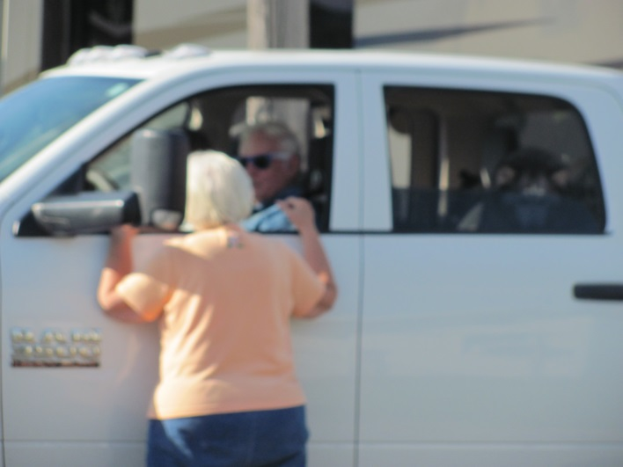
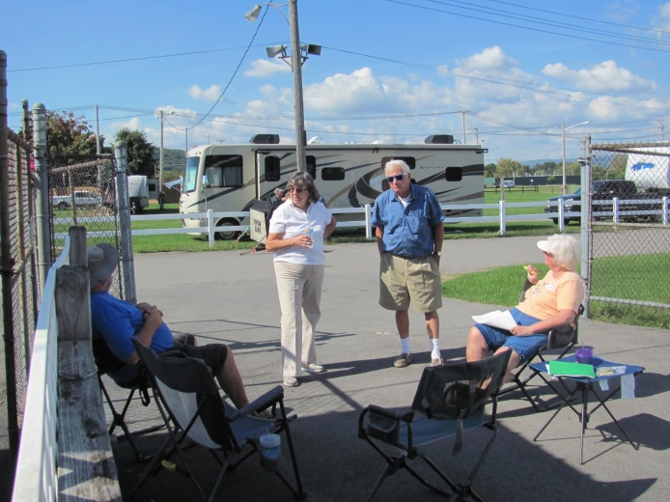
Early Registration began on Thursday (9/24) with approximately 23 units arriving. The day (actually the whole weekend) was much more “laid back” than the Samboree in July. Since it was so “laid back,” You will find this Newsletter mostly of photos taken during the weekend.

Carol Ellis, Registrar, "checking" in one of our Members

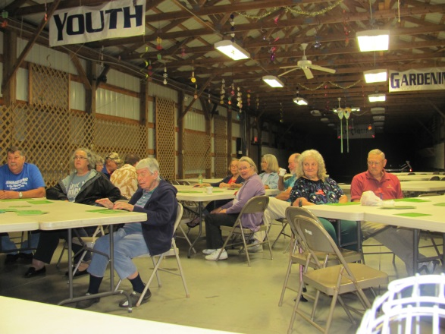
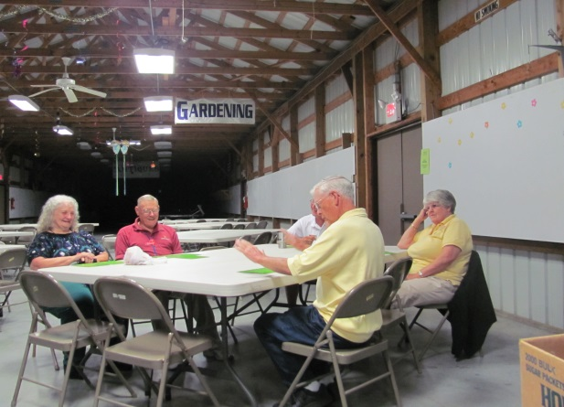
Evening activities included Candy Bar Bingo with Ice Cream following.

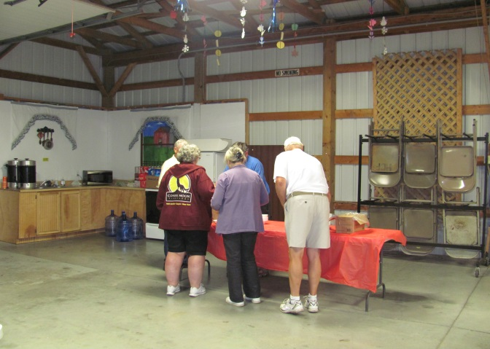

Friday morning was the Golf Outing and the Carpool to Fly Creek Cider Mill & Cooperstown Ommegang Brewery. I did not hear of anyone that had participated in either of those outings.

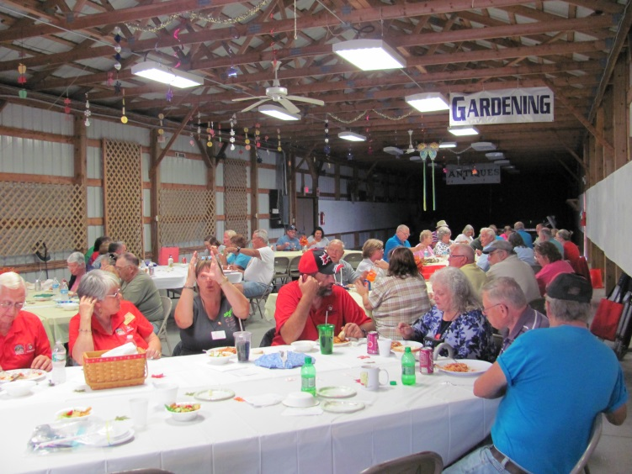
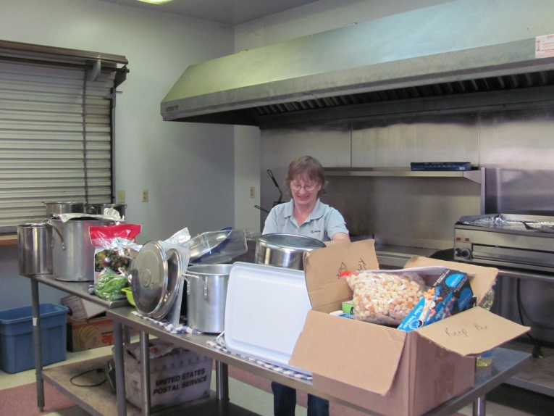
Once again, another round of Candy Bar Bingo was played in the afternoon followed by a Spaghetti Casserole Dinner (prepared by our Kitchen Director – Karen Fogg) at 5:30 PM. Outstanding job Karen! Desserts were provided by attendees with the last initial of A – J.

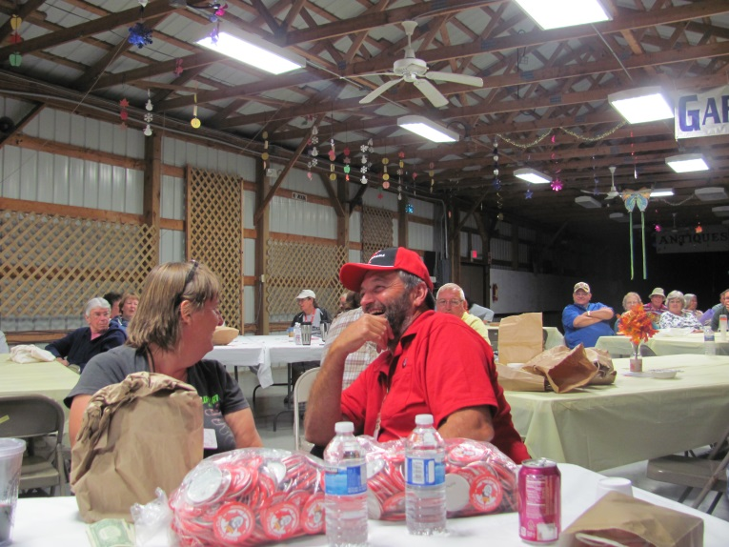
After dinner, the BROWN BAG Auction began and what a “blast” of bidding it was with a few different bidding wars, right Jean-Marie? The Auction resulted in total proceeds of $308.50.

Saturday morning rolled around with a BREAKFAST of scrambled eggs, sausage, hash browns, cofee and orange juice. Attendees with the last initial of K – P provided a breakfast pastry. (Unfortunately I was too busy eating and failed to get pictures – sorry!)

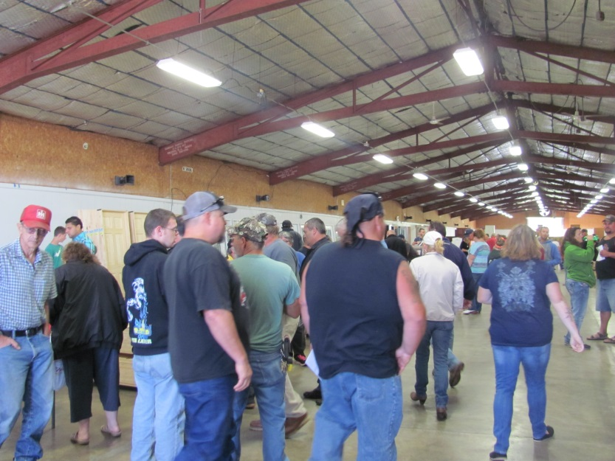

An additional 7 units registered on Saturday. During the day, a Contractor’s Auction was being held on the fairgrounds which brought many people from the general public. Our Good Sam attendees were also welcomed to bid on items. Didn’t hear of too many that did BUT do know of at least one attendee that was lucky enough to walk away with a good buy!

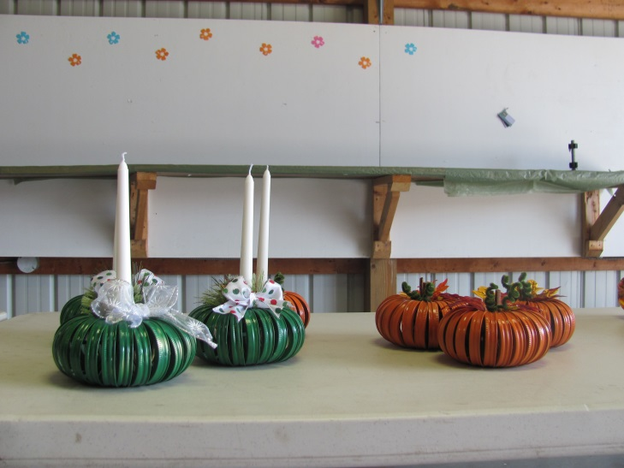
Everyone was on their own for lunch and a State Meeting was held at 1:00 PM – everyone was welcome to attend but only Chapter Presidents and Representatives could vote. A CRAFT session was scheduled for the afternoon to make pumpkins and/or candle holders. Unfortunately, there were no “takers” for the craft but all of the pre-made crafts (which were used for table decorations) were purchased for the price of the craft class. There was also a Flea Market/Craft Sales/Swap Meet from 9:30 – 11:00 AM.

A delicious Stuffed Pork Loin and side dishes was served for Saturday evening dinner. Desserts were provided from attendees with last initials of Q – P. Thanks again Karen!

Following dinner, local Entertainer Frank Crocco sang and performed to the Good Sam audience.
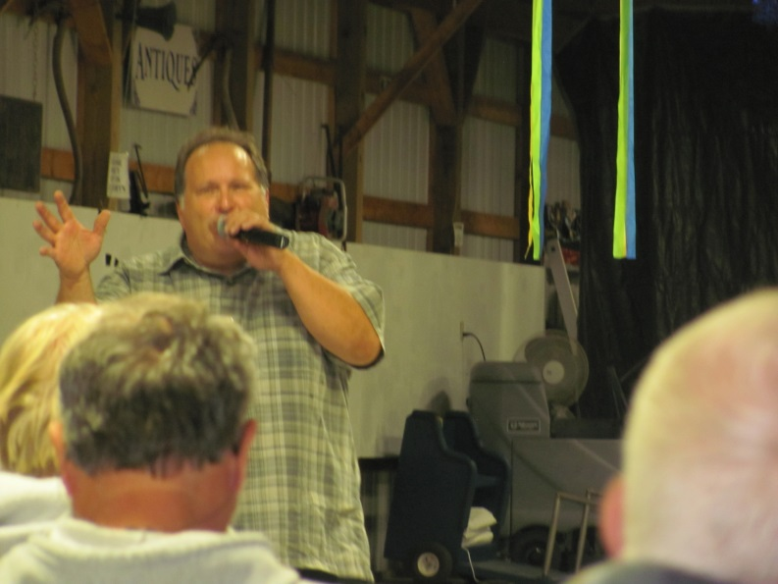

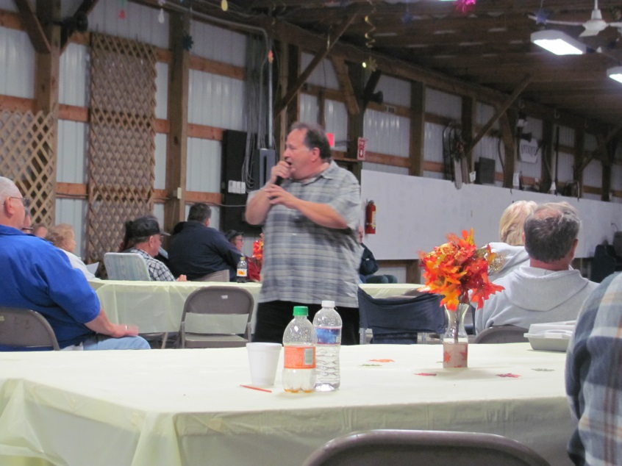

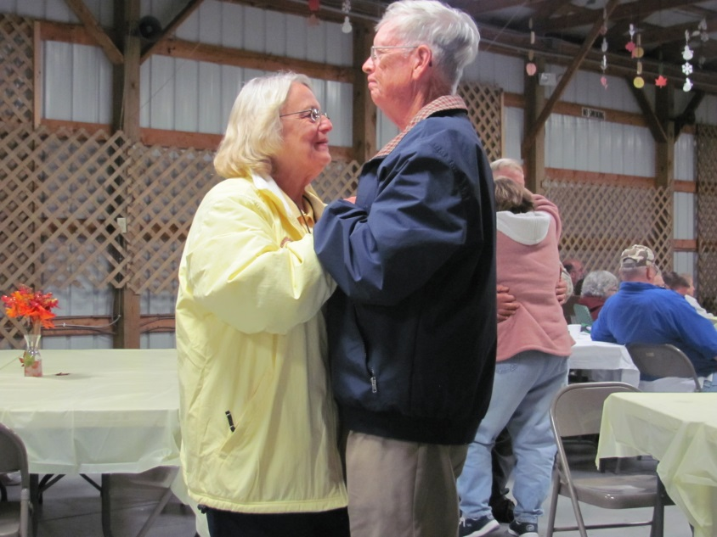
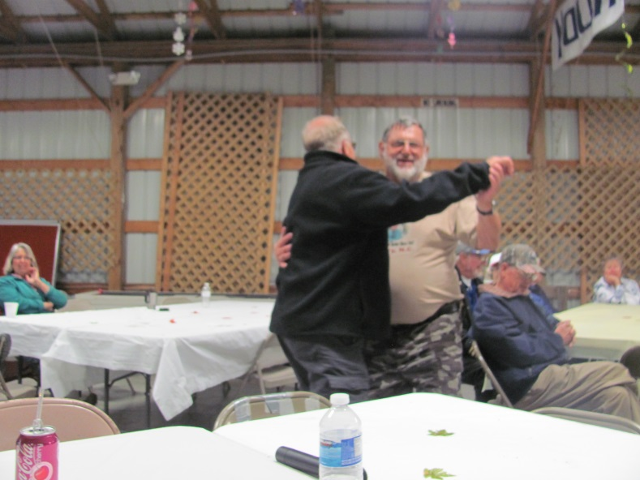
Dancers soon took to the dance floor and YES that is 2 men dancing together – Butch Ellis and Glen Gasstrom!

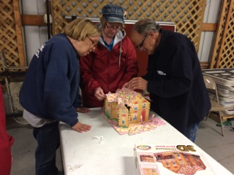
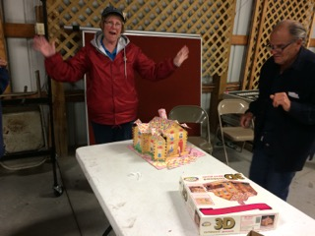
During the course of the weekend, several attendees worked on a 3-D Puzzle and finally managed to finish it on Saturday evening! Thanks for the pictures Barbara Treagus (Ontario State Co-Director).

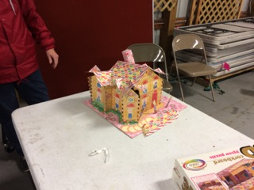

As always, I had to get some pictures of some our four legged members:

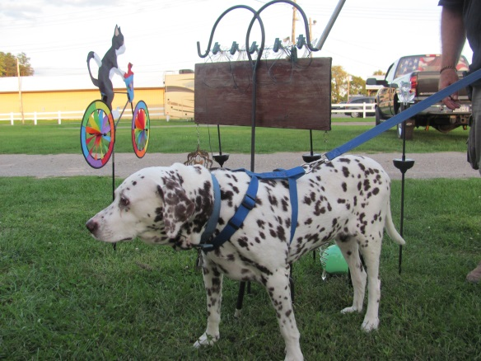
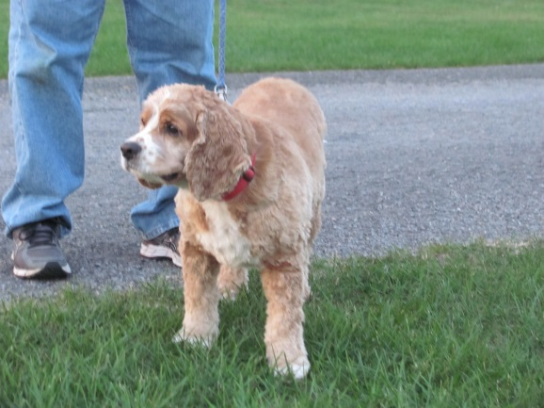
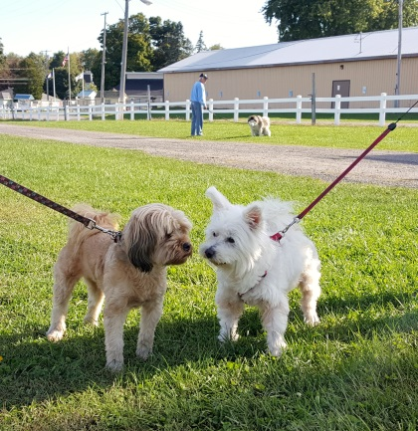
SUNDAY morning included Coffee & Donuts … farewells were said and another NYS Good Sam year is behind us!
Hope to see everyone next year!

