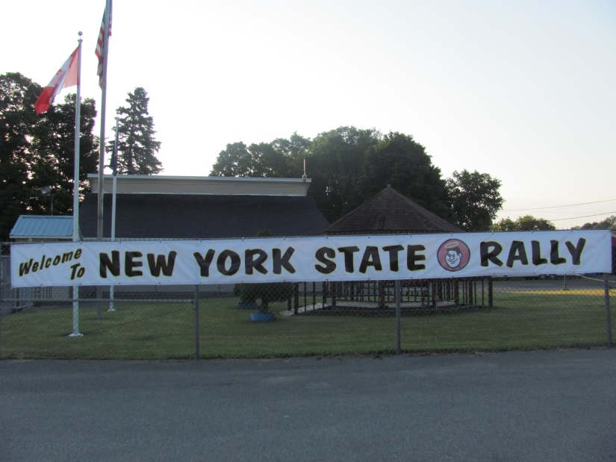
NEW YORK STATE GOOD SAM FAMILY RALLY
July 15 - 17, 2016
Herkimer County Fairgrounds
Frankfort, NY

Celebrating 50 years of

“___________________”

Much activity began at the fairgrounds as early as July 12th when the NYS Directors (Maryann & Dick Crouch) and their staff started to arrive. First course of action was to get the “welcome bags” filled. Each unit attending was given one of the welcome bags filled with lots of goodies.

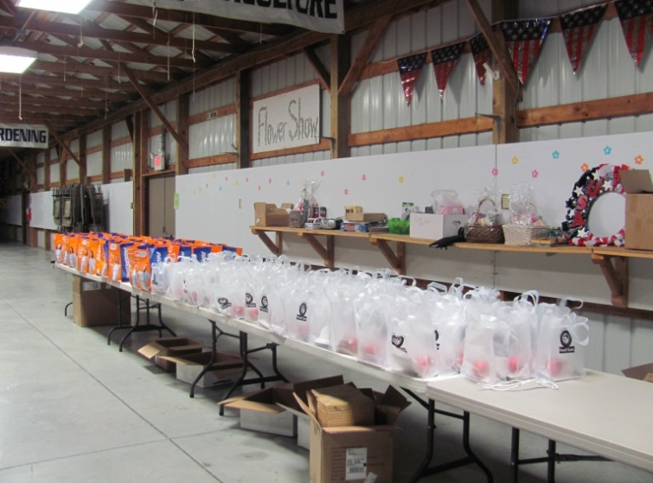
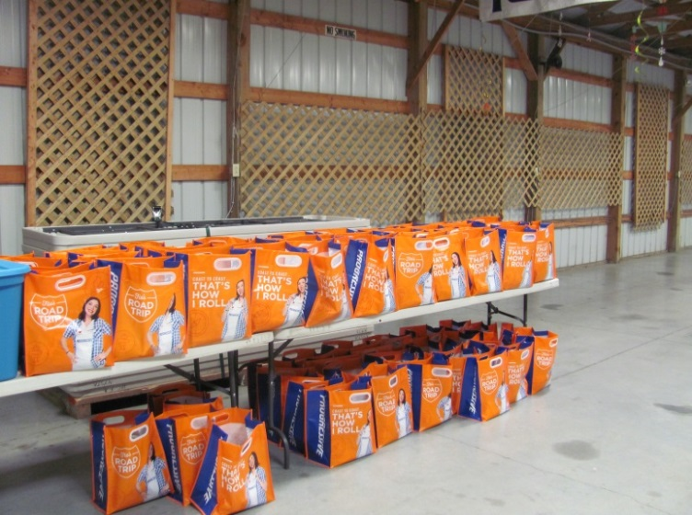

A total of 101 units were welcomed by several different volunteers as they approached the Rally area.
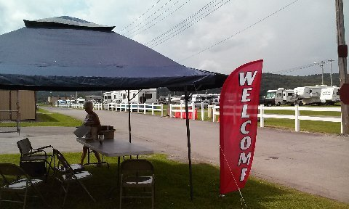

According to Ed Laraway, Wagonmaster, 9 units arrived on Tuesday, 14 units on Wednesday, 45 units on Thursday and 33 units on Friday for a total of 101. There were 5 units that registered but did not attend. And, according to Betty Neilson, Registrar, there were 23 “First Timers” present at this year’s Rally!
Photo courtesy of Dick Kashdin
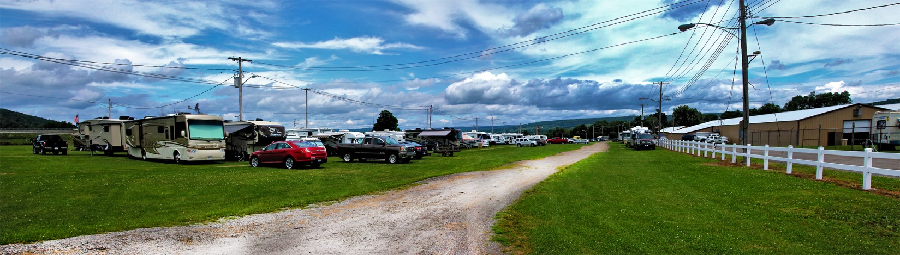
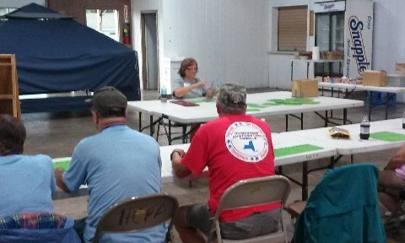
Photo courtesy of John Basile

The Rally activities began with Candy Bar Bingo on Wednesday evening. Just as it was played last year, “Bingo” winners were given a choice of a candy bar upon YELLING “BINGO.” Several attendees were present to enjoy a good time and some delicious Hood ice cream was dished out following Bingo.
Photo courtesy of Dick Kashdin

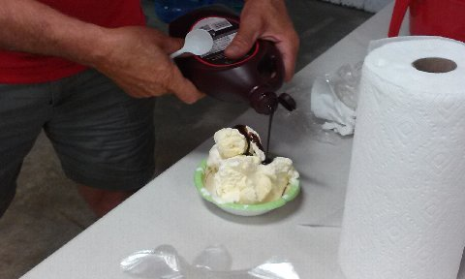
Photo courtesy of Dick Kashdin

Thursday morning started out bright and VERY warm. The majority of arrivals came in on Thursday and were soon greeted by the Wagonmaster or one of his assistants who then led them to their site. Once each arrival was all “set up,” they were to return to Registration so that they could get their assigned
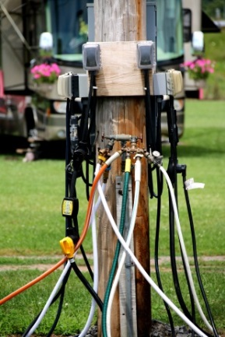
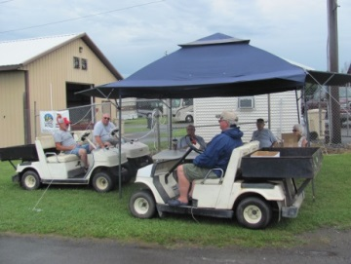
“numbers” and “welcome bags.”

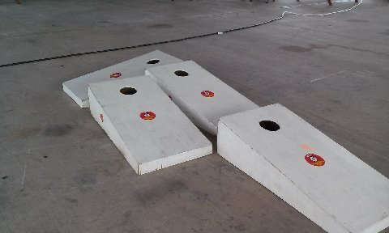
The Snack Bar opened between 11:30 AM – 1 PM and was staffed by SUPER SAMS who did a superb job! Activities for the day included Corn Hole Toss (sponsored by Sams Grape Stompers) and Crazy Golf (sponsored by Mohawk Majestics).
Courtesy of John Basile

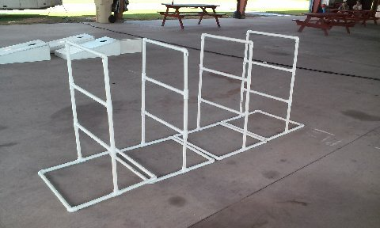
Photos courtesy of Dick Kashdin

Approximately 4:00 PM, the same Food Truck from last year’s Samboree arrived and the scrumptious food was once again enjoyed by many of our Rally attendees once again.
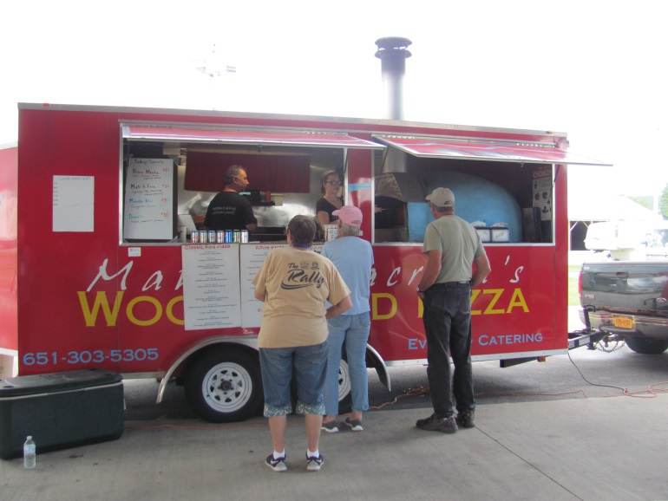
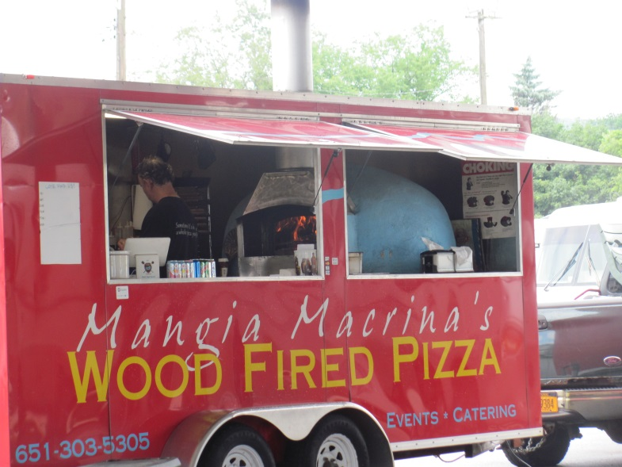
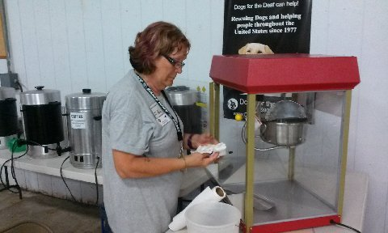
Soon it was time for the evening’s movie – “The Long, Long Trailer” starring Lucille Ball and Desi Arnaz. Free popcorn was served for those interested.

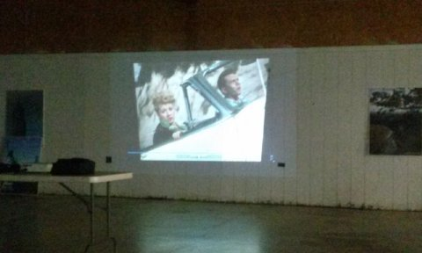
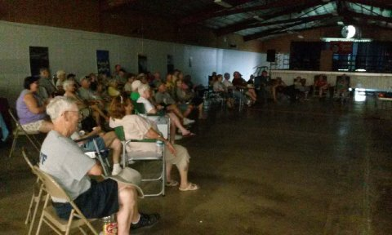
Following the movie, prize drawings were drawn out of the Registration Tags received so far. Prizes included certificates from Melrose Market and KOA Campground.
Photos courtesy of Dick Kashdin

Several RV units were brought in for display by both Camping World (Syracuse) and Meyers RV (Churchville).

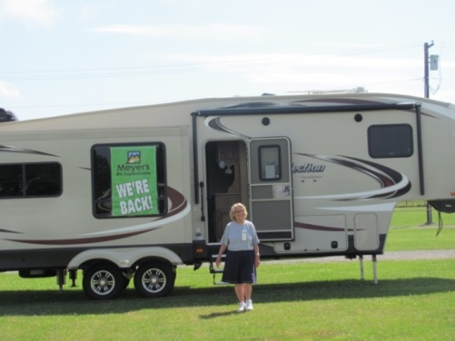

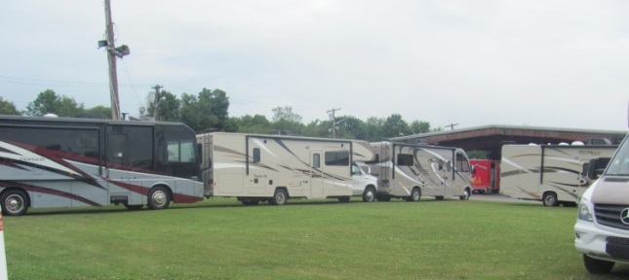

Coffee and donuts were served on Friday morning .
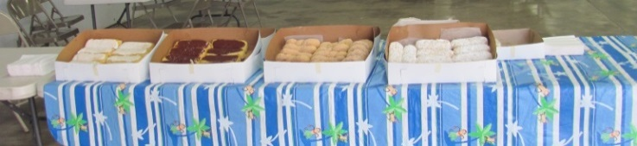

Scheduled activities for the day were a Golf Outing (hosted by Center State Sams), Cooking Demonstration, and Beanbag Baseball (hosted by the Instigator Sams).
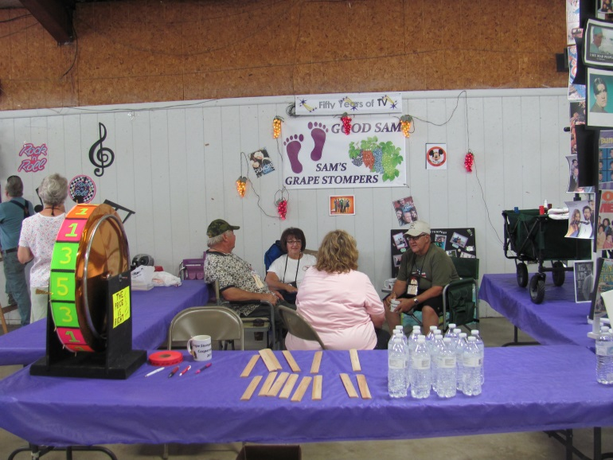
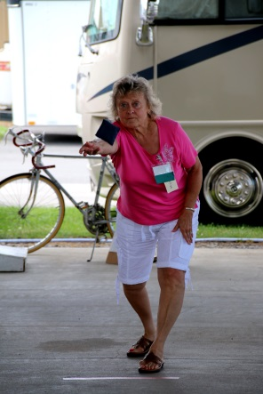
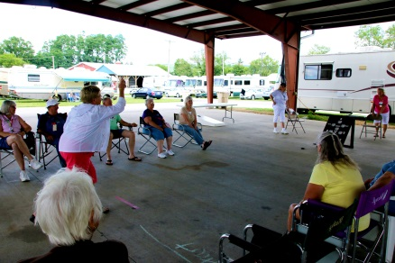
Courtesy of John Basile

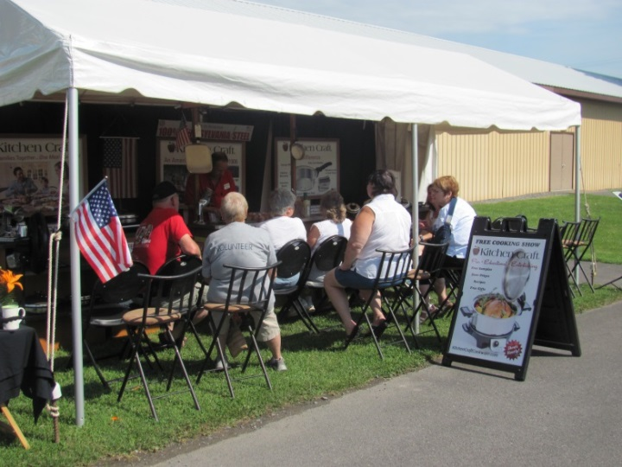
Courtesy of John Basile

The theme for the 2016 Rally was “Celebrating 50 years of __________________.” Each chapter was to “fill in the blank” when creating their Booth. Each booth was to be opened on Friday from 1 – 4 PM and Saturday from 9:30 – 11:30.

Winning booths were announced during the Opening Ceremonies on Friday evening. The first place prize winner received a trophy while second and third place both won ribbons.

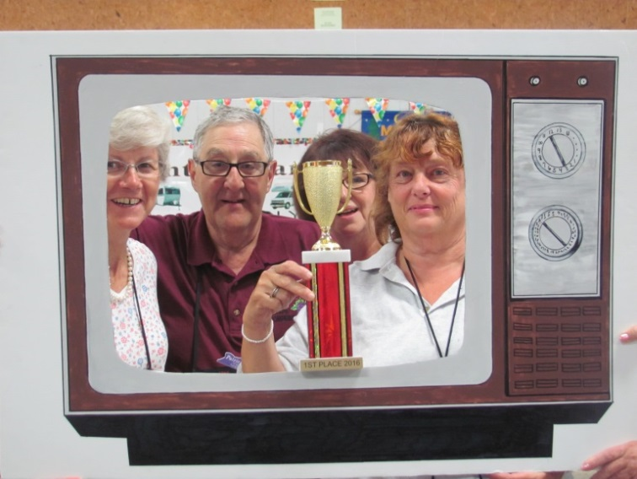
First place went to the Grape Stompers

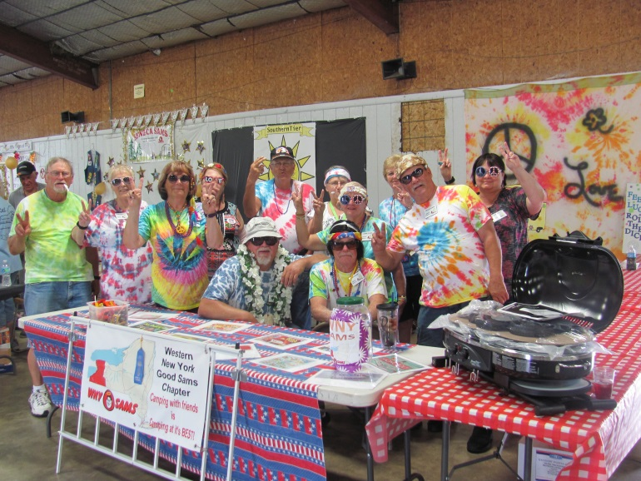
Second place went to WNY Sams

And, third place went to Adirondack Sams
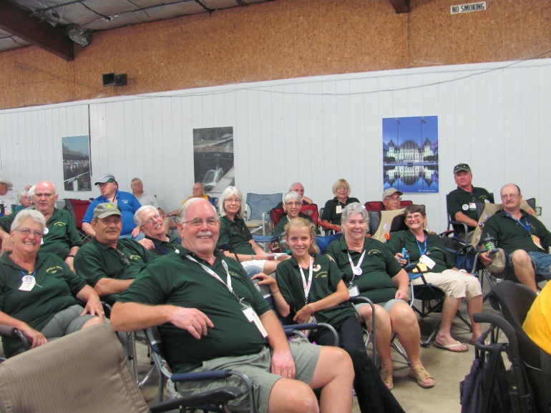
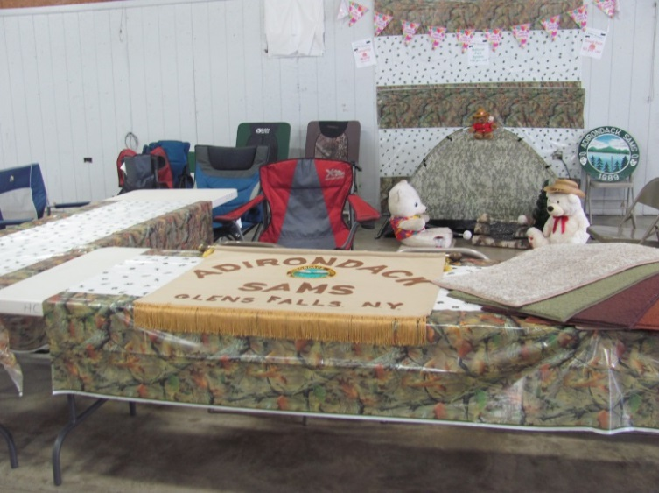
Congratulations to all – a great deal of planning went in to ALL of the booths. The Judges definitely must have had a hard time selecting the top three based on the booths present – more photos can be found towards the end of the newsletter.

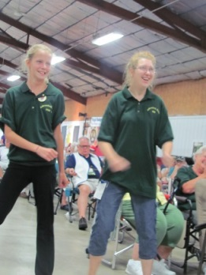
Opening Ceremonies and the Parade of Chapters began approximately 6:30 PM. Chapters were announced in order of their charter date with the oldest chapters first. Maryann Crouch (State Director) introduced her State Staff and also introduced Directors, Tim and Suzie Zich, from Virginia. Certificates were presented to:

Super Sams and Southern Tier Sams – both chartered in 1971 - 45 years

Seneca Sams - chartered in 1991 - 25 years

Center State Sams - chartered in 2006 - 10 year

A representative From TST (Truck Systems Technology) was also present to draw a name (from registration tickets received) for a free system which was to be installed during the Rally. The winners were: Sharon and Bill Clark. Congratulations!

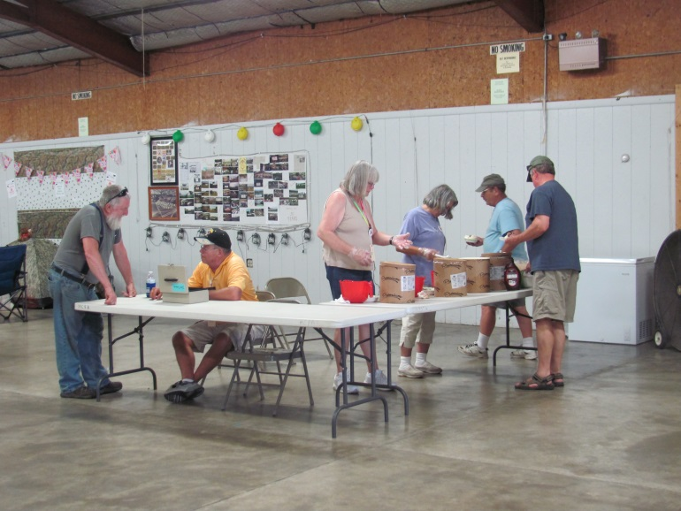
Ice cream sales (hosted by Center State Sams) were being held from 6:30 – 7:30 PM as well as other times throughout the weekend!
Unfortunately the Food Truck that was suppose to arrive on Friday had cancelled which was disappointing to many of the attendees.

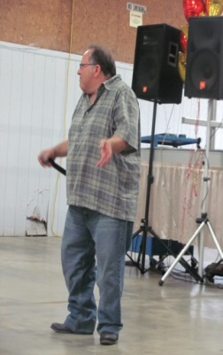
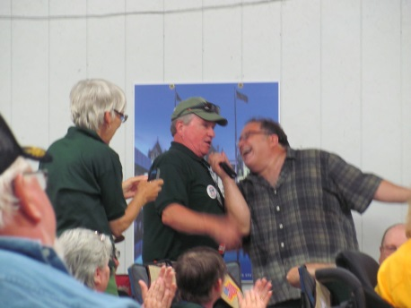
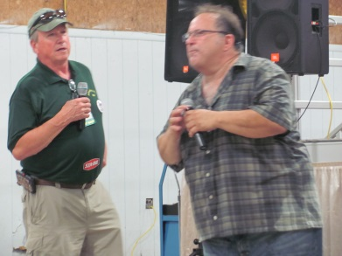
Friday night’s entertainment was Rockin with the Croc who had previously entertained at the 2015 Fall Fest. Mike – one of the Rally attendees was a good “egg” and helped the Croc several times! Possibly Mike should think about presenting the entertainment next year! Great job!
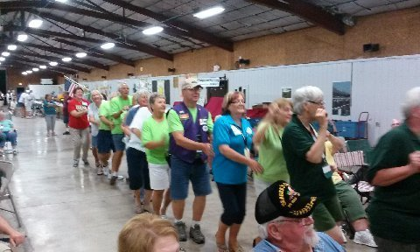
Lots of laughs were heard throughout the evening as well as a “bit” of dancing and singing. . .

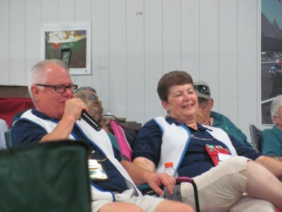
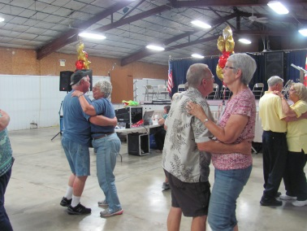
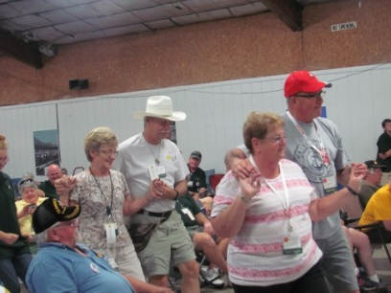
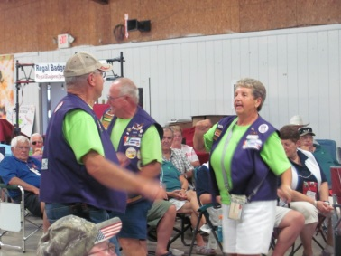
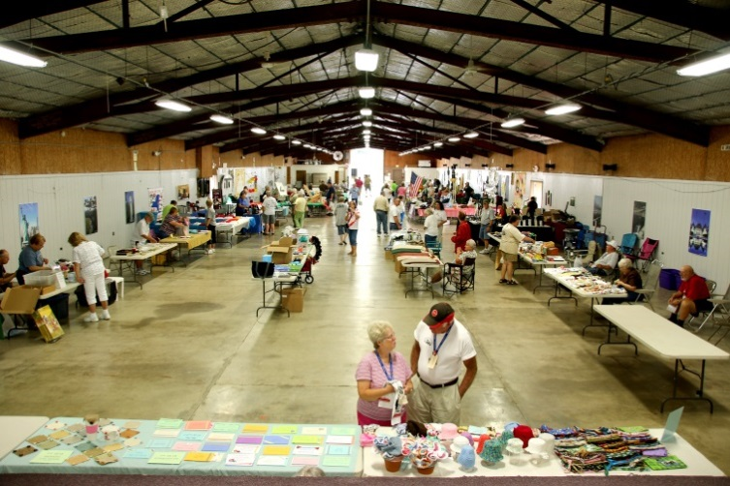
Saturday morning was the Catered Breakfast (hosted by the Southern Tier Good Sams and the Kitchen Staff)
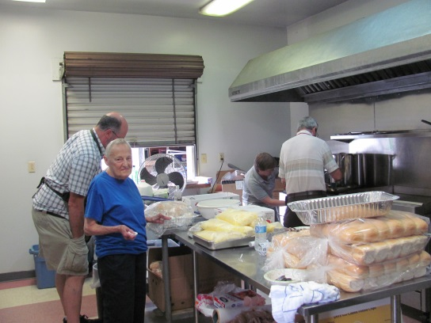

Photo Courtesy of John Basile

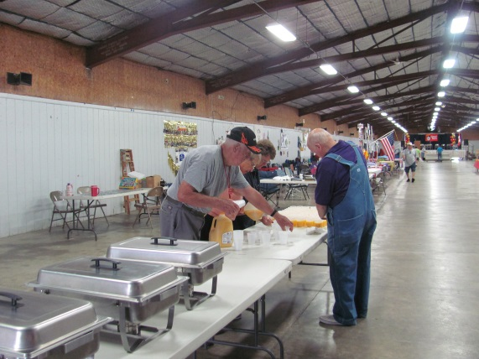
A flurry of activities were planned for the day on Saturday – no rest for the weary!

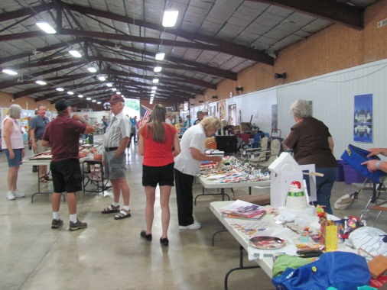
Flea market/Swap Meet/Craft Sales
Photo Courtesy of Dick Kashdin

Milking Contest
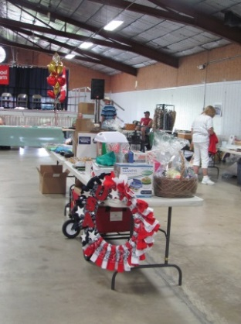
(hosted by the Fairgrounds)
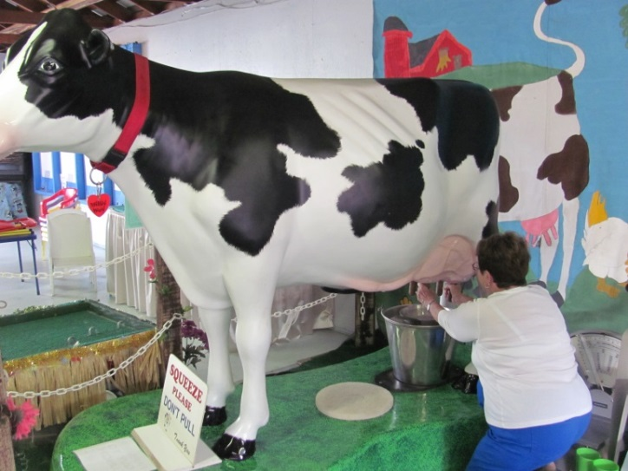
Winners of the Milking Contest were:
Male – Glenn Thurber – 25 oz. in 30 seconds
Female – Deanna Harris – 15 oz. in 30 seconds
Children – Alexis Smith (14) – 15 oz. in 30 seconds
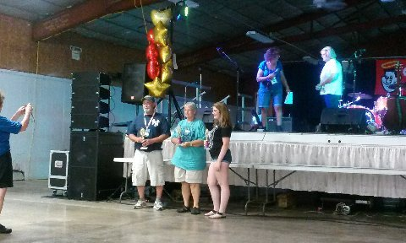
Congratulations!

Live Auction:
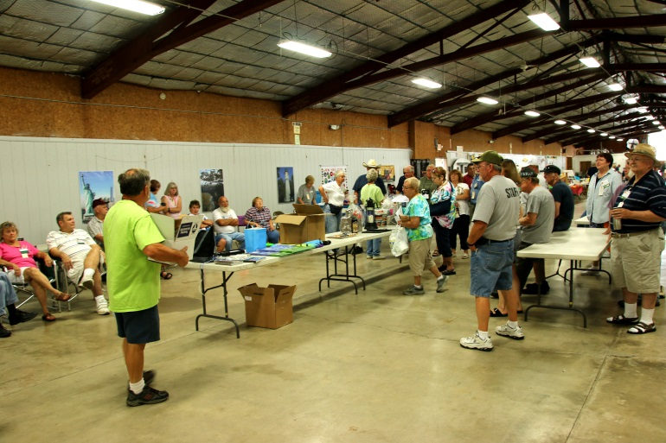
Courtesy of John Basil1
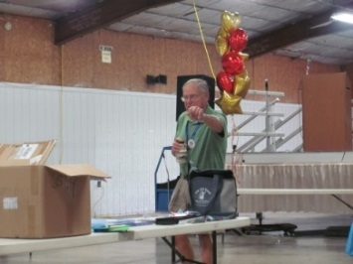

A total of $378
was raised from the
Live Auction

Pet Safety Seminar Presented by Virginia Directors

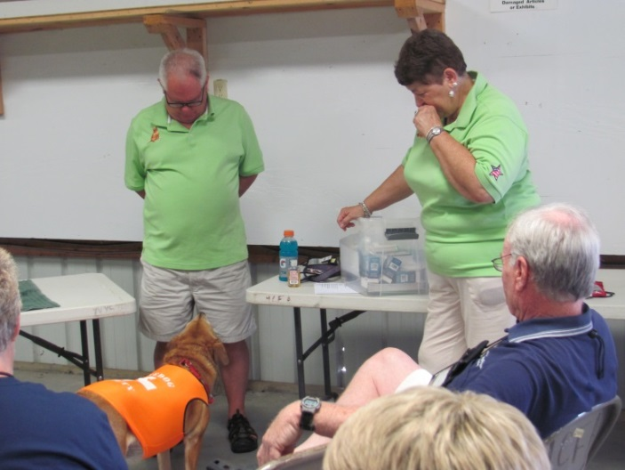

Courtesy of Dick Kashdin

Tim & Suzie Zich and Kellie

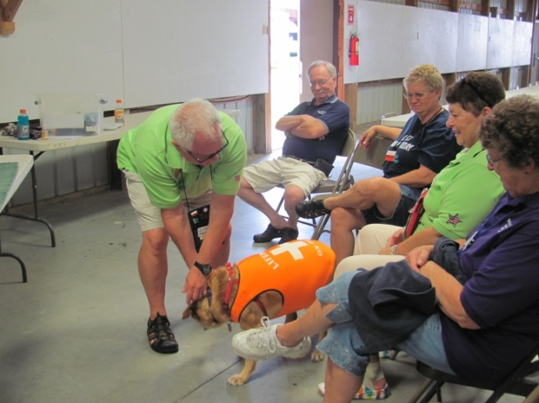

Frying Pan Toss (hosted by the Adirondack Sams)
(sorry – no pictures of this activity)

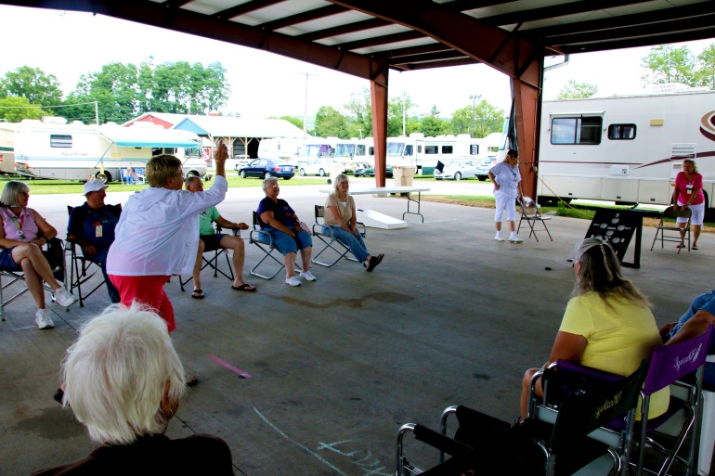
Winners:
Girls (11 & Under)
Britta Stone – 26’

Ladies (50+)
Sue Knott – 31’ – 1st
Joan Dowd – 29’ – 2nd
Lynda Glenn – 25’ – 3rd
Linda Smith – 25’ – 3rd

Men (50+)
Steve David – 60’ – 1st
Rob Youngs – 50’ – 2nd
ike Rossner – 49’ – 3rd
Courtesy of John Basile

Really Old People
Roger Glenn – 44’ – 1st
Glenn Brown – 39’ – 2nd

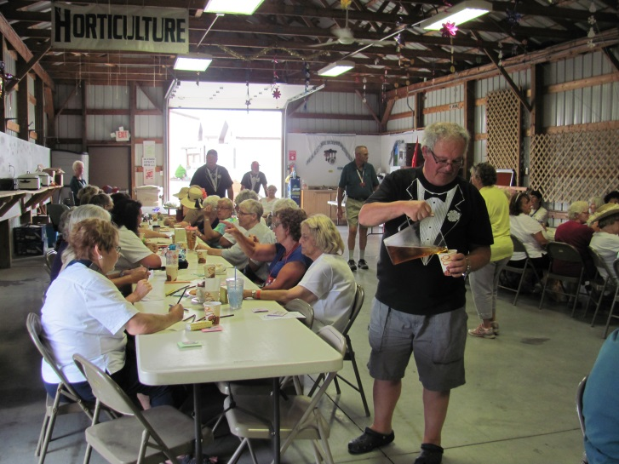
Book Seminar Janetta Fudge-Messmer
and her husband, Ben

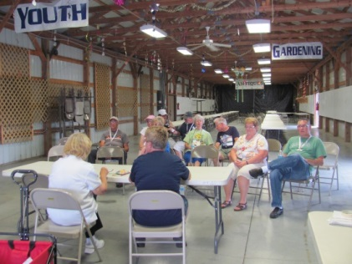
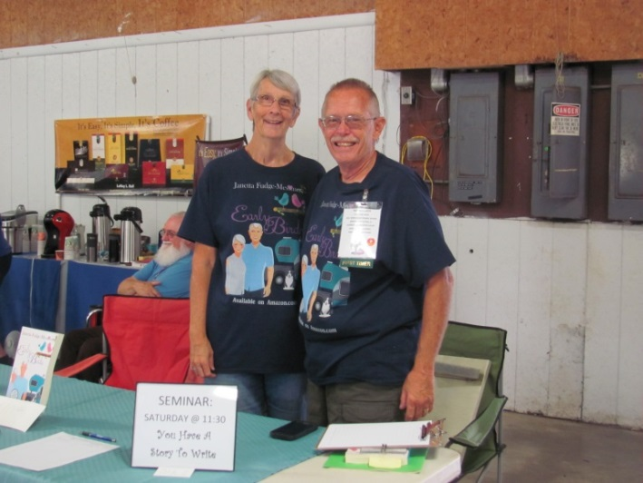
“Writing Memories and Everyone has a
Story to write”

1st Timers Meeting

And Bean Bag Baseball continues in to another day
(sponsored by Instigator Sams)

Samantha Tea
(hosted by Seneca Sams)
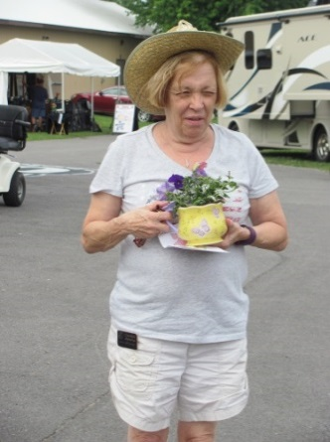

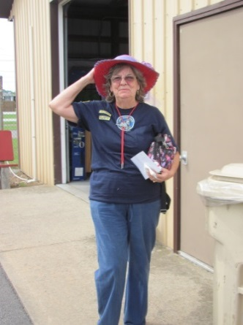

Ticket Auction (formerly Chinese Auction)
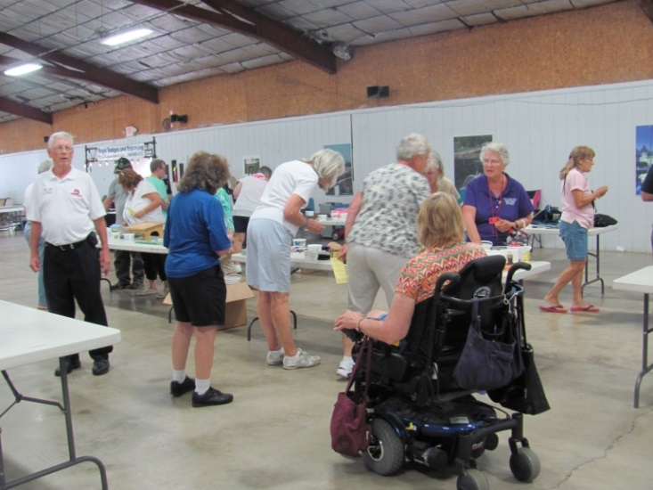(hosted by WNY SAMS)
A total of $180 was raised for the State’s Charity

Seminar – Truck System Technologies
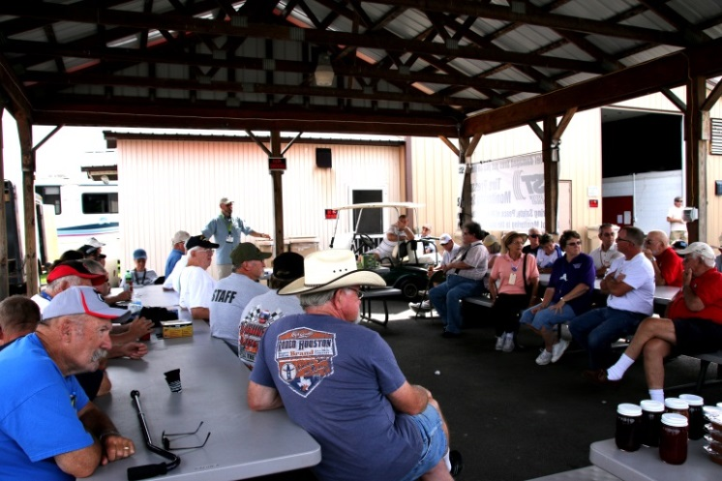
Amish Baked Goods
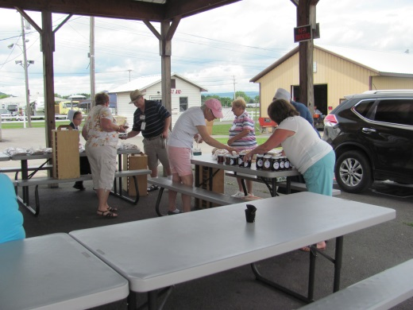

Jam Session
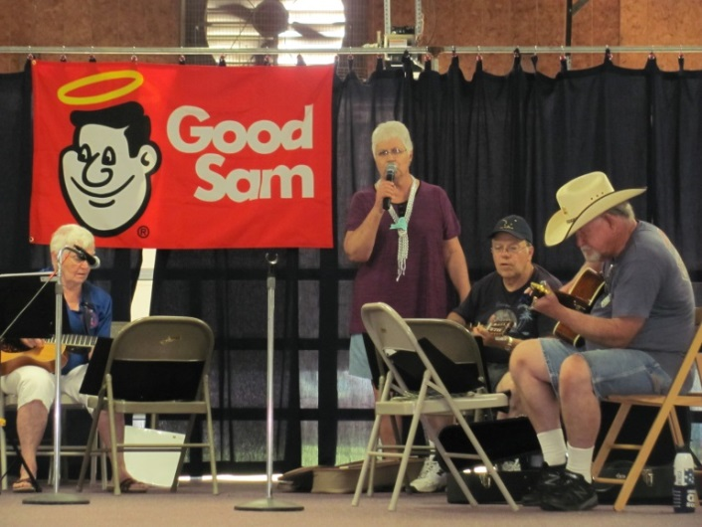

Horse Races
(sponsored by Sippin’ Sams)
Unfortunately there were no contestants for this event

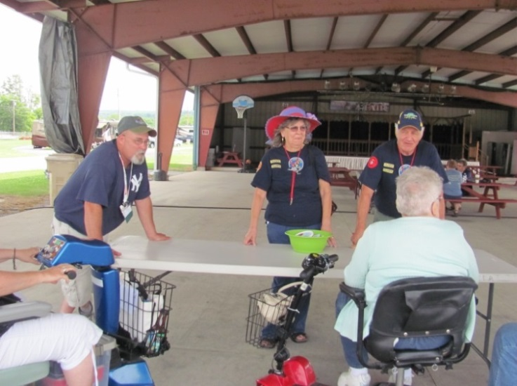

And, of course, the delicious “Chicken BBQ” smells permeated the area throughout the afternoon

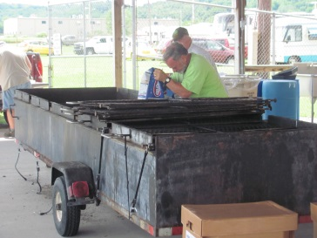
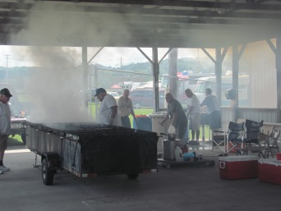

Chicken BBQ Time

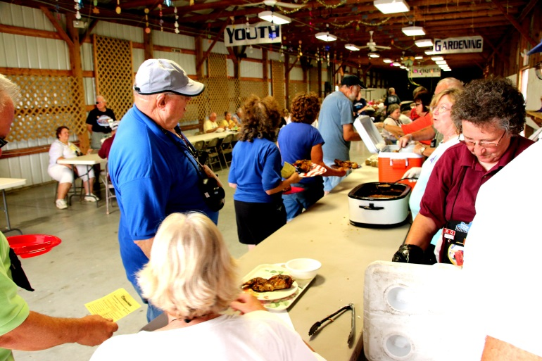
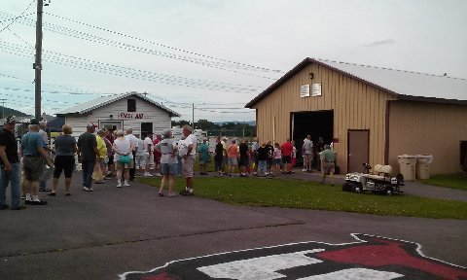
Courtesy of Jack Basile
Photo Courtesy of Dick Kashdin

Saturday Evening entertainment
was graciously sponsored by the
Herkimer County Fairgrounds. . . . THANK YOU!

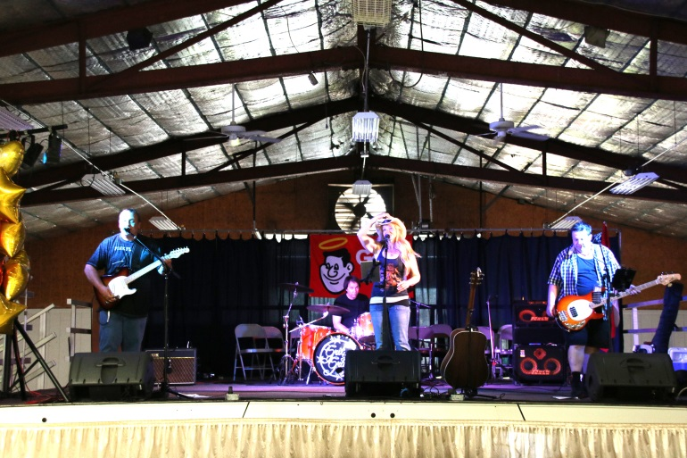
“Grits and Grace”
Courtesy of Jack Basile
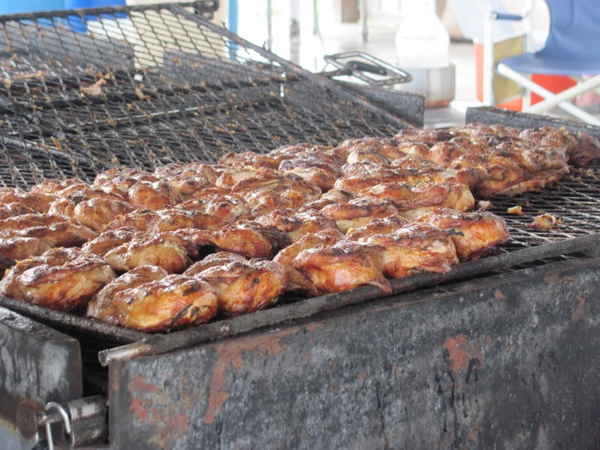
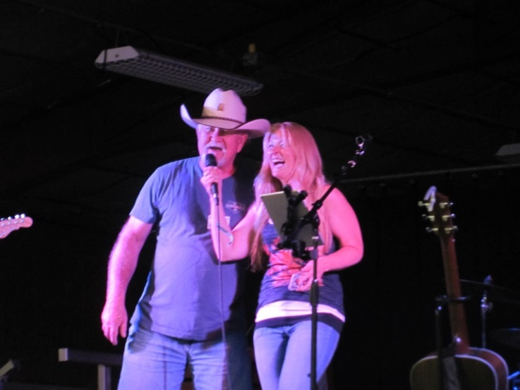
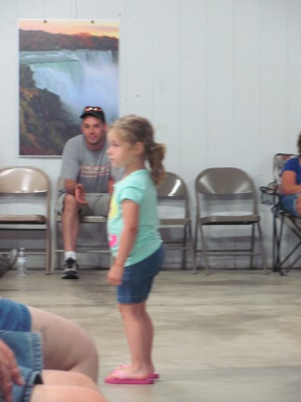
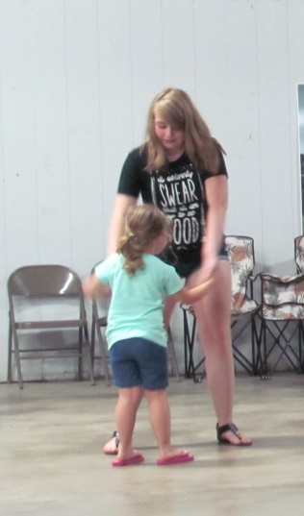

Chapter Raffles and the Winner of the $50 Hat was drawn during intermission.

Most of the chapters present had held a raffle with proceeds being announced as winners were drawn.

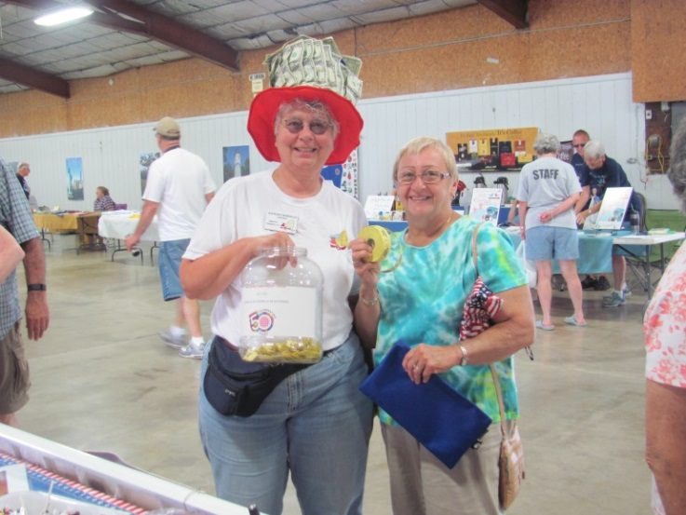
Following the Chapter Raffles, the winner of the $50 hat (hosted by WNY Sams) was picked. A total of $141 was raised for the State’s charity.

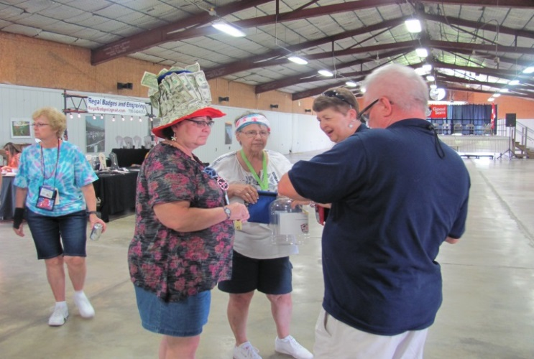
Coffee and donuts were served once again on Sunday morning. The State Committee meeting and Non Denominational Service were also held.

Following the meeting, Closing ceremonies were held in the main hall with stage prizes being given out and the drawing for the Pot O’ Gold (hosted by Instigator Sams). It was also announced by the Director that there will not be a Fall Fest in September as previously announced. Rich Ferolito, Chaplain, closed the Rally with a closing prayer and a poem entitled “I’m Fine.”

Farewells and Safe Travels were said ...until we meet again!

Other AWESOME Photos taken by
John Basile

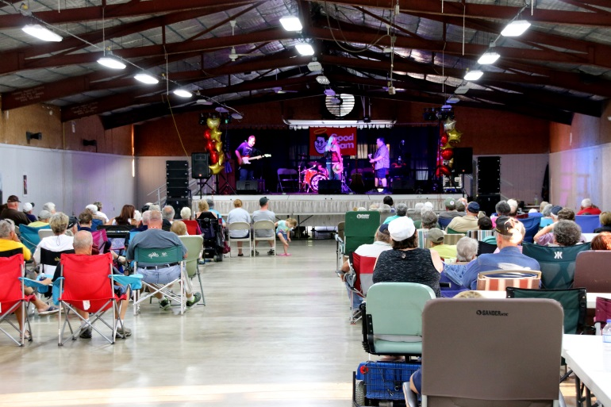
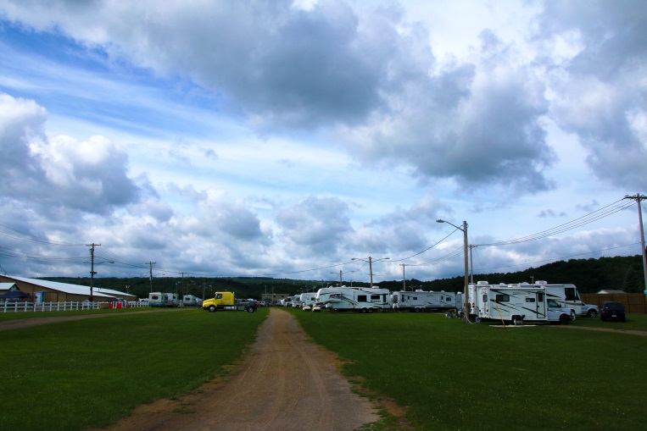
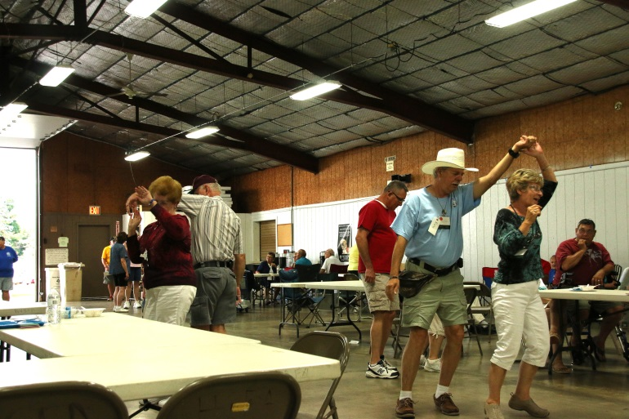
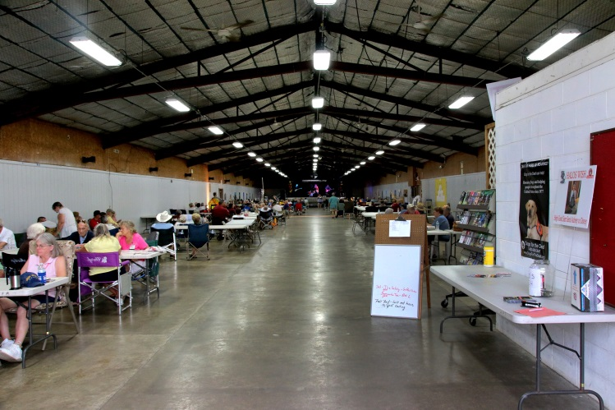

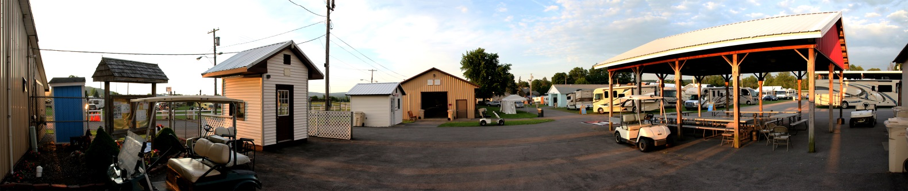

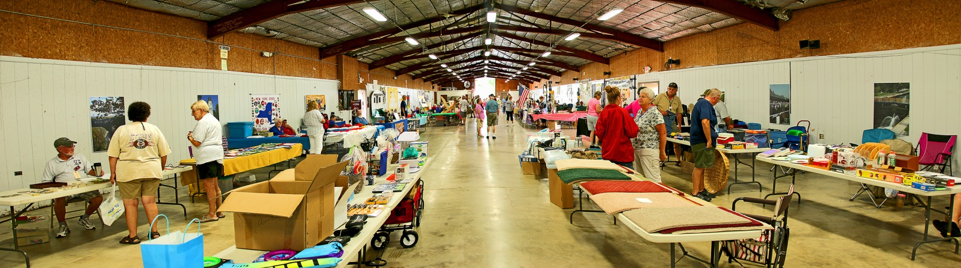

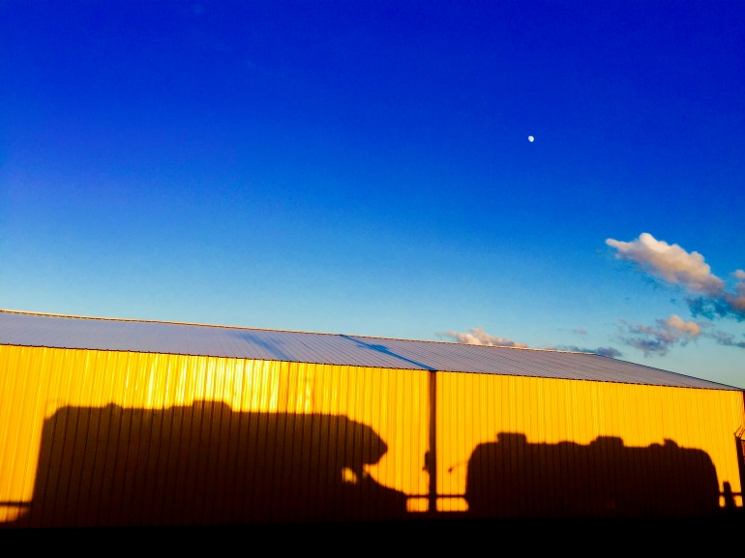

A BIG “THANKS” GO OUT TO
DICK KASHDIN AND JOHN BASILE
FOR SHARING THEIR AWESOME PICTURES!

ANOTHER BIG “THANKS” TO
DICK & MARYANN CROUCH FOR ANOTHER
AWESOME RALLY!

THANK YOU … THANK YOU .. THANK YOU!

Chapter Booth photos
(I apologize if I failed to get a photo of your booth):
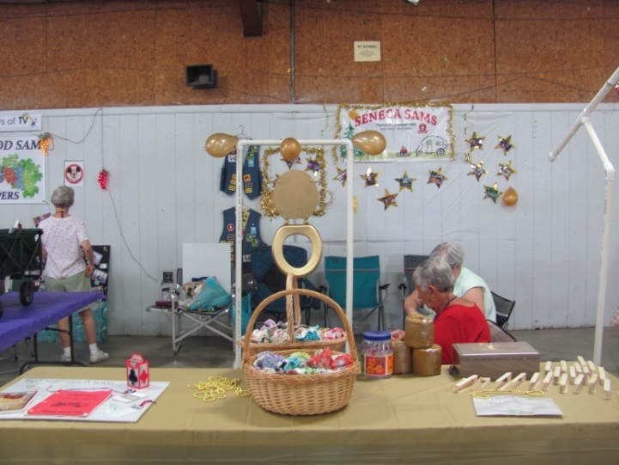
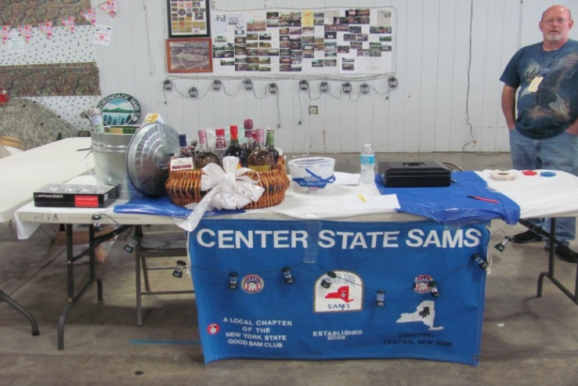
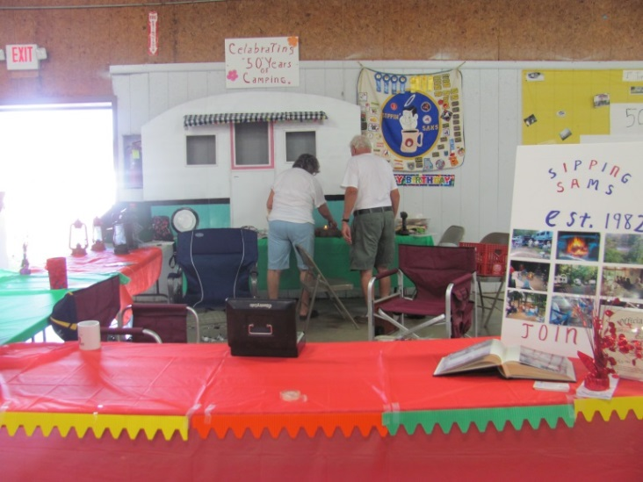
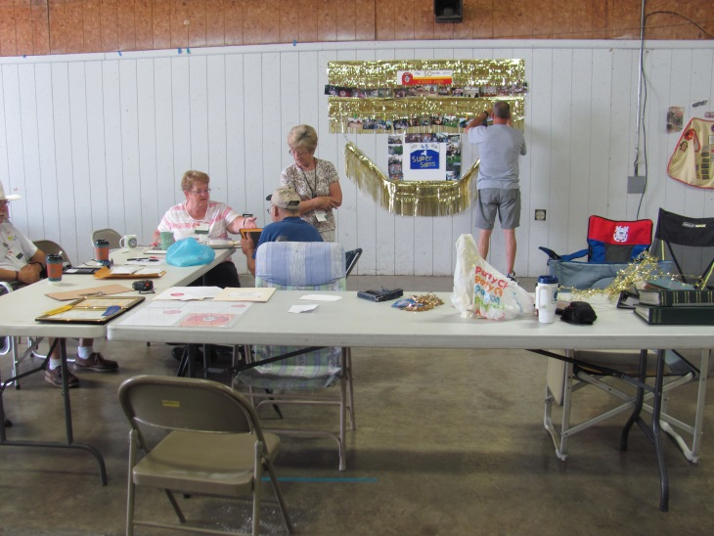
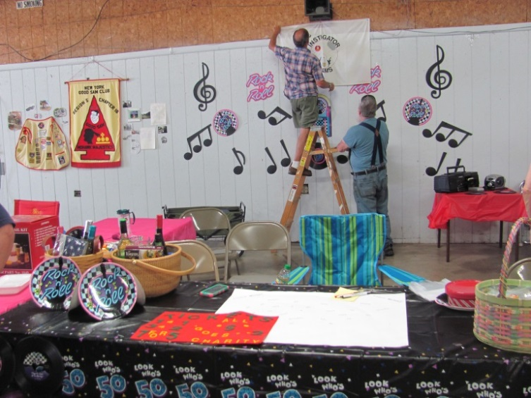

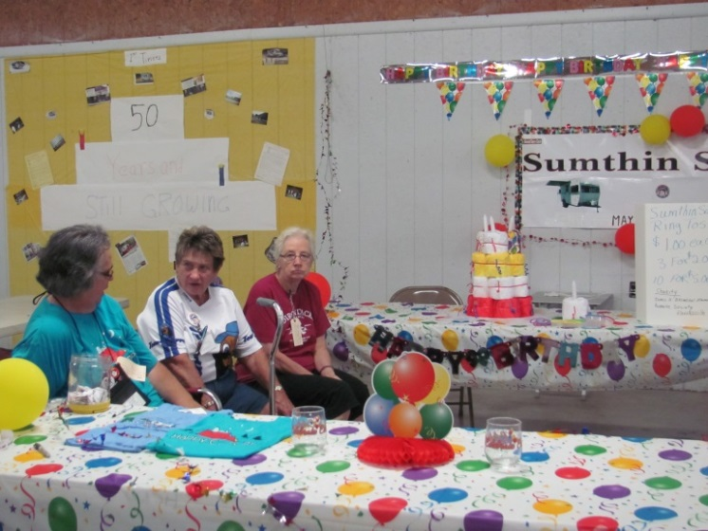

Vendor Row

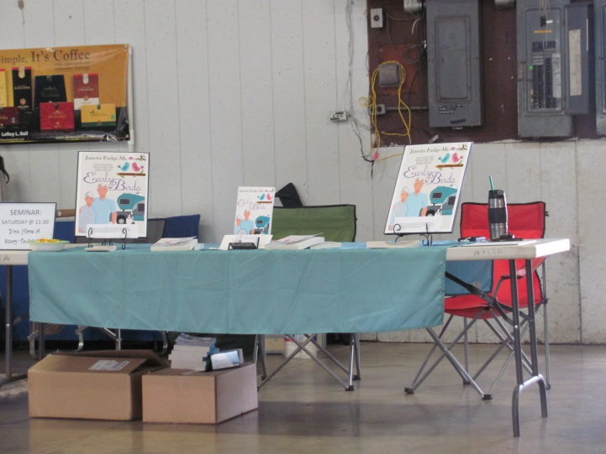
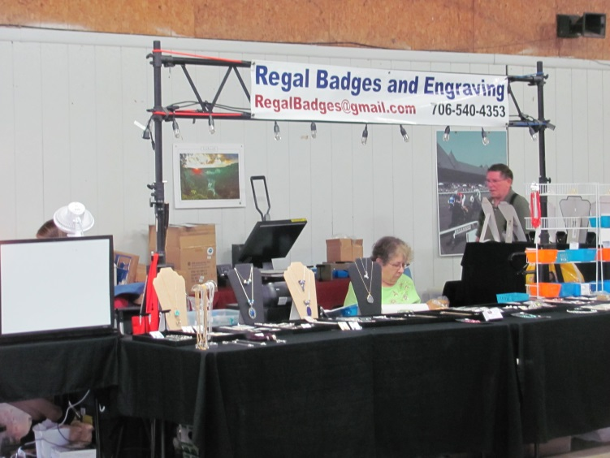

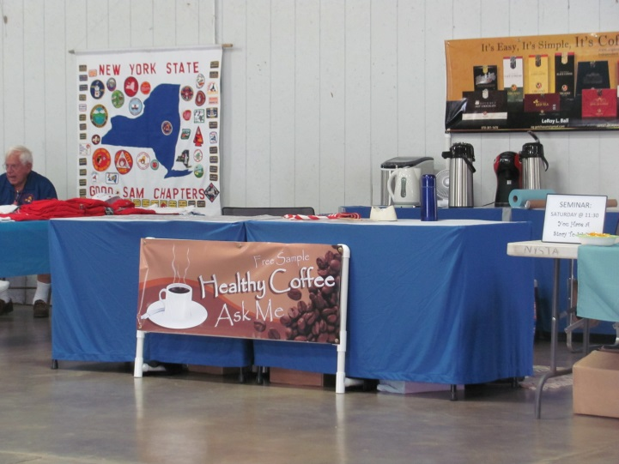

State Store
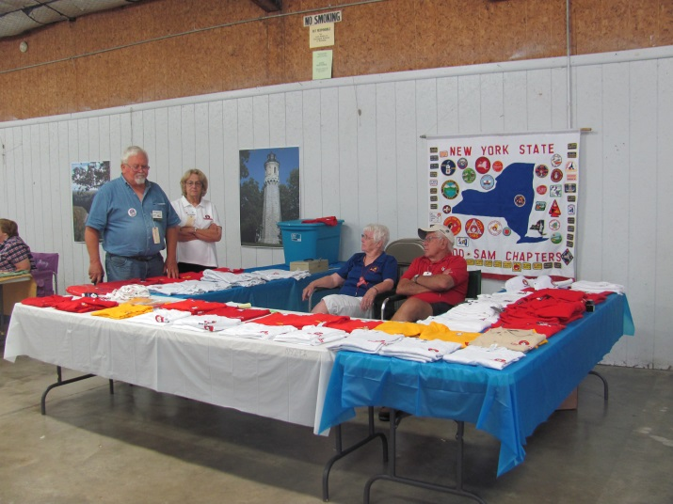

Miscellaneous Pictures from throughout the event

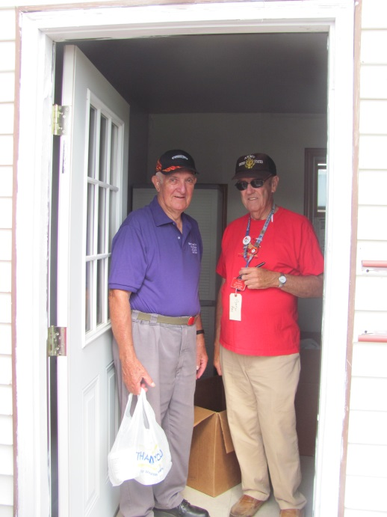

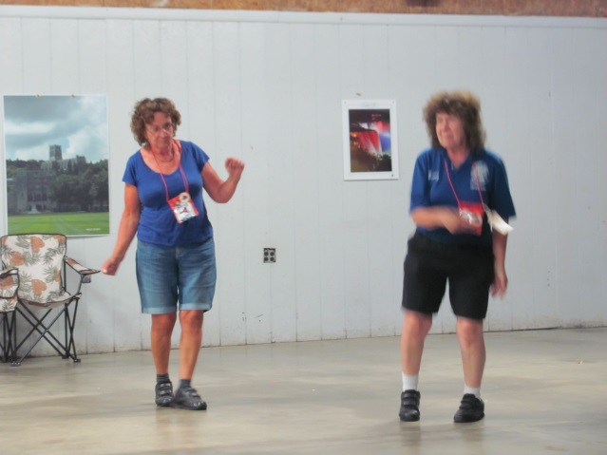

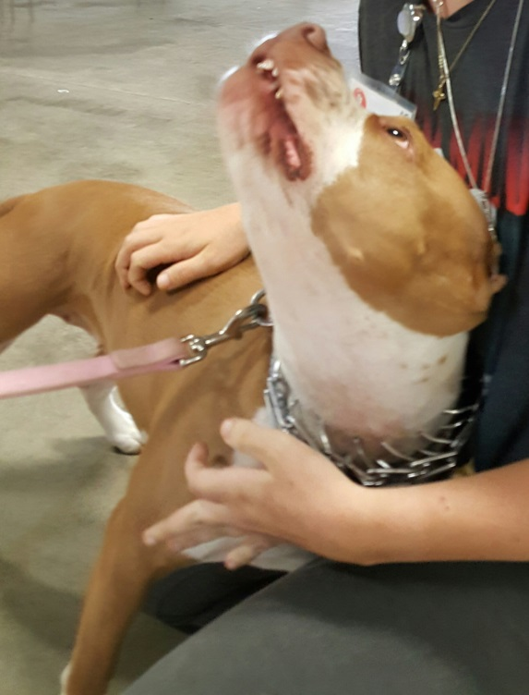
And, of course, Photos of some of our 4 Legged Members I saw throughout the Rally

