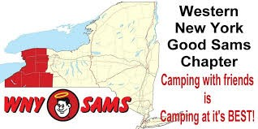
September 2016

WNY Sam’s Club Newsletter

Linda DeRose, Editor

September Newsletter 2016

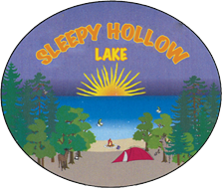
WNY Sam’s were welcomed to Sleepy Hallow Campground in Akron, NY this month. Our hosts, Carol & Rich Ward, who are seasonal residentsand Marge & Jerry Meyers planned a fun weekend for us. Arrivals are as follows:

Thursday Arrivals
Rich & Carol Ward & Ralphy (of course, since they
have a seasonal site at Sleepy Hollow)
Ed & Diana Fackler
Dean & Bonnie Stenshorn (and Augusta)
Bob & Pat Wyble (and Kadie) - guests for the
weekend
Dick & Maryann Crouch (and Teddy & Lilly)
Jim & Ellie Strickland
Jerry & Marge Meyer
Carol Ellis
Chuck Massey (Sue arrived on Friday)

Friday Arrivals
Jack & Ginger Morinello (and Bert & Ernie)
Barb Westermeier & friend, Barb - guests for the
weekend
Ginny Groff and Mary Thompson
Jan Ingerson & Cindy Jaeger (and Ozzie & Buttons)
Dave & Debbie Swanson (and Buddy) - rejoined
group
Bill & Ann Marino
Don & Terri Sokol
Mike & Linda DeRose
Mark & Liz Eichelberger
Dick & Bev Elliott
Dave & Carolyn Nelson and niece Alex (and
Morgan)
Bob & Debbie Reumann (and Percy)
Mike & Jane Gurr – guests for the weekend

Welcome to our “guests” who became members by the end of the campout: Barb Westermeier, Bob & Pat Wyble and Mike & Jane Gurr

Saturday visitors included Dick & Judy Cox for the morning meeting and Dick Kashdin & Sandy Donovan for the afternoon, dinner and raffles.

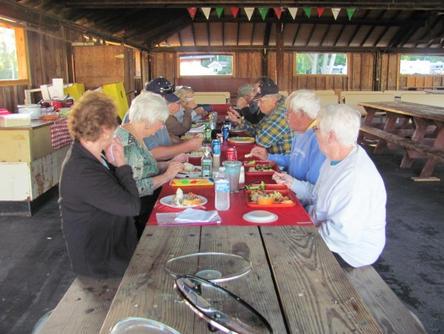
Thursday night Potluck took place with all Thursday arrivals except Jerry & Marge who were unable to attend.

Friday Night: Following went to the campground snack bar: Dean & Bonnie, Ed & Diana, Chuck Massey, Dick & Maryann, Bob & Pat, Carol Ellis & Kathy (her guest for the day/night), Dave & Debbie Swanson. A camp fire followed and we enjoyed small group conversations, and another “newbie dance” led by Jan and her followers (Cindy, Barb and Barb). They were all good sports, dancing around the fire, and they even had the dogs singing
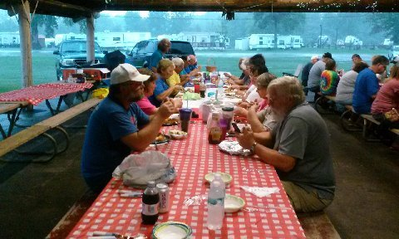
along in their campers. I’m not sure if the ladies were doing some sort of rain dance, but more on that later. The group was up until 11:30 or midnight and it was a beautiful night complete with the full moon!!

Saturday Morning a continental pot luck breakfast took place at 8:30. There was a delicious assortment of apple cakes, oatmeal, yogurt, cookies, assorted brownies, muffins and breads. We also had coffee and orange juice. Breakfast was followed by a very short meeting and crafts. The ladies made beautiful Halloween and fall wreaths. It was a good thing we had a shelter this month, because the sky opened up and poured rain upon us.

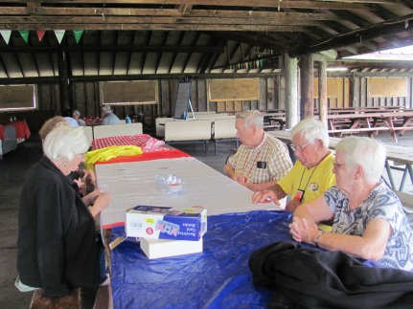
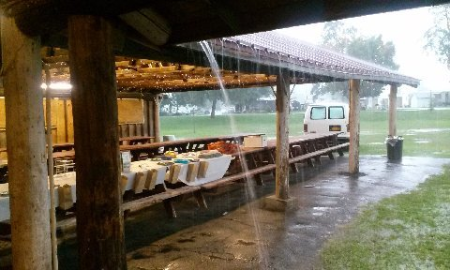
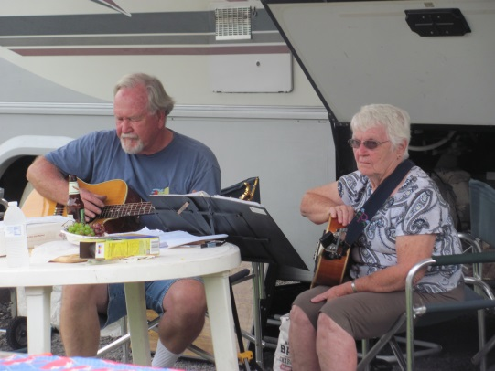
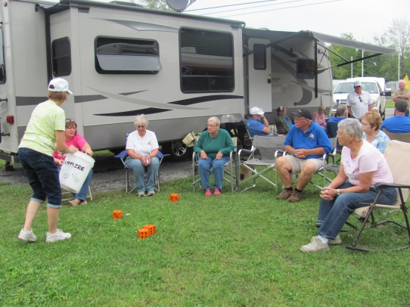
Some of us headed back to our campers for lunch, naps, TV watching and reading. When the sun broke out again, the air was filled with Jack’s smoked brisket and the happy cheers of members playing “Yardzee”, an outdoor lawn version of the dice game Yahtzee. Not sure who won, but it looked and sounded like everyone was having a great time. Jack Morinello and Pat Wyble treated the group to dueling guitars playing many good tunes together.

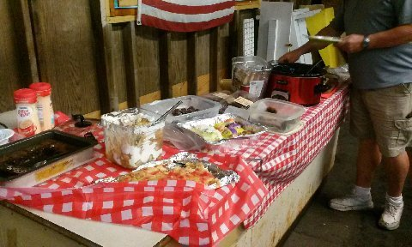
Saturday night the rain continued through our catered dinner of roasted chicken, potatoes, baked beans, and salad. Of course our Good Sam’s Club members provided another array of delicious desserts. They included fall favorites of apple and pumpkin, and well as chocolate and cherry desserts and everything in between. Yum Yum!!

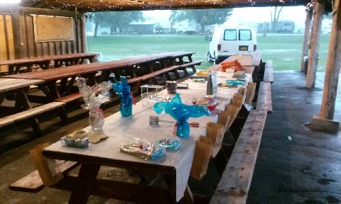
After dinner, the fun continued. A total of $144 was raised from the Foldable Wagon Raffle. to Carol and Rich Ward on winning. Another $122 was raised from the Chinese Auction. Total for charity - $266 on top of the $104 raised at the August campout. Way to go WNY Sam’s!!

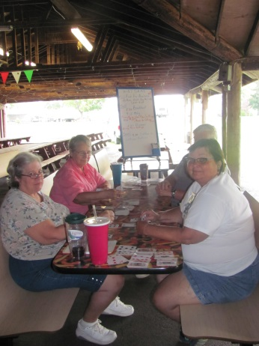
With the night still young, many members branched out to play cards…Hand and Foot was the popular game of the night,

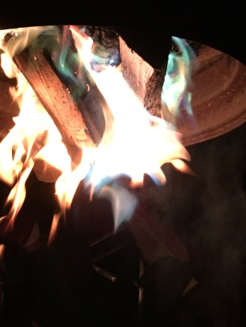
and some hardy souls ventured off to the campfire site and actually got the fire going. It didn’t last long though as the rain soon came down and the umbrellas went up. While some were scared away, others lingered for a little while more before saying good night.

Sunday morning was a bright and beautiful beginning of the day. We gathered for coffee and goodies and enjoyed the last bit of fellowship before ending the weekend. Wishing everyone a safe trip home, we left with another weekend of happy memories and another camping week end yet to come.

