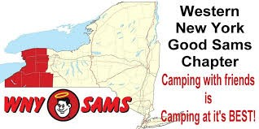
Turning Stone 2016

WNY Sam’s Club Newsletter

May Turning Stone Newsletter 2016 Linda DeRose, Editor

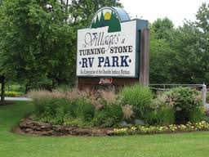
A few of us participate in a State sponsored “fun” weekend at Turning Stone Casino and Villages RV Park in Verona NY. This is a 10-10-10 rated resort. Some units arrived on Thursday, with the rest of us arriving the next day. The North East Directors didn’t plan anything special for us so we had to create our own activities and fun…Here are some of the things we did and enjoyed!

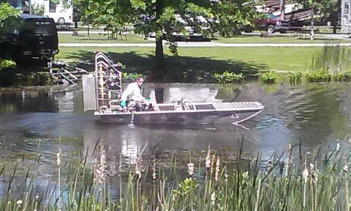
There are several ponds/lakes around the Villages, large enough to hold a small boat. That is what is being done as this boat was spraying for mosquitos. There were many geese and even a mother duck and ducklings that made regular appearances through the camp sites.

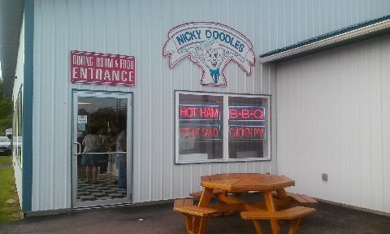
Friday night dinner was at a 50’s style diner called Nicky Doodles. They offered a very extensive menu, including everything from burgers, dogs, chicken, salads and ice cream. We had a full table with Teri & Don joining us shortly after we were seated. After dinner, it was a short ride back to the campground, literally 3 minutes down the road, for a fire. A small group took the free shuttle from the campground to the casino, to try our luck and to seek out entertainment at one of the clubs. Unfortunately, entertainment was not scheduled until 10:30 pm. The casino did offer free play for new visitors. We got our cards, and played the machines. Most lost their free play, but some of us managed to return with a small profit.
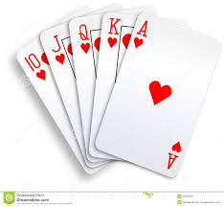

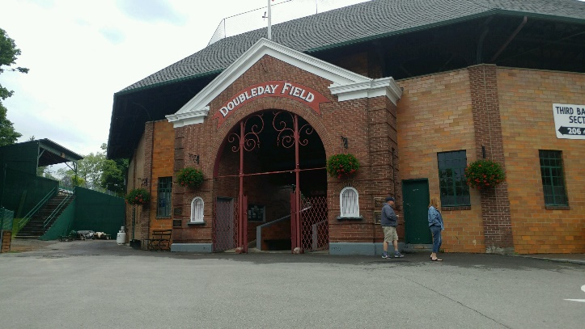
On Saturday, the Sokols and DeRoses headed to Cooperstown while the rest of the WNY Sam’s group headed to the casino buffet. They also attended a State get together to meet the directors and Good Sam members from other chapters. It was a good turn out with fruit and snacks to enjoy.
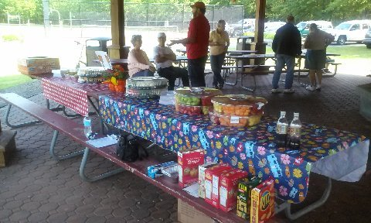
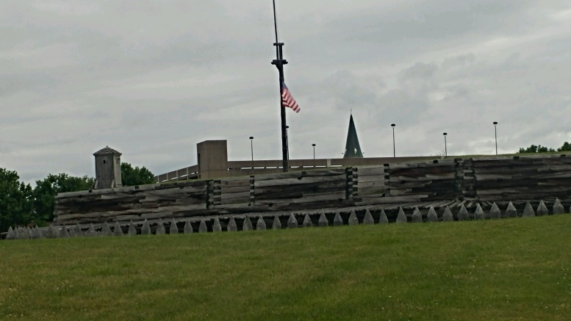
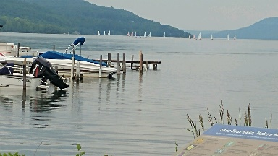
In Cooperstown, Don & Mike headed to the Baseball Hall of Fame, while the girls took in the other local interests. We checked out Double Day Field and enjoyed the gardens located on Otsego Lake. There was a group of sailboats on the lake that afternoon, and it was relaxing just to sit on the bench for a while and enjoy the tranquil view.

The weather was very warm in town, although it was overcast and rain was always a threat. We walked to a local coffee shop and enjoyed a delicious and refreshing cold blended frozen treat.
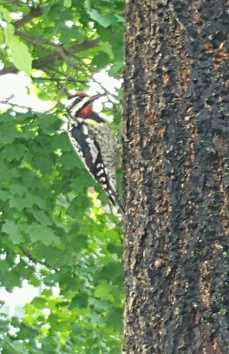

On our way, we encountered this beautiful red head at work looking for his meal in this tree. What a find!! We watched for a while as he tapped out a rhythmic tune on the tree. The rain held off, especially since we both purchased an umbrella.

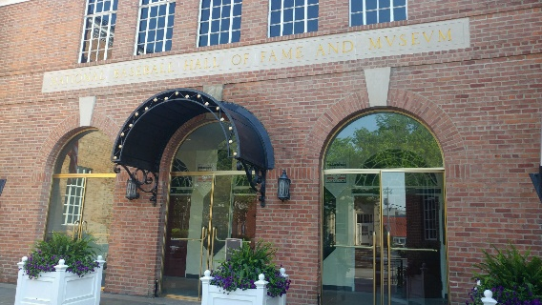
The boys took several hours touring the museum and the day went by quickly. We stopped at a local pizzeria for a late dinner and it was dusk by the time we headed back to camp for the night. It was a busy, but enjoyable day. The other campers were just breaking up from the campfire as we pulled into our sites.

FORT STANWIX, ROME NY
Sunday afternoon, found the Sokol’s, DeRoses and Morinello’s heading to Rome NY where we toured Fort Stanwix. The fort is located in the heart of town, and greets you as you exit the thruway. There is no off street parking, and we had to circle a few times before realizing there was no actual parking lot. That only proved that the fort was impenetrable. The fort is run by a staff of NY State Rangers, who are friendly and knowledgeable. We learned that this is a replica of the original Fort, which was a stronghold during the American Revolution and built during the 70’s when much of the downtown Rome area was demolished during a renovation and tourism boost to the city.
The actual site has everything you would expect as well as self-guided movies and a well-stocked gift shop. Ginger got stamps to add to her US National Parks Passport, and Terri was happy to purchase her Passport and receive her first stamps. We got some great pictures and enjoyed talking to the Rangers who were on staff that afternoon.

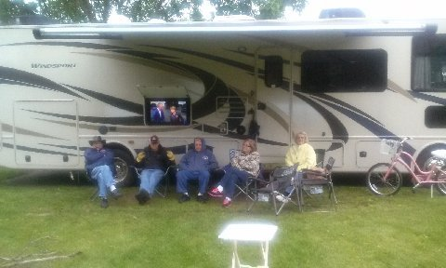
Back at camp, the others spent the day around the campground and gathered together to watch the Stanley Cup finals at the State Director’s, Maryann and Dick Crouch’s outdoor television. They sat under the awning when it began to rain, and enjoyed a campfire to ward off the cooler temperatures and gloomy day.

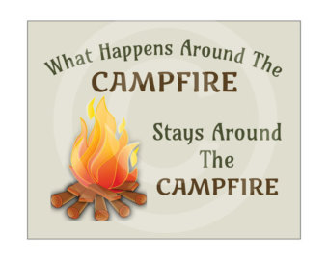
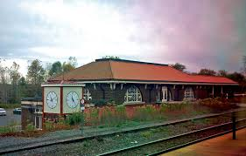
We headed to the Rome train station about 6 pm Sunday evening to meet my daughter who was coming in from Vermont. When we arrived, she was texting that the train was running late. The station was empty, and no employees were on site. We waited….and waited….and waited some more, as several long freight trains passed by. They were going both east and west bound. Our daughter’s train finally arrived about an hour late…the holdup was the freights. We were only about 20 minutes from camp, and decided to check out one of the casino’s restaurants, Upstate Tavern, for dinner. It was a sports bar type restaurant, and the food was great…Terri and I enjoyed a chicken pot pie, while Mike got what he described as “one of the best burgers he ever ate”. Don had a delicious looking meat loaf dinner, which was a nice portion of meat on a bed of mashed potatoes with a side of carrots.. Our vegetarian daughter opted for the Panini sandwich, which she also enjoyed. After another long day, we were happy to return back to the campers for a restful night. Don & Terri took a late night stroll around The Villages.

Monday morning greeted us with rain again. Most of the group was packed up and out of the park early. We bid farewell and safe travel to our friends, and it was good to know we would be together again very soon. Our next campout is scheduled on Thursday at Four Mile State Park in Lewiston. The camping season is upon us and even though the weather was not cooperating this time, we look forward to another great camping week end with our friends!

Happy Camping. Next camp outing is the Rally in Herkimer. Then we will see everyone in August at Dream Lake … Still looking for a few people to host the August Campout. This campout is also an opportunity to volunteer at Camp Get Away. Please be generous with your time for these kids and families.

