WNY Sam’s Club Newsletter

May 2016

May Newsletter 2016
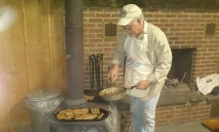

Members of WNY Sam’s were eager to kick off the 2016 camping season at Wood Stream Campground in Gainsville, NY. As usual, early birds began arriving on Thursday. Those included this month were Diana & Eddie, Big Dick & Sandy, Bonnie & Dean, Jim and Ellie, Marge & Jerry, and Rich & Carol. Glad to see these members were there to help ring in the New Year!!

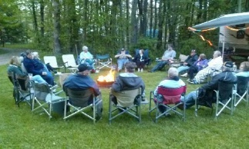
Friday Night’s activities included a pizza and chicken wing dinner, an initiation “newbie” dance performed by new members, Jan Ingerson & Cindy Jaeger from Springville, and another great gathering around the fire, which was especially nice because of the cooler weather. Jerry treated us to some campfire popcorn, which we all enjoyed. I noticed Ginger was sporting a new knit cap. Could this be the finished project from the October 2015 campout? Nicely done Ginger, the hat looked warm for a cool spring night. A fire was also started in the pavilion, in anticipation of a cooking fire and warmth for the next day’s breakfast and activities.

Saturday arrived early, and our hosts, the Fackler’s and the Morinello’s provided a feast for us. We dined on French toast, sausages, juices, fresh fruits and a delicious assortment of homemade baked goods. The monthly meeting followed, with plans being made for the July Samboree. It was decided that WNY Sam’s would have a 60’s style booth, complete with tie dye shirts and shorts (under or over), which we will be making during the June campout at Four Mile State Park Campground.
Since members apparently had a restless winter, and chose to visit some of the RV shows in the area, a Saturday afternoon activity included a TOUR OF HOMES, motor homes & trailers that is. We were welcomed into the new homes of the Crouches, the DeRoses, the Masseys, the Meyers, and the Reumanns. All these new RV’s were fun to look at, and the owners were happy and proud to welcome us visitors into their personal space. There were different styles, makes and models. We had our own little show only second to Camping World. The Devantier/Gray family also have a new trailer that we can check out at the next camp out.
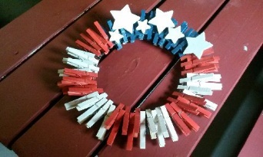
CRAFT CORNER: Immediately following the meeting, a group met together in the pavilion, and under the direction of Nancy Craig, created beautifully crafted Memorial Day wreaths from clothespins. Keith was on hand helping to pass out clothespins, collecting money and offering helpful advice on how to complete the craft.
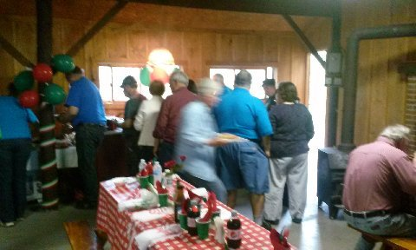
Saturday evening, we had an Italian buffet. Everything from Soup, Stoup, Salads, chicken parmesan, meatballs and sauce, sausage with peppers and onions, Italian and garlic bread and many more items, I probably am forgetting. The pavilion was brightly decorated with checkerboard tablecloths, wine bottle centerpieces and festive balloons and streamers. The dessert table was also laden with some delicious treats, including a strawberry angel food cake, biscotti, an enormous cookie tray, and even warm lava cake, oozing with deliciousness!! Yum yum. After cleanup, we dragged ourselves out to the bonfire, and didn’t even let the rain get in our way. Many of the men showed their chivalry, giving up their chairs, & offering rain protection and umbrellas for their ladies. We enjoyed laughs around the fire, and some of us were surprised to learn that mild mannered Rich Ward has road rage and crazy driving skills. He even admitted to driving the wrong way through a Kentucky Fried chicken drive thru. The fires are always my favorite time. I enjoy the conversations, and even the quiet time as we just sit back to relax.

There wasn’t many games or activities this weekend (baseball & corn hole), but there was a hot card game in the pavilion until late hours of the night. Rumor has it that with lots of help and intervention from above, the boys took the win. Players were the Ellis’s, (yes, the group says, and I believe that Butch played a part in the winning hands), Stenshorns, Coxes and Stricklands. Great game guys, but don’t worry, the girls will come back to take the lead.!
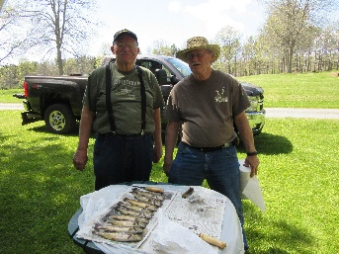
Dick Cox & Jim Strickland took the Catch of the Day! Between them, they caught 10 fish. Here is the proof. Another camper, Jim Gray mentioned at Saturday night dinner, that he also went fishing and caught 3 large stixs. Not being a fisherwoman myself, I was impressed at the size he showed as he measured with his hands. I asked if they were catch and release. He assured me he did put them aside. It wasn’t until after he explained that they were actually wooden sticks, and not a new species of fish, that I understood he came up empty.
I want to thank everyone for their patience with me getting this first newsletter out. Diana always made it happen in a timelier manner. I am getting used to my duties as the new secretary, and Diana is a tough act to follow.
Thank you to “BIG DICK” Kashdin for providing pictures and blogs for me to build on and create this issue.
If anyone is interested in contributing to a guest corner, sharing something funny, useful, interesting or amusing to our group, I will be happy to share it in our future publications.
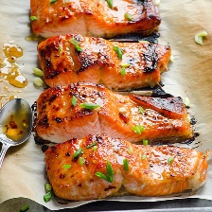
COMING SOON: The June campout will be June 16-19 at Four Mile State Park in Youngstown. Terri & Don Sokol and Mike and Linda DeRose will be hosting. There will be a catered dinner from Melloni’s in Lewiston on Saturday night. If you are interested in the dinner, please e-mail Mike DeRose at mderose51@yahoo.com to confirm your interest. Payment is $10/person and will include breakfast. Lewiston will be holding a garden show that week end, and Niagara Falls and Fort Niagara are a short drive away.
Recipe of the Month:
Clean Eating Baked Thai Salmon
Ingredients
6 x 6 oz sockeye salmon fillets, skin on or off
• Pinch of salt
• 1/2 cup + 2 tbsp Thai sweet chili sauce, divided
• 2 - 3 tbsp green onions, chopped
• Cooking spray
Directions
In a large baking dish, lay down salmon fillets in a row. Each fillet - sprinkle with a pinch of salt and top with 1 tbsp Thai sweet chili sauce. Brush or rub with your fingers to coat fish with sauce evenly on top, bottom and sides. Cover and let marinate in the fridge for at least 2 hours or overnight is the best (up to 24 hours).
Turn on oven's broiler on High and position top oven rack 5" - 6" below the heat source. Line large baking sheet with unbleached parchment paper, spray with cooking spray and place salmon fillets skin side down (if any). Coat with remaining marinade from the dish (if any).
Broil for 8 minutes, rotating baking sheet once. Remove from the oven and brush top of each fillet with 2 tsp of Thai sweet chili sauce. Return to the oven and broil for another 5 minutes or until salmon has caramelized. Serve hot garnished with green onions, extra sauce (if desired) with brown rice or quinoa on a side.

